Laporan Kemiringan Menara pada 20kV APEL & ANGGUR SPAN 1-156

Tegangan : 20kV
Nama RoW : APEL & ANGGUR SPAN 1-156
Unit Pelaksana : PT PLN ELECTRICITY SERVICES
Unit Pelaporan : OASIS

2026/09/21

Kemiringan Menara

Daftar Kemiringan Menara
Nomor Menara | Searah RoW (%) | Tegak Lurus RoW (%) | Resultan (%) | Nilai Standar (%) | Searah RoW | Tegak Lurus RoW | Penilaian
1 | 9.78 | 9.14 | 13.39 | 5.00 | BC | CD | Tidak Lulus
2 | 1.74 | 4.70 | 5.01 | 5.00 | BC | CD | Tidak Lulus
3 | 3.34 | 2.74 | 4.32 | 5.00 | BC | CD | Lulus
4 | 0.67 | 2.14 | 2.24 | 5.00 | BC | AB | Lulus
5 | 3.02 | 1.73 | 3.48 | 5.00 | BC | CD | Lulus
6 | 1.87 | 1.67 | 2.51 | 5.00 | BC | CD | Lulus
7 | 1.39 | 2.53 | 2.89 | 5.00 | BC | CD | Lulus
8 | 0.27 | 1.06 | 1.09 | 5.00 | BC | CD | Lulus
9 | 1.76 | 1.66 | 2.42 | 5.00 | AD | AB | Lulus
10 | 1.98 | 3.04 | 3.63 | 5.00 | BC | CD | Lulus
11 | 3.27 | 2.86 | 4.34 | 5.00 | AD | CD | Lulus
12 | 1.83 | 3.15 | 3.64 | 5.00 | BC | AB | Lulus
13 | 1.79 | 4.03 | 4.41 | 5.00 | BC | CD | Lulus
14 | 0.00 | 5.51 | 5.51 | 5.00 | - | CD | Tidak Lulus
15 | 0.39 | 6.42 | 6.43 | 5.00 | BC | CD | Tidak Lulus
16 | 3.34 | 9.71 | 10.27 | 5.00 | AD | CD | Tidak Lulus
17 | 0.57 | 7.40 | 7.42 | 5.00 | AD | CD | Tidak Lulus
18 | 2.31 | 4.90 | 5.42 | 5.00 | AD | AB | Tidak Lulus
19 | 1.66 | 3.51 | 3.88 | 5.00 | AD | AB | Lulus
20 | 0.24 | 0.02 | 0.24 | 5.00 | AD | AB | Lulus
21 | 1.44 | 1.06 | 1.79 | 5.00 | AD | AB | Lulus
22 | 1.76 | 4.96 | 5.26 | 5.00 | BC | AB | Tidak Lulus
23 | 1.42 | 6.93 | 7.07 | 5.00 | BC | CD | Tidak Lulus
24 | 3.74 | 0.88 | 3.84 | 5.00 | BC | AB | Lulus
25 | 4.19 | 1.47 | 4.44 | 5.00 | BC | CD | Lulus
26 | 3.37 | 2.80 | 4.38 | 5.00 | AD | CD | Lulus
27 | 3.39 | 1.18 | 3.59 | 5.00 | BC | CD | Lulus
28 | 2.24 | 3.70 | 4.33 | 5.00 | BC | CD | Lulus
29 | 8.69 | 5.56 | 10.32 | 5.00 | AD | CD | Tidak Lulus
30 | 4.35 | 4.15 | 6.01 | 5.00 | AD | CD | Tidak Lulus
31 | 1.57 | 0.14 | 1.58 | 5.00 | AD | CD | Lulus
32 | 7.35 | 3.12 | 7.98 | 5.00 | AD | CD | Tidak Lulus
33 | 1.25 | 0.21 | 1.27 | 5.00 | AD | AB | Lulus
34 | 2.11 | 1.24 | 2.45 | 5.00 | BC | CD | Lulus
35 | 1.15 | 1.55 | 1.93 | 5.00 | BC | CD | Lulus
36 | 5.32 | 4.31 | 6.85 | 5.00 | AD | AB | Tidak Lulus
37 | 20.20 | 1.00 | 20.22 | 5.00 | BC | CD | Tidak Lulus
38 | 2.70 | 1.83 | 3.26 | 5.00 | AD | CD | Lulus
39 | 0.17 | 0.12 | 0.21 | 5.00 | AD | CD | Lulus
40 | 2.39 | 3.05 | 3.87 | 5.00 | BC | CD | Lulus
41 | 2.57 | 3.16 | 4.07 | 5.00 | AD | CD | Lulus
42 | 2.57 | 2.59 | 3.65 | 5.00 | AD | CD | Lulus
43 | 1.88 | 2.11 | 2.83 | 5.00 | AD | CD | Lulus
44 | 2.52 | 3.58 | 4.38 | 5.00 | AD | CD | Lulus
45 | 6.11 | 5.54 | 8.25 | 5.00 | AD | AB | Tidak Lulus
46 | 4.31 | 3.16 | 5.34 | 5.00 | AD | AB | Tidak Lulus
47 | 16.80 | 0.02 | 16.80 | 5.00 | BC | AB | Tidak Lulus
48 | 1.72 | 2.03 | 2.66 | 5.00 | AD | AB | Lulus
49 | 3.85 | 1.14 | 4.02 | 5.00 | BC | CD | Lulus
50 | 3.50 | 0.53 | 3.54 | 5.00 | AD | AB | Lulus
51 | 2.18 | 3.94 | 4.50 | 5.00 | BC | AB | Lulus
52 | 2.66 | 2.61 | 3.73 | 5.00 | BC | CD | Lulus
53 | 4.43 | 1.39 | 4.64 | 5.00 | AD | AB | Lulus
54 | 2.29 | 2.85 | 3.66 | 5.00 | AD | AB | Lulus
55 | 0.25 | 1.08 | 1.11 | 5.00 | AD | CD | Lulus
56 | 0.31 | 2.14 | 2.16 | 5.00 | AD | AB | Lulus
57 | 3.28 | 5.39 | 6.31 | 5.00 | BC | AB | Tidak Lulus
58 | 1.40 | 0.43 | 1.46 | 5.00 | AD | AB | Lulus
59 | 1.45 | 3.46 | 3.75 | 5.00 | BC | AB | Lulus
60 | 6.85 | 4.87 | 8.40 | 5.00 | BC | CD | Tidak Lulus
61 | 0.56 | 2.05 | 2.13 | 5.00 | BC | CD | Lulus
62 | 2.17 | 6.28 | 6.64 | 5.00 | BC | AB | Tidak Lulus
63 | 4.61 | 2.28 | 5.14 | 5.00 | BC | CD | Tidak Lulus
64 | 4.61 | 1.48 | 4.84 | 5.00 | AD | CD | Lulus
65 | 3.60 | 0.60 | 3.65 | 5.00 | AD | AB | Lulus
66 | 4.31 | 0.07 | 4.31 | 5.00 | AD | CD | Lulus
67 | 4.30 | 0.75 | 4.36 | 5.00 | AD | CD | Lulus
68 | 4.58 | 1.13 | 4.72 | 5.00 | AD | AB | Lulus
69 | 0.84 | 6.15 | 6.21 | 5.00 | AD | CD | Tidak Lulus
70 | 8.50 | 2.65 | 8.90 | 5.00 | AD | AB | Tidak Lulus
71 | 0.90 | 4.47 | 4.56 | 5.00 | AD | CD | Lulus
72 | 1.69 | 3.20 | 3.62 | 5.00 | BC | CD | Lulus
73 | 0.00 | 3.62 | 3.62 | 5.00 | - | CD | Lulus
74 | 6.44 | 1.43 | 6.60 | 5.00 | AD | CD | Tidak Lulus
75 | 1.56 | 2.65 | 3.08 | 5.00 | BC | AB | Lulus
76 | 1.65 | 2.88 | 3.32 | 5.00 | AD | CD | Lulus
77 | 6.07 | 5.33 | 8.08 | 5.00 | BC | CD | Tidak Lulus
78 | 2.93 | 2.68 | 3.97 | 5.00 | AD | CD | Lulus
79 | 4.60 | 0.70 | 4.65 | 5.00 | AD | AB | Lulus
80 | 0.55 | 4.11 | 4.15 | 5.00 | AD | CD | Lulus
81 | 3.33 | 0.47 | 3.36 | 5.00 | AD | CD | Lulus
82 | 0.34 | 10.78 | 10.79 | 5.00 | BC | AB | Tidak Lulus
83 | 2.47 | 1.71 | 3.00 | 5.00 | AD | AB | Lulus
84 | 10.75 | 2.27 | 10.99 | 5.00 | AD | CD | Tidak Lulus
85 | 4.48 | 1.90 | 4.87 | 5.00 | BC | AB | Lulus
86 | 8.69 | 3.66 | 9.43 | 5.00 | BC | AB | Tidak Lulus
87 | 0.15 | 1.75 | 1.76 | 5.00 | AD | CD | Lulus
88 | 0.73 | 0.54 | 0.91 | 5.00 | BC | AB | Lulus
89 | 1.32 | 1.43 | 1.95 | 5.00 | BC | CD | Lulus
90 | 6.35 | 6.36 | 8.99 | 5.00 | AD | AB | Tidak Lulus
91 | 0.80 | 0.03 | 0.80 | 5.00 | BC | AB | Lulus
92 | 7.92 | 0.42 | 7.93 | 5.00 | AD | AB | Tidak Lulus
93 | 11.03 | 5.44 | 12.30 | 5.00 | AD | AB | Tidak Lulus
94 | 3.92 | 2.46 | 4.63 | 5.00 | AD | CD | Lulus
95 | 8.13 | 1.20 | 8.22 | 5.00 | AD | AB | Tidak Lulus
96 | 10.39 | 1.25 | 10.46 | 5.00 | AD | AB | Tidak Lulus
97 | 12.90 | 3.58 | 13.39 | 5.00 | AD | AB | Tidak Lulus
98 | 12.14 | 5.81 | 13.46 | 5.00 | AD | CD | Tidak Lulus
99 | 36.05 | 6.74 | 36.67 | 5.00 | AD | CD | Tidak Lulus
100 | 0.34 | 2.83 | 2.85 | 5.00 | BC | CD | Lulus
101 | 5.39 | 17.57 | 18.38 | 5.00 | AD | CD | Tidak Lulus
102 | 13.16 | 9.66 | 16.32 | 5.00 | AD | CD | Tidak Lulus
103 | 8.93 | 1.84 | 9.12 | 5.00 | AD | AB | Tidak Lulus
104 | 1.36 | 3.10 | 3.39 | 5.00 | AD | CD | Lulus
105 | 3.26 | 0.86 | 3.37 | 5.00 | BC | CD | Lulus
106 | 0.84 | 0.24 | 0.87 | 5.00 | BC | CD | Lulus
107 | 2.51 | 3.45 | 4.27 | 5.00 | BC | CD | Lulus
108 | 0.65 | 0.34 | 0.73 | 5.00 | BC | CD | Lulus
109 | 2.73 | 7.77 | 8.24 | 5.00 | AD | AB | Tidak Lulus
110 | 3.19 | 0.13 | 3.19 | 5.00 | AD | AB | Lulus
111 | 3.69 | 0.68 | 3.75 | 5.00 | AD | CD | Lulus
112 | 0.72 | 1.47 | 1.64 | 5.00 | BC | AB | Lulus
113 | 1.44 | 10.23 | 10.33 | 5.00 | BC | AB | Tidak Lulus
114 | 5.30 | 0.67 | 5.34 | 5.00 | BC | AB | Tidak Lulus
115 | 2.73 | 3.50 | 4.44 | 5.00 | AD | CD | Lulus
116 | 0.50 | 8.93 | 8.94 | 5.00 | BC | AB | Tidak Lulus
117 | 17.31 | 0.57 | 17.32 | 5.00 | AD | AB | Tidak Lulus
118 | 5.11 | 11.21 | 12.32 | 5.00 | BC | AB | Tidak Lulus
119 | 5.29 | 9.96 | 11.28 | 5.00 | AD | CD | Tidak Lulus
120 | 6.77 | 16.88 | 18.19 | 5.00 | BC | AB | Tidak Lulus
121 | 11.05 | 11.01 | 15.60 | 5.00 | BC | CD | Tidak Lulus
122 | 4.86 | 10.00 | 11.12 | 5.00 | AD | CD | Tidak Lulus
123 | 1.96 | 1.70 | 2.59 | 5.00 | BC | CD | Lulus
124 | 1.51 | 8.02 | 8.16 | 5.00 | BC | AB | Tidak Lulus
125 | 0.30 | 29.86 | 29.86 | 5.00 | AD | AB | Tidak Lulus
126 | 1.57 | 5.99 | 6.19 | 5.00 | BC | AB | Tidak Lulus
127 | 0.46 | 5.22 | 5.24 | 5.00 | AD | CD | Tidak Lulus
128 | 0.45 | 1.57 | 1.63 | 5.00 | AD | AB | Lulus
129 | 5.59 | 11.91 | 13.16 | 5.00 | BC | AB | Tidak Lulus
130 | 1.36 | 2.25 | 2.63 | 5.00 | BC | CD | Lulus
131 | 7.05 | 9.58 | 11.89 | 5.00 | AD | AB | Tidak Lulus
132 | 1.14 | 2.58 | 2.82 | 5.00 | AD | CD | Lulus
133 | 5.95 | 3.08 | 6.70 | 5.00 | BC | CD | Tidak Lulus
134 | 7.08 | 4.04 | 8.15 | 5.00 | BC | CD | Tidak Lulus
135 | 4.75 | 19.61 | 20.18 | 5.00 | BC | AB | Tidak Lulus
136 | 9.93 | 2.35 | 10.20 | 5.00 | BC | CD | Tidak Lulus
137 | 6.48 | 1.09 | 6.57 | 5.00 | BC | AB | Tidak Lulus
138 | 7.24 | 17.57 | 19.00 | 5.00 | BC | CD | Tidak Lulus
139 | 1.54 | 0.13 | 1.55 | 5.00 | BC | AB | Lulus
140 | 1.01 | 6.89 | 6.96 | 5.00 | AD | CD | Tidak Lulus
141 | 0.98 | 1.98 | 2.21 | 5.00 | AD | CD | Lulus
142 | 0.58 | 4.56 | 4.60 | 5.00 | AD | CD | Lulus
143 | 3.00 | 2.48 | 3.89 | 5.00 | AD | CD | Lulus
144 | 15.90 | 2.36 | 16.07 | 5.00 | BC | AB | Tidak Lulus
145 | 3.60 | 2.09 | 4.16 | 5.00 | AD | CD | Lulus
146 | 0.00 | 4.03 | 4.03 | 5.00 | - | CD | Lulus
147 | 1.05 | 2.22 | 2.46 | 5.00 | AD | CD | Lulus
148 | 0.59 | 1.85 | 1.94 | 5.00 | AD | AB | Lulus
149 | 4.44 | 16.73 | 17.31 | 5.00 | AD | CD | Tidak Lulus
150 | 1.19 | 1.56 | 1.96 | 5.00 | AD | AB | Lulus
151 | 4.69 | 1.75 | 5.01 | 5.00 | AD | AB | Tidak Lulus
152 | 1.57 | 0.50 | 1.65 | 5.00 | AD | CD | Lulus
153 | 1.27 | 4.27 | 4.45 | 5.00 | AD | CD | Lulus
154 | 9.15 | 36.80 | 37.92 | 5.00 | AD | CD | Tidak Lulus
155 | 2.29 | 2.15 | 3.14 | 5.00 | AD | AB | Lulus
156 | 1.18 | 5.99 | 6.11 | 5.00 | BC | CD | Tidak Lulus

Detail Kemiringan Menara
Tabel 1. Kemiringan Menara 1
Nomor Menara | Searah RoW (%) | Tegak Lurus RoW (%) | Resultan (%) | Nilai Standar (%) | Searah RoW | Tegak Lurus RoW | Penilaian
1 | 9.78 | 9.14 | 13.39 | 5.00 | BC | CD | Tidak Lulus
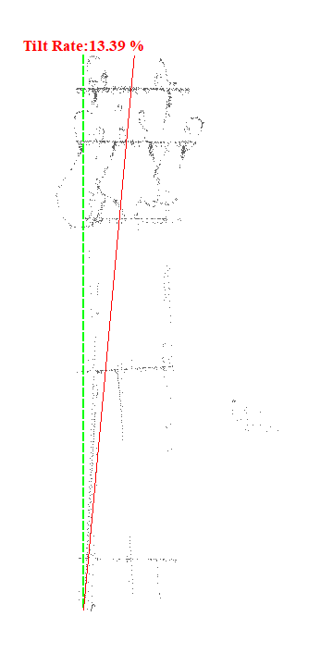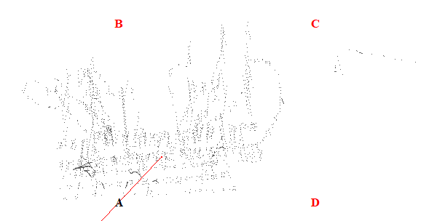
Gambar 1. Kemiringan Menara 1

Tabel 2. Kemiringan Menara 2
Nomor Menara | Searah RoW (%) | Tegak Lurus RoW (%) | Resultan (%) | Nilai Standar (%) | Searah RoW | Tegak Lurus RoW | Penilaian
2 | 1.74 | 4.70 | 5.01 | 5.00 | BC | CD | Tidak Lulus
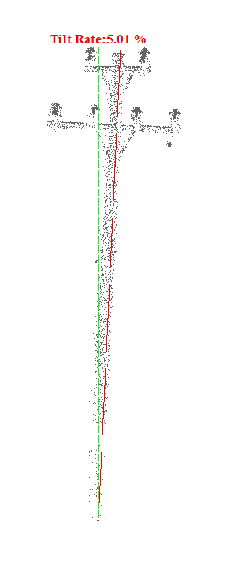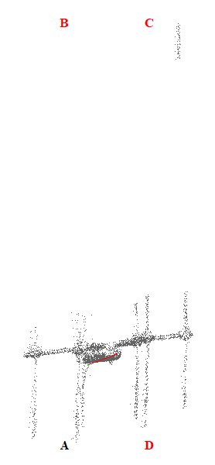
Gambar 2. Kemiringan Menara 2

Tabel 3. Kemiringan Menara 3
Nomor Menara | Searah RoW (%) | Tegak Lurus RoW (%) | Resultan (%) | Nilai Standar (%) | Searah RoW | Tegak Lurus RoW | Penilaian
3 | 3.34 | 2.74 | 4.32 | 5.00 | BC | CD | Lulus
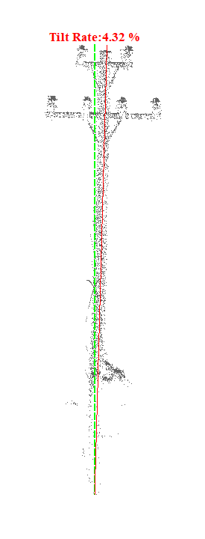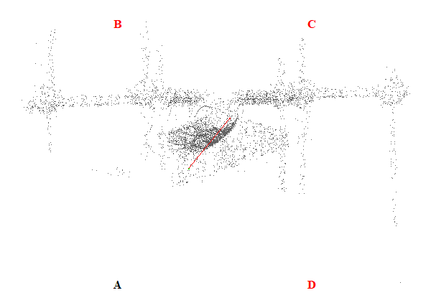
Gambar 3. Kemiringan Menara 3

Tabel 4. Kemiringan Menara 4
Nomor Menara | Searah RoW (%) | Tegak Lurus RoW (%) | Resultan (%) | Nilai Standar (%) | Searah RoW | Tegak Lurus RoW | Penilaian
4 | 0.67 | 2.14 | 2.24 | 5.00 | BC | AB | Lulus
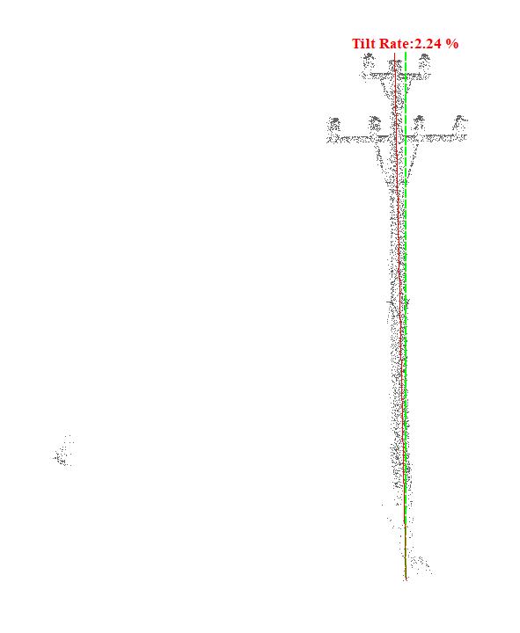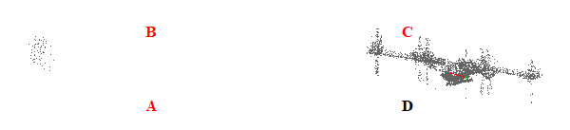
Gambar 4. Kemiringan Menara 4

Tabel 5. Kemiringan Menara 5
Nomor Menara | Searah RoW (%) | Tegak Lurus RoW (%) | Resultan (%) | Nilai Standar (%) | Searah RoW | Tegak Lurus RoW | Penilaian
5 | 3.02 | 1.73 | 3.48 | 5.00 | BC | CD | Lulus
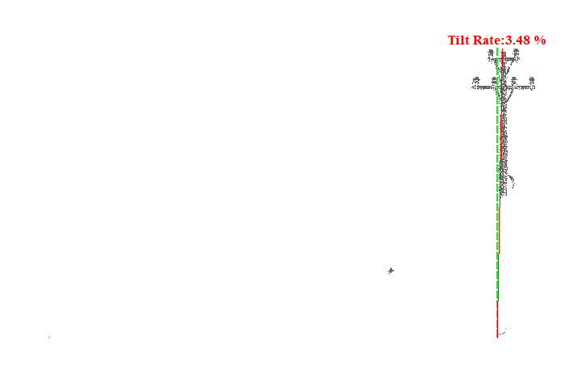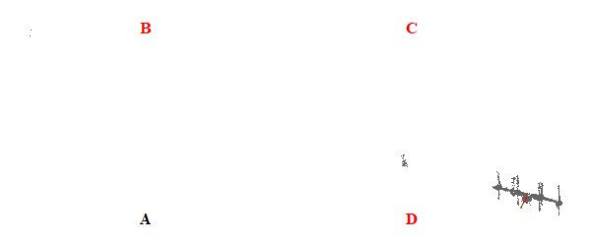
Gambar 5. Kemiringan Menara 5

Tabel 6. Kemiringan Menara 6
Nomor Menara | Searah RoW (%) | Tegak Lurus RoW (%) | Resultan (%) | Nilai Standar (%) | Searah RoW | Tegak Lurus RoW | Penilaian
6 | 1.87 | 1.67 | 2.51 | 5.00 | BC | CD | Lulus
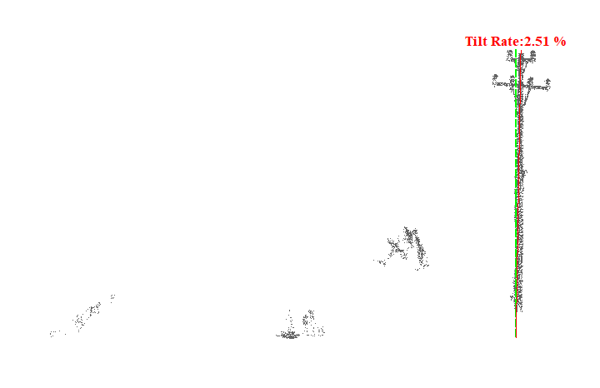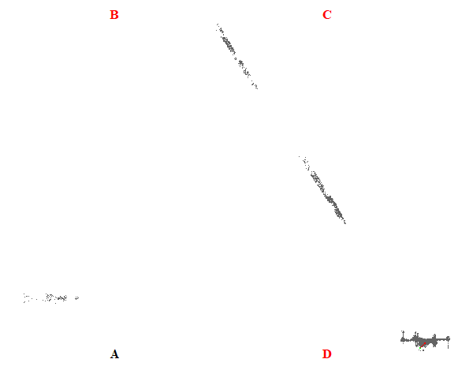
Gambar 6. Kemiringan Menara 6

Tabel 7. Kemiringan Menara 7
Nomor Menara | Searah RoW (%) | Tegak Lurus RoW (%) | Resultan (%) | Nilai Standar (%) | Searah RoW | Tegak Lurus RoW | Penilaian
7 | 1.39 | 2.53 | 2.89 | 5.00 | BC | CD | Lulus
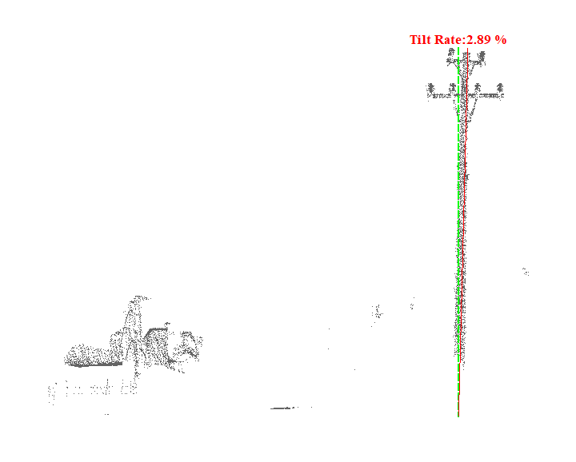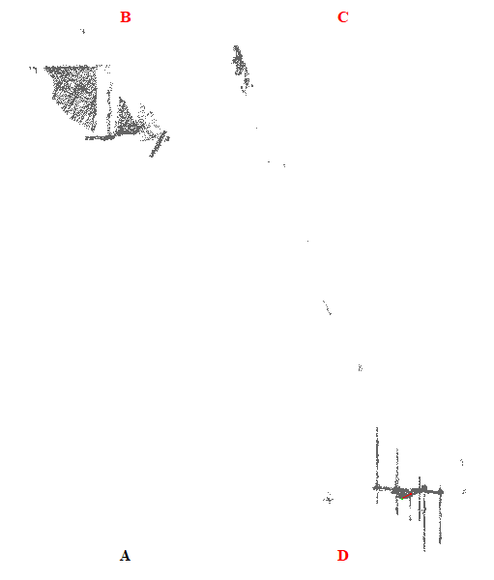
Gambar 7. Kemiringan Menara 7

Tabel 8. Kemiringan Menara 8
Nomor Menara | Searah RoW (%) | Tegak Lurus RoW (%) | Resultan (%) | Nilai Standar (%) | Searah RoW | Tegak Lurus RoW | Penilaian
8 | 0.27 | 1.06 | 1.09 | 5.00 | BC | CD | Lulus
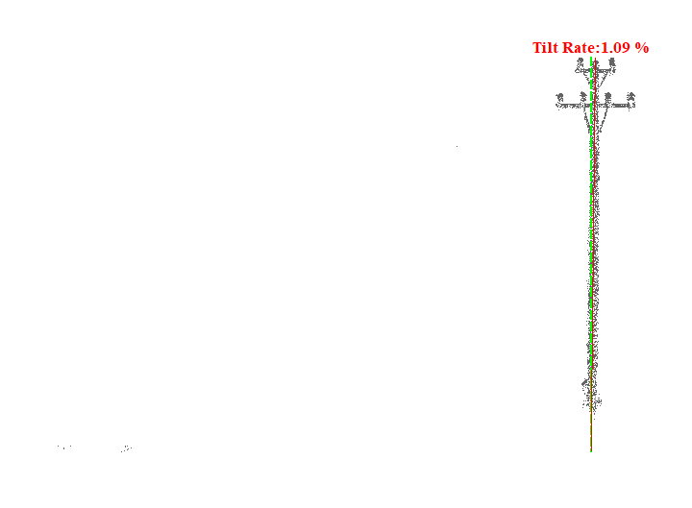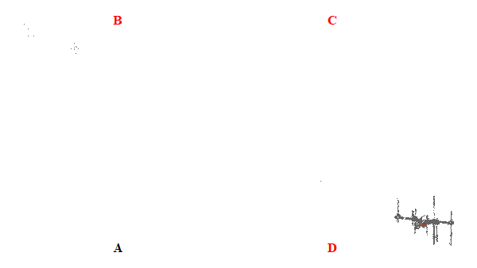
Gambar 8. Kemiringan Menara 8

Tabel 9. Kemiringan Menara 9
Nomor Menara | Searah RoW (%) | Tegak Lurus RoW (%) | Resultan (%) | Nilai Standar (%) | Searah RoW | Tegak Lurus RoW | Penilaian
9 | 1.76 | 1.66 | 2.42 | 5.00 | AD | AB | Lulus
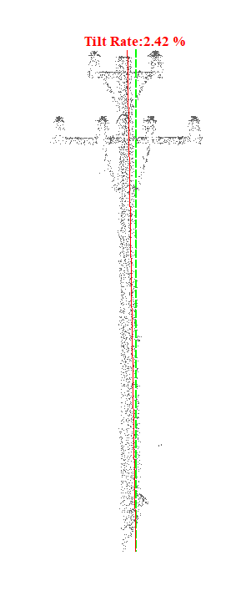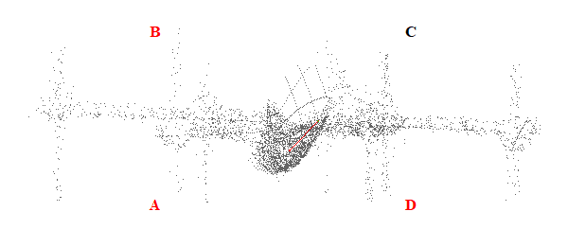
Gambar 9. Kemiringan Menara 9

Tabel 10. Kemiringan Menara 10
Nomor Menara | Searah RoW (%) | Tegak Lurus RoW (%) | Resultan (%) | Nilai Standar (%) | Searah RoW | Tegak Lurus RoW | Penilaian
10 | 1.98 | 3.04 | 3.63 | 5.00 | BC | CD | Lulus
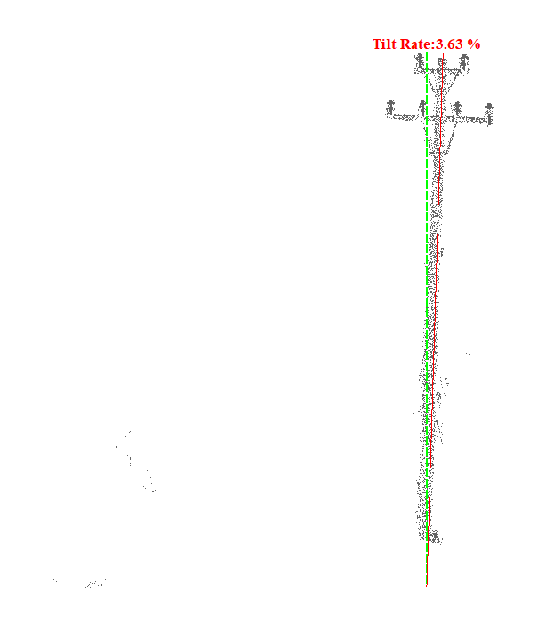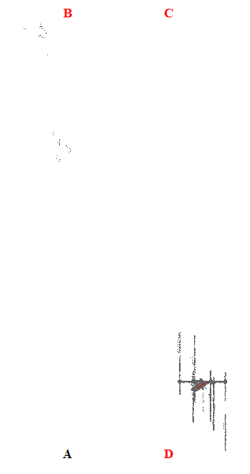
Gambar 10. Kemiringan Menara 10

Tabel 11. Kemiringan Menara 11
Nomor Menara | Searah RoW (%) | Tegak Lurus RoW (%) | Resultan (%) | Nilai Standar (%) | Searah RoW | Tegak Lurus RoW | Penilaian
11 | 3.27 | 2.86 | 4.34 | 5.00 | AD | CD | Lulus
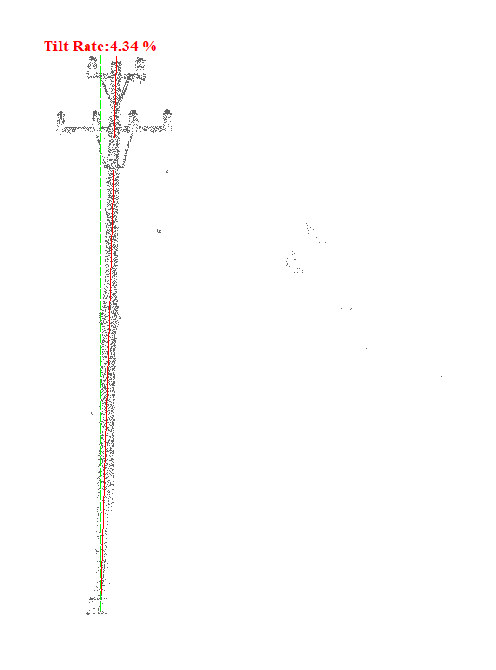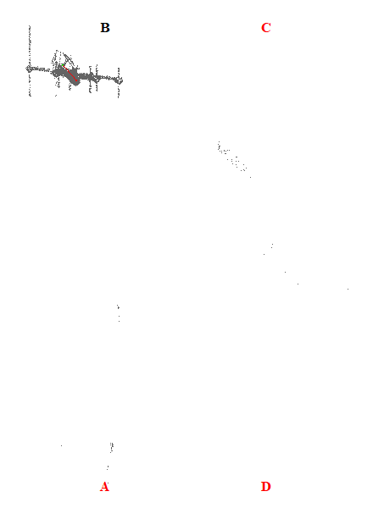
Gambar 11. Kemiringan Menara 11

Tabel 12. Kemiringan Menara 12
Nomor Menara | Searah RoW (%) | Tegak Lurus RoW (%) | Resultan (%) | Nilai Standar (%) | Searah RoW | Tegak Lurus RoW | Penilaian
12 | 1.83 | 3.15 | 3.64 | 5.00 | BC | AB | Lulus
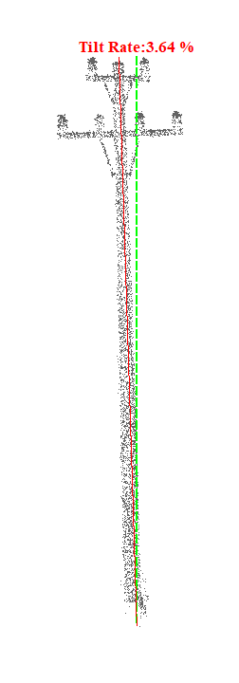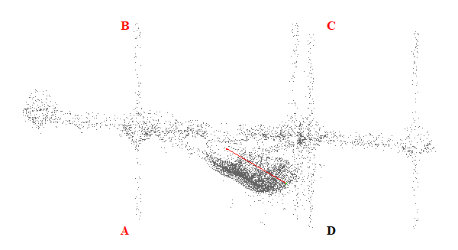
Gambar 12. Kemiringan Menara 12

Tabel 13. Kemiringan Menara 13
Nomor Menara | Searah RoW (%) | Tegak Lurus RoW (%) | Resultan (%) | Nilai Standar (%) | Searah RoW | Tegak Lurus RoW | Penilaian
13 | 1.79 | 4.03 | 4.41 | 5.00 | BC | CD | Lulus
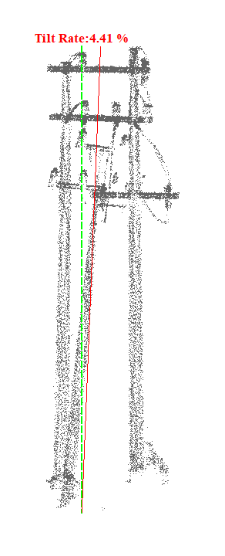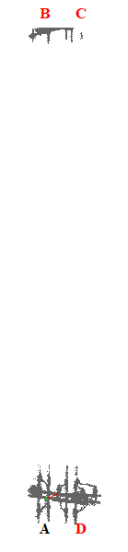
Gambar 13. Kemiringan Menara 13

Tabel 14. Kemiringan Menara 14
Nomor Menara | Searah RoW (%) | Tegak Lurus RoW (%) | Resultan (%) | Nilai Standar (%) | Searah RoW | Tegak Lurus RoW | Penilaian
14 | 0.00 | 5.51 | 5.51 | 5.00 | - | CD | Tidak Lulus
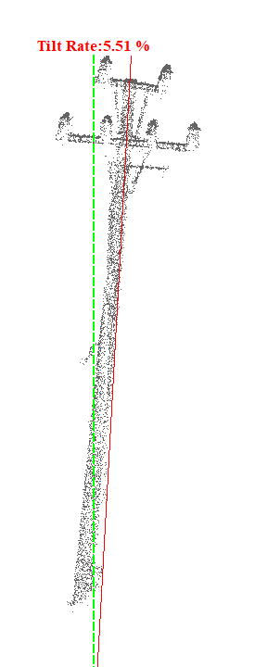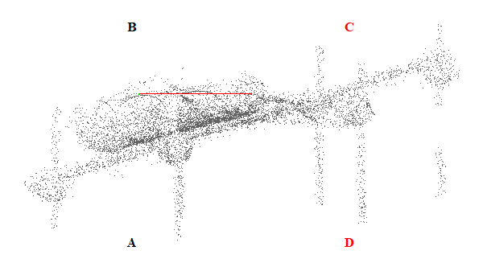
Gambar 14. Kemiringan Menara 14

Tabel 15. Kemiringan Menara 15
Nomor Menara | Searah RoW (%) | Tegak Lurus RoW (%) | Resultan (%) | Nilai Standar (%) | Searah RoW | Tegak Lurus RoW | Penilaian
15 | 0.39 | 6.42 | 6.43 | 5.00 | BC | CD | Tidak Lulus
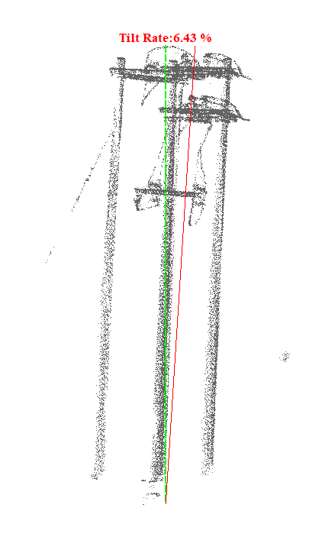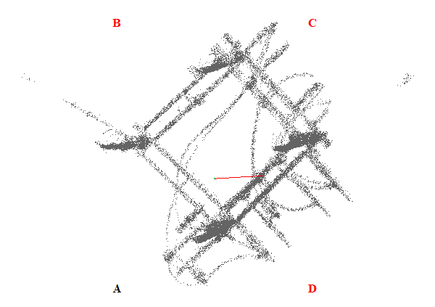
Gambar 15. Kemiringan Menara 15

Tabel 16. Kemiringan Menara 16
Nomor Menara | Searah RoW (%) | Tegak Lurus RoW (%) | Resultan (%) | Nilai Standar (%) | Searah RoW | Tegak Lurus RoW | Penilaian
16 | 3.34 | 9.71 | 10.27 | 5.00 | AD | CD | Tidak Lulus
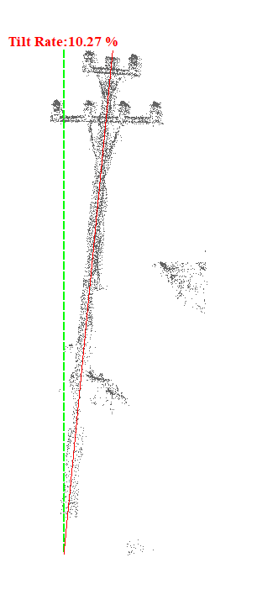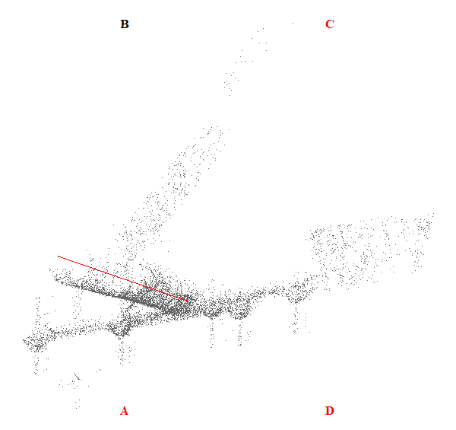
Gambar 16. Kemiringan Menara 16

Tabel 17. Kemiringan Menara 17
Nomor Menara | Searah RoW (%) | Tegak Lurus RoW (%) | Resultan (%) | Nilai Standar (%) | Searah RoW | Tegak Lurus RoW | Penilaian
17 | 0.57 | 7.40 | 7.42 | 5.00 | AD | CD | Tidak Lulus
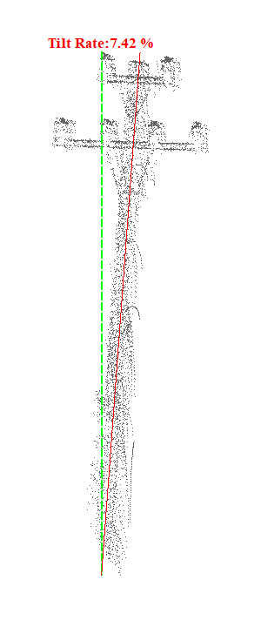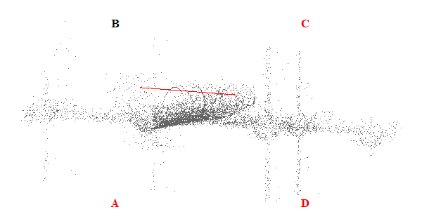
Gambar 17. Kemiringan Menara 17

Tabel 18. Kemiringan Menara 18
Nomor Menara | Searah RoW (%) | Tegak Lurus RoW (%) | Resultan (%) | Nilai Standar (%) | Searah RoW | Tegak Lurus RoW | Penilaian
18 | 2.31 | 4.90 | 5.42 | 5.00 | AD | AB | Tidak Lulus
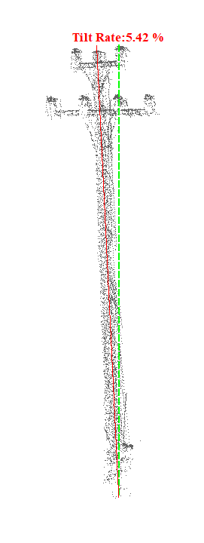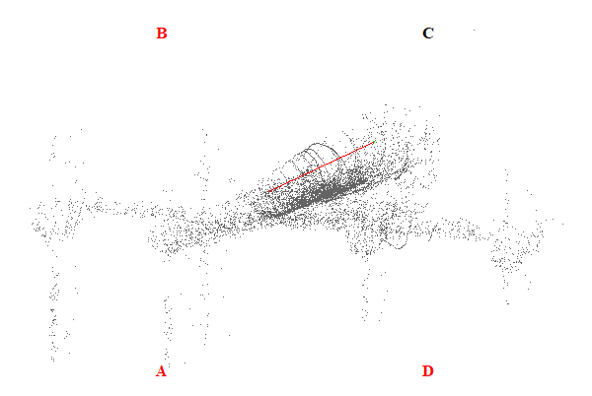
Gambar 18. Kemiringan Menara 18

Tabel 19. Kemiringan Menara 19
Nomor Menara | Searah RoW (%) | Tegak Lurus RoW (%) | Resultan (%) | Nilai Standar (%) | Searah RoW | Tegak Lurus RoW | Penilaian
19 | 1.66 | 3.51 | 3.88 | 5.00 | AD | AB | Lulus
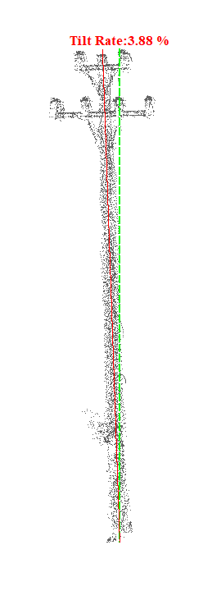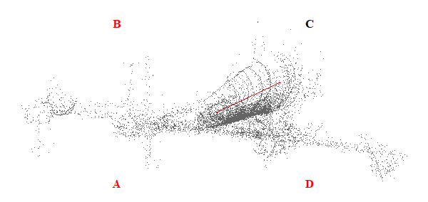
Gambar 19. Kemiringan Menara 19

Tabel 20. Kemiringan Menara 20
Nomor Menara | Searah RoW (%) | Tegak Lurus RoW (%) | Resultan (%) | Nilai Standar (%) | Searah RoW | Tegak Lurus RoW | Penilaian
20 | 0.24 | 0.02 | 0.24 | 5.00 | AD | AB | Lulus
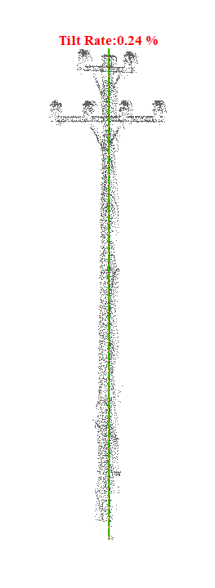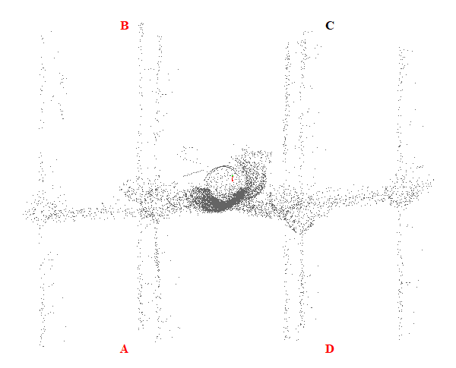
Gambar 20. Kemiringan Menara 20

Tabel 21. Kemiringan Menara 21
Nomor Menara | Searah RoW (%) | Tegak Lurus RoW (%) | Resultan (%) | Nilai Standar (%) | Searah RoW | Tegak Lurus RoW | Penilaian
21 | 1.44 | 1.06 | 1.79 | 5.00 | AD | AB | Lulus
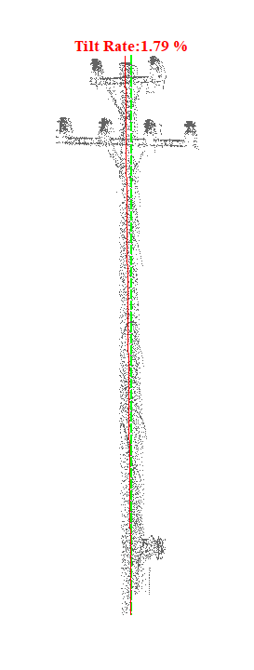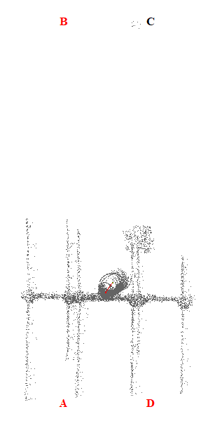
Gambar 21. Kemiringan Menara 21

Tabel 22. Kemiringan Menara 22
Nomor Menara | Searah RoW (%) | Tegak Lurus RoW (%) | Resultan (%) | Nilai Standar (%) | Searah RoW | Tegak Lurus RoW | Penilaian
22 | 1.76 | 4.96 | 5.26 | 5.00 | BC | AB | Tidak Lulus
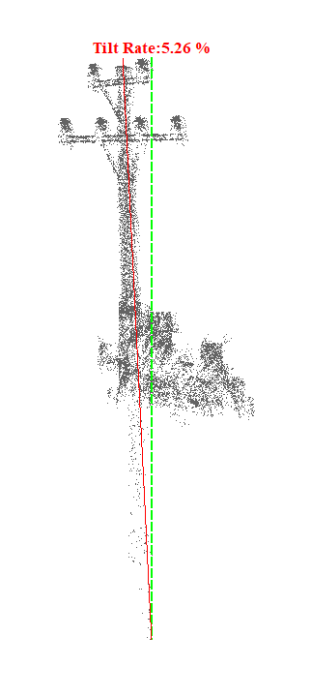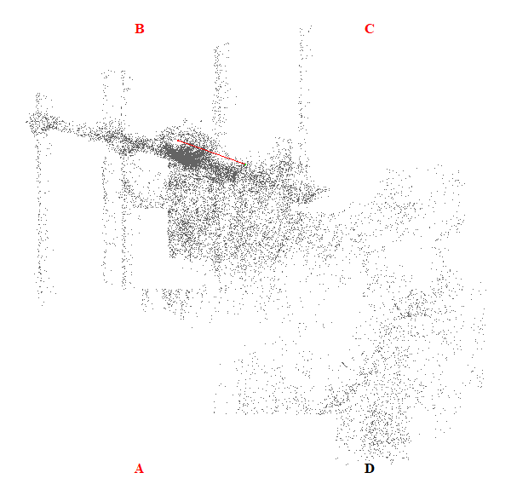
Gambar 22. Kemiringan Menara 22

Tabel 23. Kemiringan Menara 23
Nomor Menara | Searah RoW (%) | Tegak Lurus RoW (%) | Resultan (%) | Nilai Standar (%) | Searah RoW | Tegak Lurus RoW | Penilaian
23 | 1.42 | 6.93 | 7.07 | 5.00 | BC | CD | Tidak Lulus
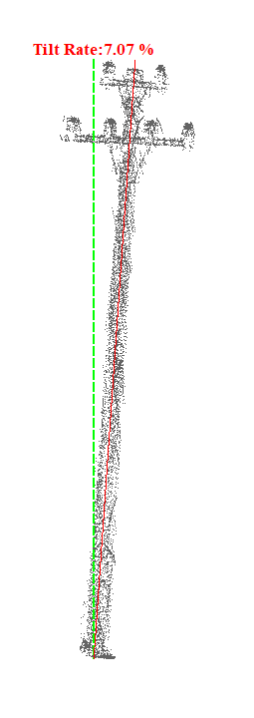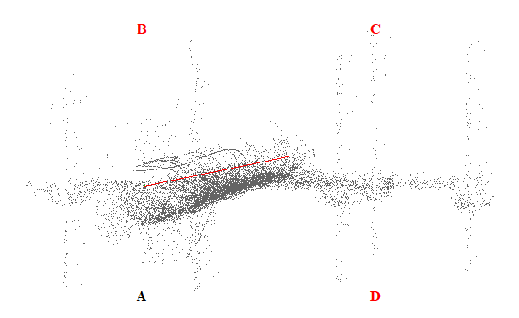
Gambar 23. Kemiringan Menara 23

Tabel 24. Kemiringan Menara 24
Nomor Menara | Searah RoW (%) | Tegak Lurus RoW (%) | Resultan (%) | Nilai Standar (%) | Searah RoW | Tegak Lurus RoW | Penilaian
24 | 3.74 | 0.88 | 3.84 | 5.00 | BC | AB | Lulus
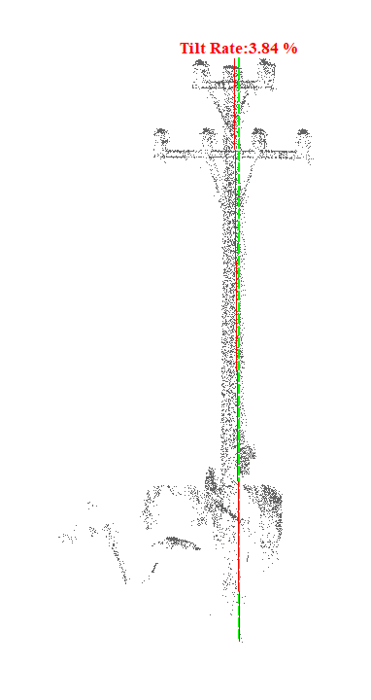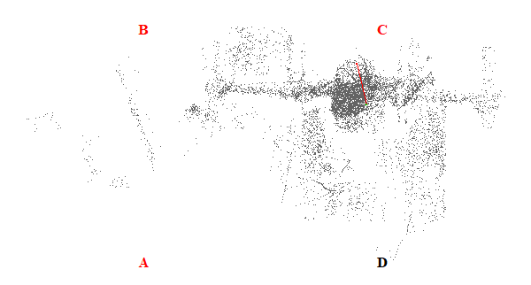
Gambar 24. Kemiringan Menara 24

Tabel 25. Kemiringan Menara 25
Nomor Menara | Searah RoW (%) | Tegak Lurus RoW (%) | Resultan (%) | Nilai Standar (%) | Searah RoW | Tegak Lurus RoW | Penilaian
25 | 4.19 | 1.47 | 4.44 | 5.00 | BC | CD | Lulus
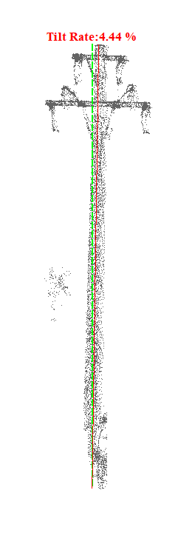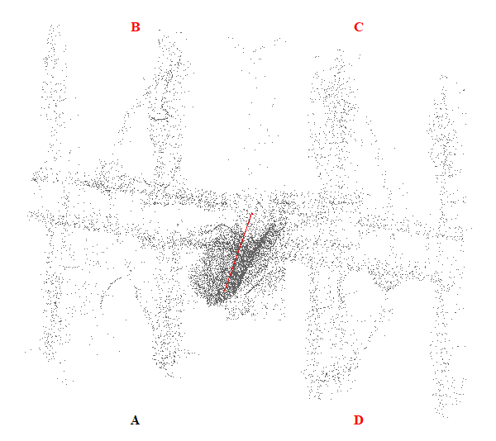
Gambar 25. Kemiringan Menara 25

Tabel 26. Kemiringan Menara 26
Nomor Menara | Searah RoW (%) | Tegak Lurus RoW (%) | Resultan (%) | Nilai Standar (%) | Searah RoW | Tegak Lurus RoW | Penilaian
26 | 3.37 | 2.80 | 4.38 | 5.00 | AD | CD | Lulus
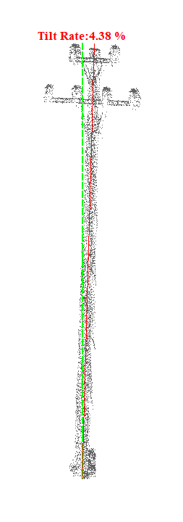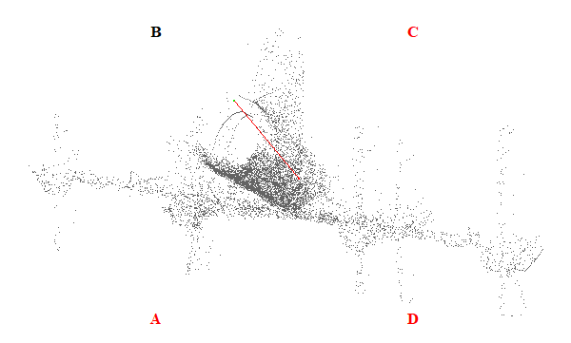
Gambar 26. Kemiringan Menara 26

Tabel 27. Kemiringan Menara 27
Nomor Menara | Searah RoW (%) | Tegak Lurus RoW (%) | Resultan (%) | Nilai Standar (%) | Searah RoW | Tegak Lurus RoW | Penilaian
27 | 3.39 | 1.18 | 3.59 | 5.00 | BC | CD | Lulus
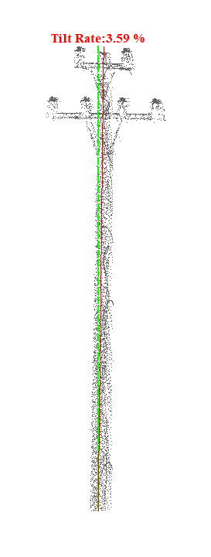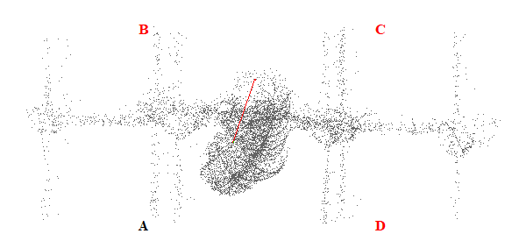
Gambar 27. Kemiringan Menara 27

Tabel 28. Kemiringan Menara 28
Nomor Menara | Searah RoW (%) | Tegak Lurus RoW (%) | Resultan (%) | Nilai Standar (%) | Searah RoW | Tegak Lurus RoW | Penilaian
28 | 2.24 | 3.70 | 4.33 | 5.00 | BC | CD | Lulus
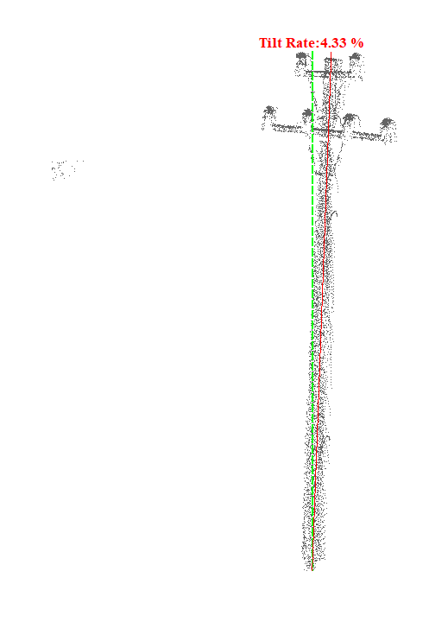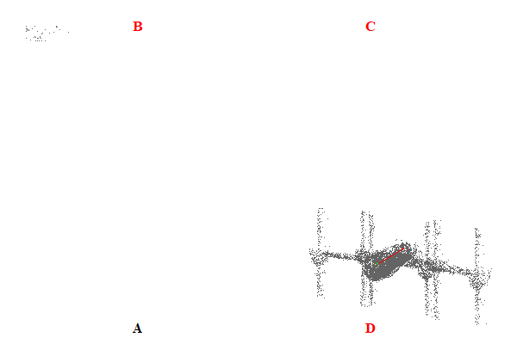
Gambar 28. Kemiringan Menara 28

Tabel 29. Kemiringan Menara 29
Nomor Menara | Searah RoW (%) | Tegak Lurus RoW (%) | Resultan (%) | Nilai Standar (%) | Searah RoW | Tegak Lurus RoW | Penilaian
29 | 8.69 | 5.56 | 10.32 | 5.00 | AD | CD | Tidak Lulus
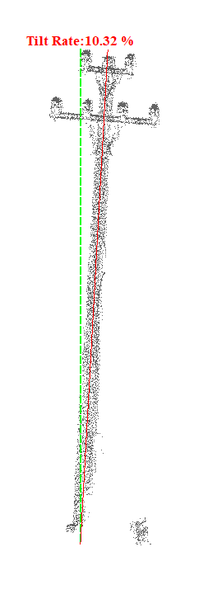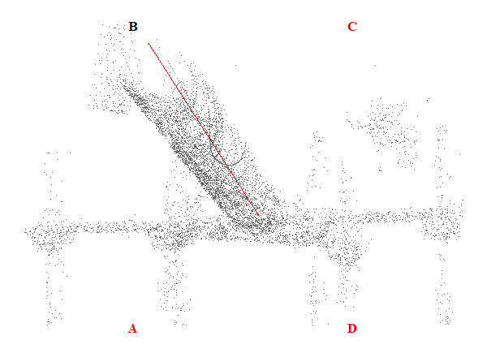
Gambar 29. Kemiringan Menara 29

Tabel 30. Kemiringan Menara 30
Nomor Menara | Searah RoW (%) | Tegak Lurus RoW (%) | Resultan (%) | Nilai Standar (%) | Searah RoW | Tegak Lurus RoW | Penilaian
30 | 4.35 | 4.15 | 6.01 | 5.00 | AD | CD | Tidak Lulus
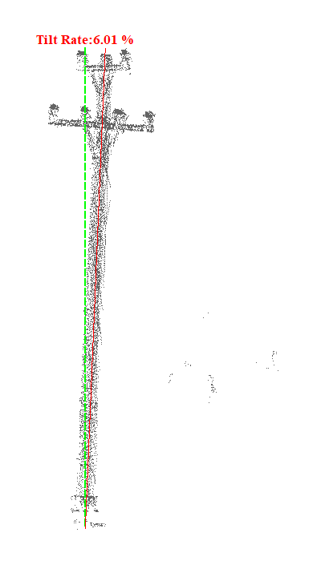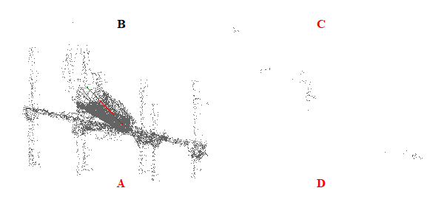
Gambar 30. Kemiringan Menara 30

Tabel 31. Kemiringan Menara 31
Nomor Menara | Searah RoW (%) | Tegak Lurus RoW (%) | Resultan (%) | Nilai Standar (%) | Searah RoW | Tegak Lurus RoW | Penilaian
31 | 1.57 | 0.14 | 1.58 | 5.00 | AD | CD | Lulus
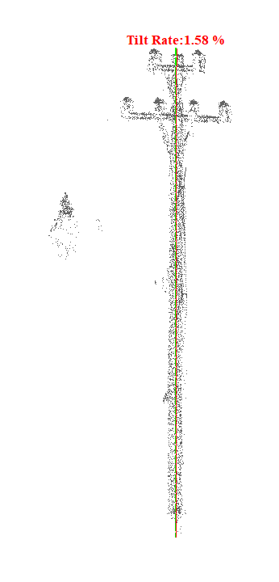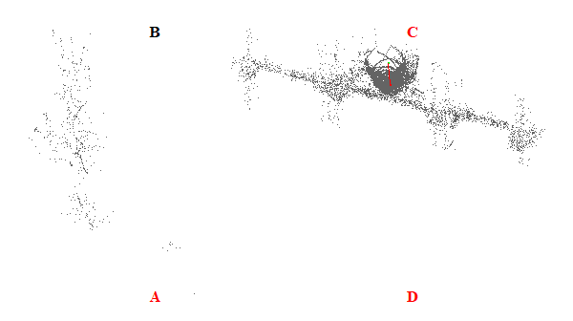
Gambar 31. Kemiringan Menara 31

Tabel 32. Kemiringan Menara 32
Nomor Menara | Searah RoW (%) | Tegak Lurus RoW (%) | Resultan (%) | Nilai Standar (%) | Searah RoW | Tegak Lurus RoW | Penilaian
32 | 7.35 | 3.12 | 7.98 | 5.00 | AD | CD | Tidak Lulus
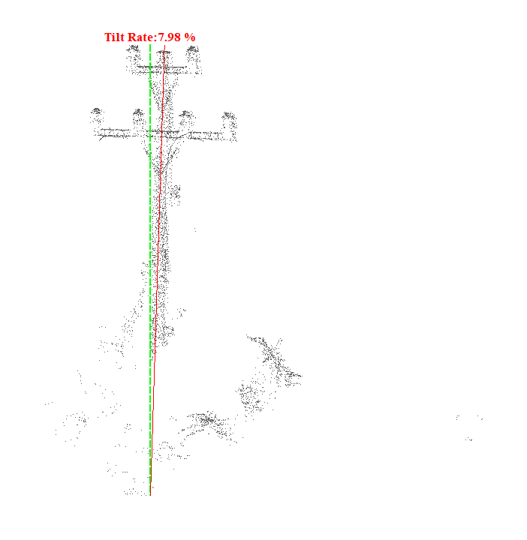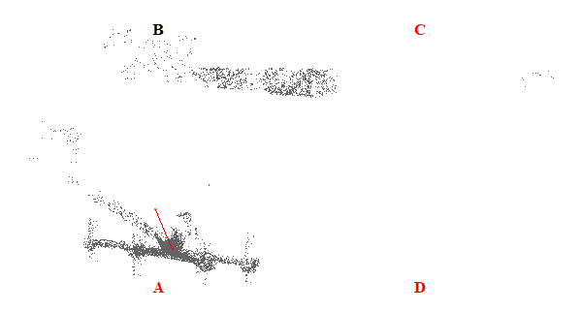
Gambar 32. Kemiringan Menara 32

Tabel 33. Kemiringan Menara 33
Nomor Menara | Searah RoW (%) | Tegak Lurus RoW (%) | Resultan (%) | Nilai Standar (%) | Searah RoW | Tegak Lurus RoW | Penilaian
33 | 1.25 | 0.21 | 1.27 | 5.00 | AD | AB | Lulus
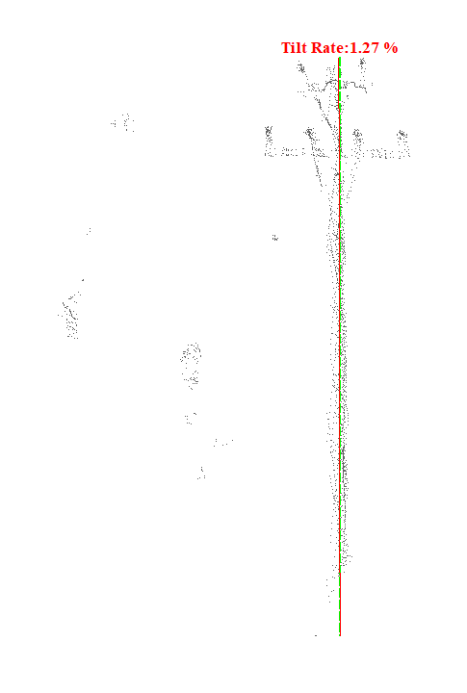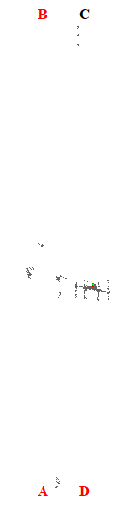
Gambar 33. Kemiringan Menara 33

Tabel 34. Kemiringan Menara 34
Nomor Menara | Searah RoW (%) | Tegak Lurus RoW (%) | Resultan (%) | Nilai Standar (%) | Searah RoW | Tegak Lurus RoW | Penilaian
34 | 2.11 | 1.24 | 2.45 | 5.00 | BC | CD | Lulus
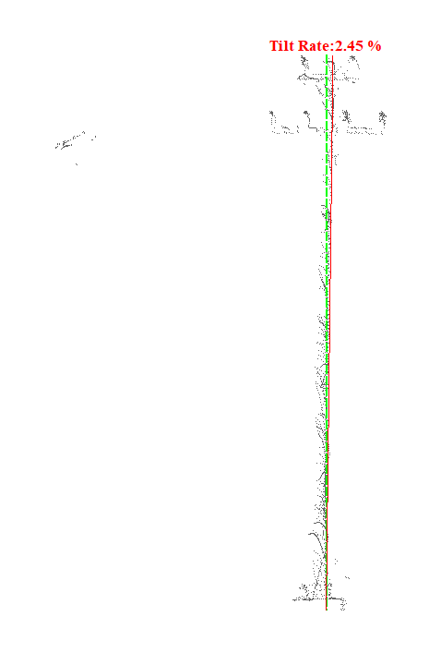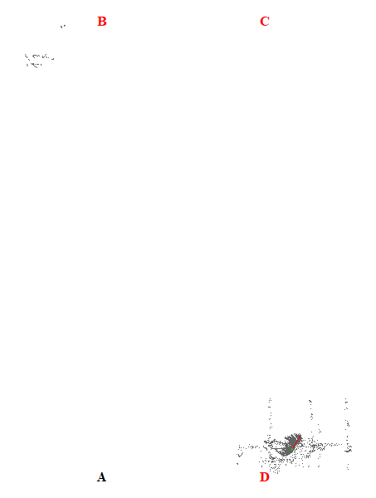
Gambar 34. Kemiringan Menara 34

Tabel 35. Kemiringan Menara 35
Nomor Menara | Searah RoW (%) | Tegak Lurus RoW (%) | Resultan (%) | Nilai Standar (%) | Searah RoW | Tegak Lurus RoW | Penilaian
35 | 1.15 | 1.55 | 1.93 | 5.00 | BC | CD | Lulus
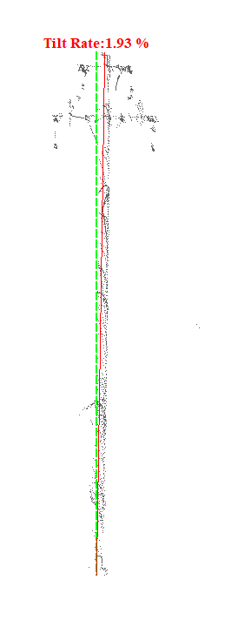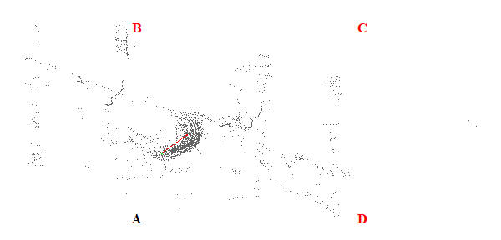
Gambar 35. Kemiringan Menara 35

Tabel 36. Kemiringan Menara 36
Nomor Menara | Searah RoW (%) | Tegak Lurus RoW (%) | Resultan (%) | Nilai Standar (%) | Searah RoW | Tegak Lurus RoW | Penilaian
36 | 5.32 | 4.31 | 6.85 | 5.00 | AD | AB | Tidak Lulus
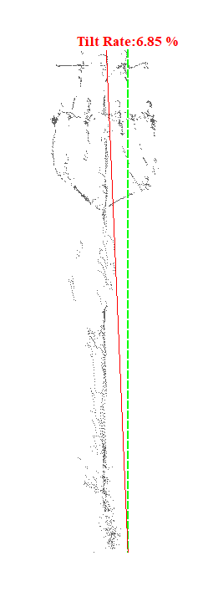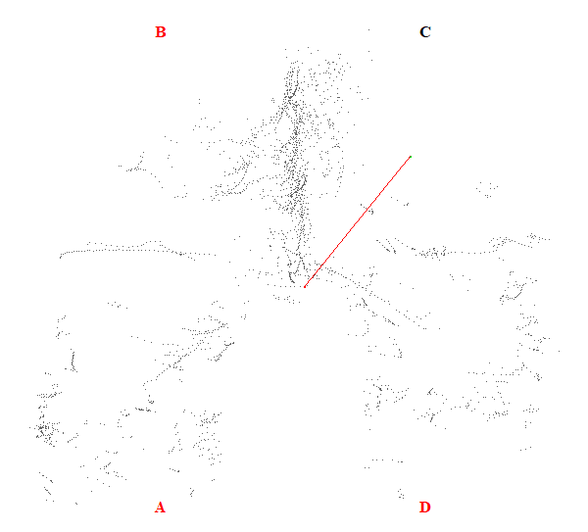
Gambar 36. Kemiringan Menara 36

Tabel 37. Kemiringan Menara 37
Nomor Menara | Searah RoW (%) | Tegak Lurus RoW (%) | Resultan (%) | Nilai Standar (%) | Searah RoW | Tegak Lurus RoW | Penilaian
37 | 20.20 | 1.00 | 20.22 | 5.00 | BC | CD | Tidak Lulus
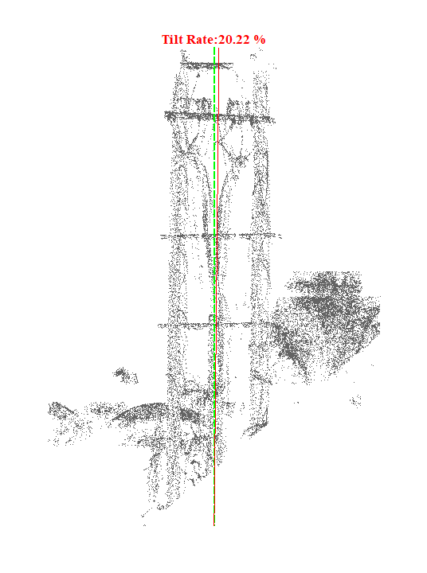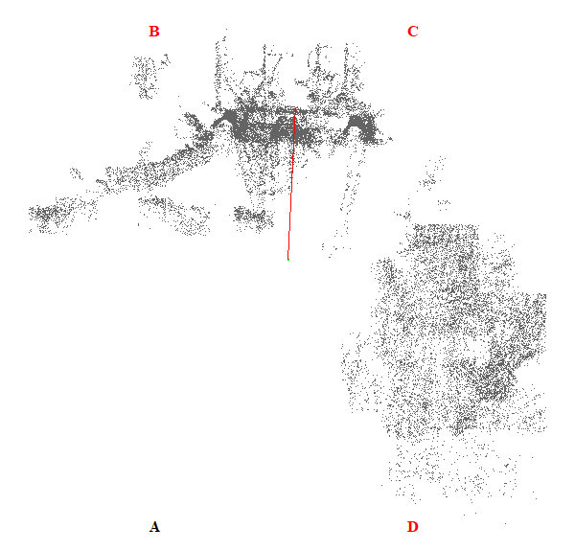
Gambar 37. Kemiringan Menara 37

Tabel 38. Kemiringan Menara 38
Nomor Menara | Searah RoW (%) | Tegak Lurus RoW (%) | Resultan (%) | Nilai Standar (%) | Searah RoW | Tegak Lurus RoW | Penilaian
38 | 2.70 | 1.83 | 3.26 | 5.00 | AD | CD | Lulus
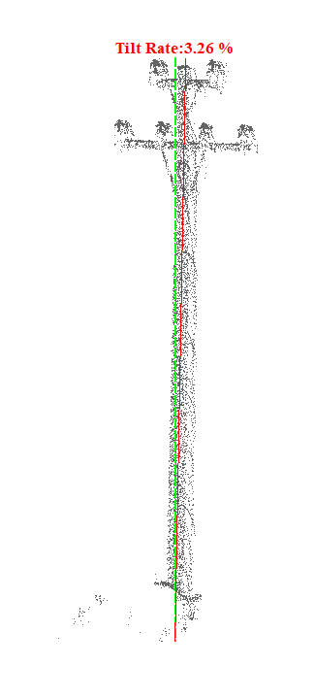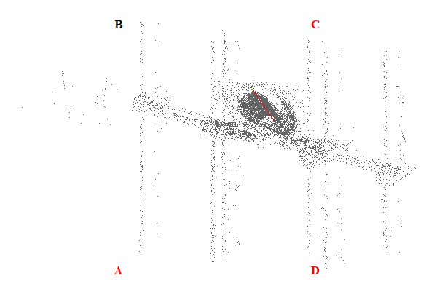
Gambar 38. Kemiringan Menara 38

Tabel 39. Kemiringan Menara 39
Nomor Menara | Searah RoW (%) | Tegak Lurus RoW (%) | Resultan (%) | Nilai Standar (%) | Searah RoW | Tegak Lurus RoW | Penilaian
39 | 0.17 | 0.12 | 0.21 | 5.00 | AD | CD | Lulus
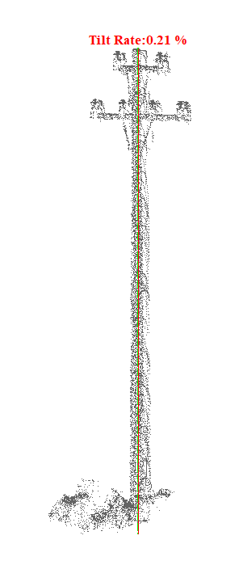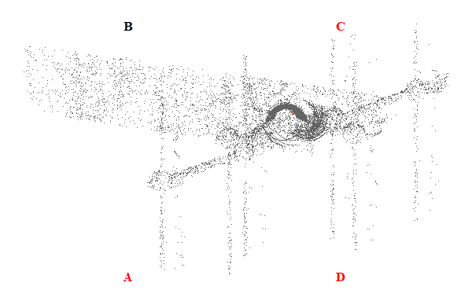
Gambar 39. Kemiringan Menara 39

Tabel 40. Kemiringan Menara 40
Nomor Menara | Searah RoW (%) | Tegak Lurus RoW (%) | Resultan (%) | Nilai Standar (%) | Searah RoW | Tegak Lurus RoW | Penilaian
40 | 2.39 | 3.05 | 3.87 | 5.00 | BC | CD | Lulus
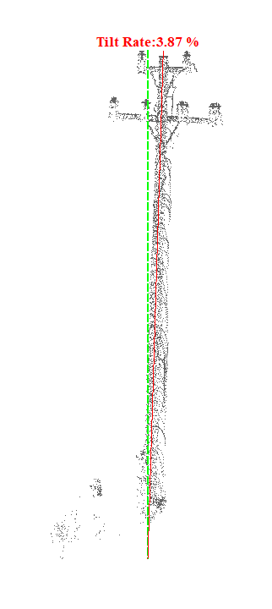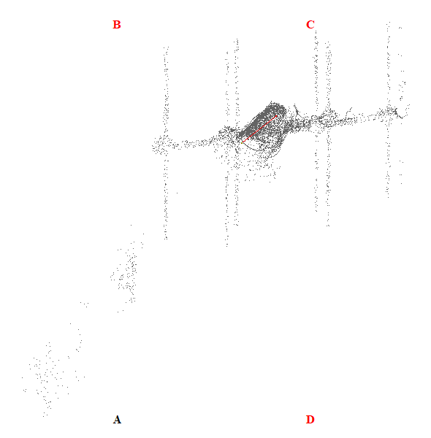
Gambar 40. Kemiringan Menara 40

Tabel 41. Kemiringan Menara 41
Nomor Menara | Searah RoW (%) | Tegak Lurus RoW (%) | Resultan (%) | Nilai Standar (%) | Searah RoW | Tegak Lurus RoW | Penilaian
41 | 2.57 | 3.16 | 4.07 | 5.00 | AD | CD | Lulus
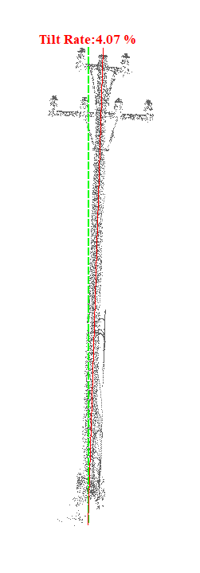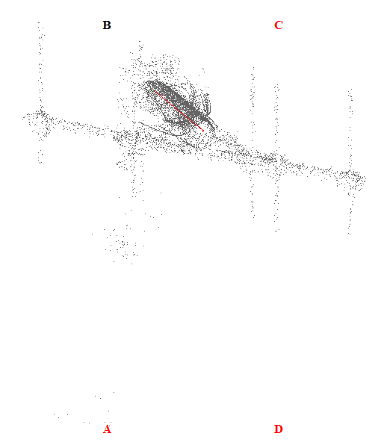
Gambar 41. Kemiringan Menara 41

Tabel 42. Kemiringan Menara 42
Nomor Menara | Searah RoW (%) | Tegak Lurus RoW (%) | Resultan (%) | Nilai Standar (%) | Searah RoW | Tegak Lurus RoW | Penilaian
42 | 2.57 | 2.59 | 3.65 | 5.00 | AD | CD | Lulus
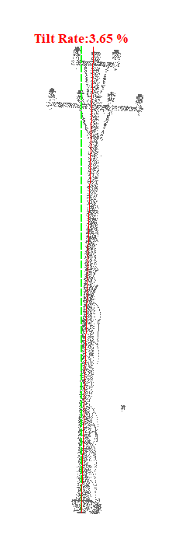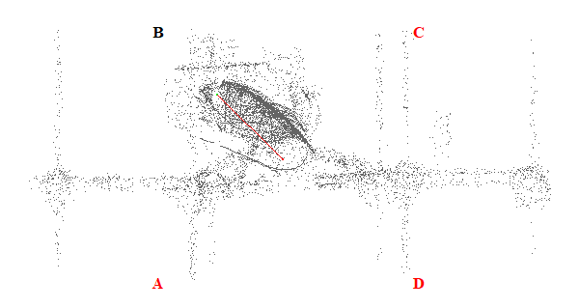
Gambar 42. Kemiringan Menara 42

Tabel 43. Kemiringan Menara 43
Nomor Menara | Searah RoW (%) | Tegak Lurus RoW (%) | Resultan (%) | Nilai Standar (%) | Searah RoW | Tegak Lurus RoW | Penilaian
43 | 1.88 | 2.11 | 2.83 | 5.00 | AD | CD | Lulus
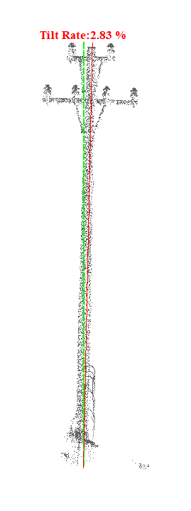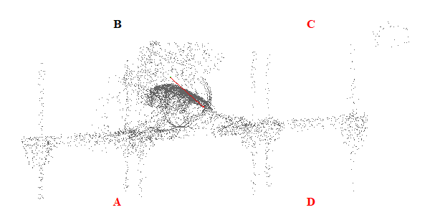
Gambar 43. Kemiringan Menara 43

Tabel 44. Kemiringan Menara 44
Nomor Menara | Searah RoW (%) | Tegak Lurus RoW (%) | Resultan (%) | Nilai Standar (%) | Searah RoW | Tegak Lurus RoW | Penilaian
44 | 2.52 | 3.58 | 4.38 | 5.00 | AD | CD | Lulus
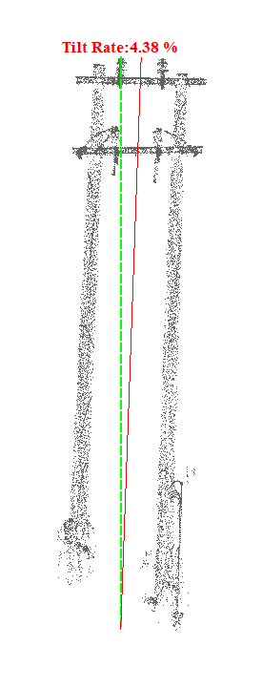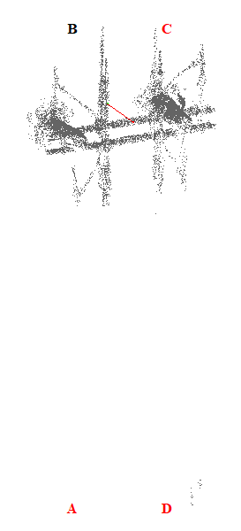
Gambar 44. Kemiringan Menara 44

Tabel 45. Kemiringan Menara 45
Nomor Menara | Searah RoW (%) | Tegak Lurus RoW (%) | Resultan (%) | Nilai Standar (%) | Searah RoW | Tegak Lurus RoW | Penilaian
45 | 6.11 | 5.54 | 8.25 | 5.00 | AD | AB | Tidak Lulus
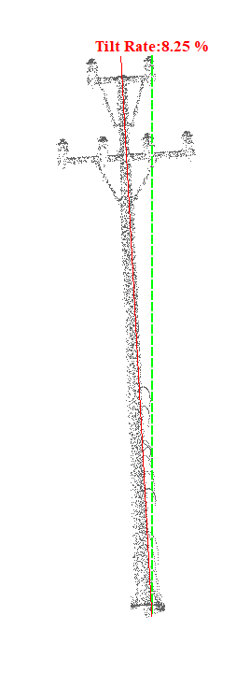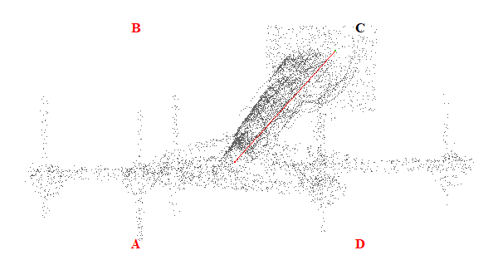
Gambar 45. Kemiringan Menara 45

Tabel 46. Kemiringan Menara 46
Nomor Menara | Searah RoW (%) | Tegak Lurus RoW (%) | Resultan (%) | Nilai Standar (%) | Searah RoW | Tegak Lurus RoW | Penilaian
46 | 4.31 | 3.16 | 5.34 | 5.00 | AD | AB | Tidak Lulus
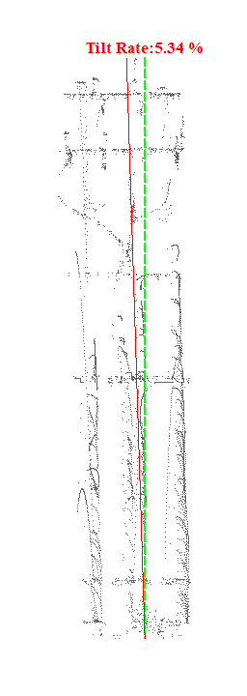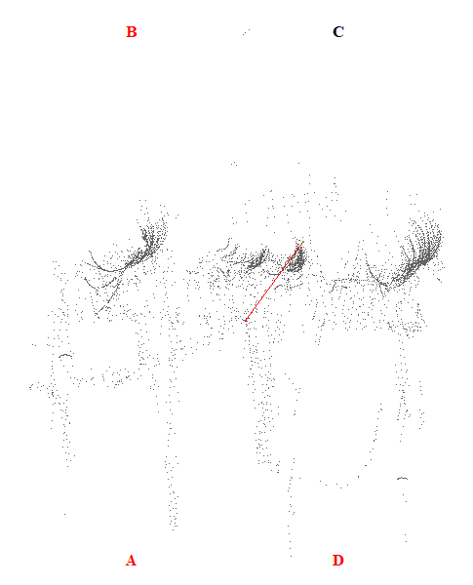
Gambar 46. Kemiringan Menara 46

Tabel 47. Kemiringan Menara 47
Nomor Menara | Searah RoW (%) | Tegak Lurus RoW (%) | Resultan (%) | Nilai Standar (%) | Searah RoW | Tegak Lurus RoW | Penilaian
47 | 16.80 | 0.02 | 16.80 | 5.00 | BC | AB | Tidak Lulus
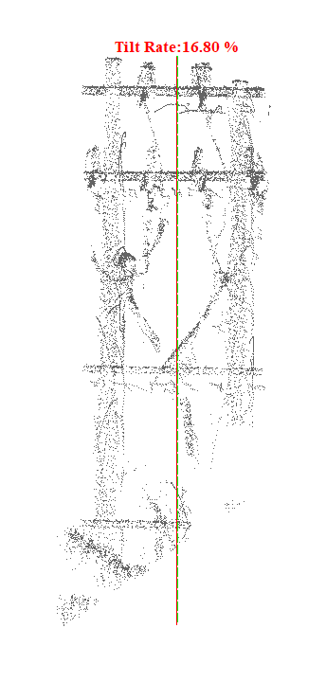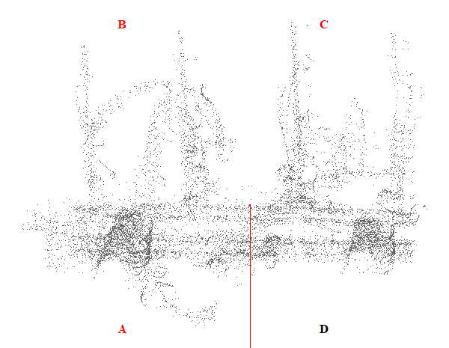
Gambar 47. Kemiringan Menara 47

Tabel 48. Kemiringan Menara 48
Nomor Menara | Searah RoW (%) | Tegak Lurus RoW (%) | Resultan (%) | Nilai Standar (%) | Searah RoW | Tegak Lurus RoW | Penilaian
48 | 1.72 | 2.03 | 2.66 | 5.00 | AD | AB | Lulus
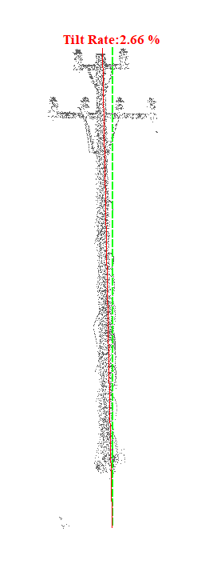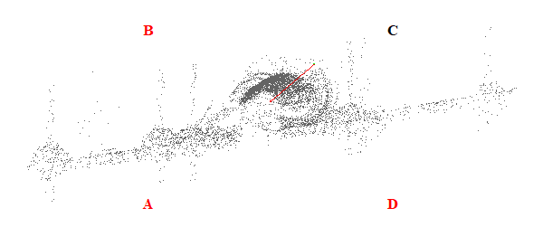
Gambar 48. Kemiringan Menara 48

Tabel 49. Kemiringan Menara 49
Nomor Menara | Searah RoW (%) | Tegak Lurus RoW (%) | Resultan (%) | Nilai Standar (%) | Searah RoW | Tegak Lurus RoW | Penilaian
49 | 3.85 | 1.14 | 4.02 | 5.00 | BC | CD | Lulus
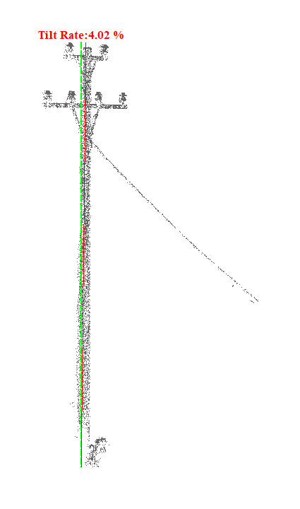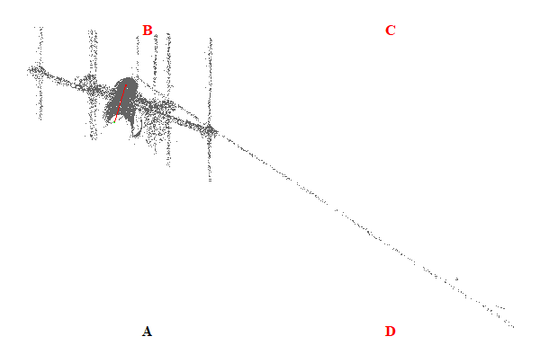
Gambar 49. Kemiringan Menara 49

Tabel 50. Kemiringan Menara 50
Nomor Menara | Searah RoW (%) | Tegak Lurus RoW (%) | Resultan (%) | Nilai Standar (%) | Searah RoW | Tegak Lurus RoW | Penilaian
50 | 3.50 | 0.53 | 3.54 | 5.00 | AD | AB | Lulus
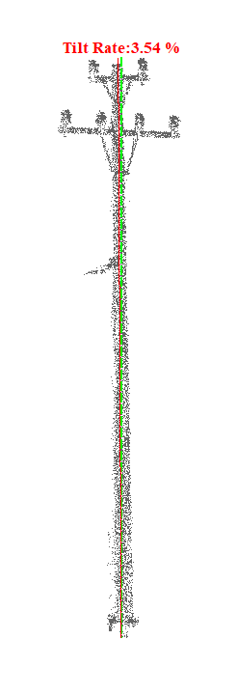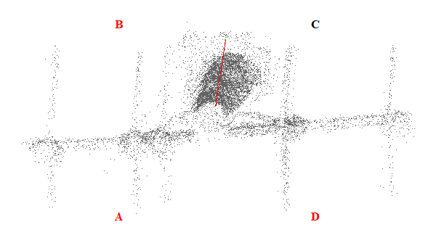
Gambar 50. Kemiringan Menara 50

Tabel 51. Kemiringan Menara 51
Nomor Menara | Searah RoW (%) | Tegak Lurus RoW (%) | Resultan (%) | Nilai Standar (%) | Searah RoW | Tegak Lurus RoW | Penilaian
51 | 2.18 | 3.94 | 4.50 | 5.00 | BC | AB | Lulus
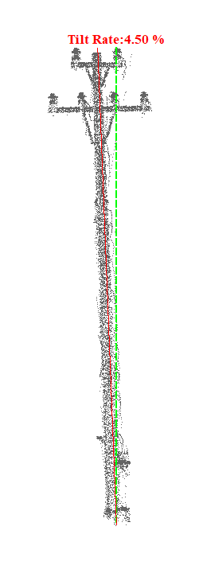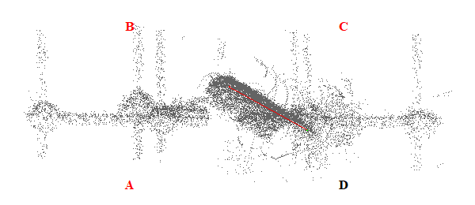
Gambar 51. Kemiringan Menara 51

Tabel 52. Kemiringan Menara 52
Nomor Menara | Searah RoW (%) | Tegak Lurus RoW (%) | Resultan (%) | Nilai Standar (%) | Searah RoW | Tegak Lurus RoW | Penilaian
52 | 2.66 | 2.61 | 3.73 | 5.00 | BC | CD | Lulus
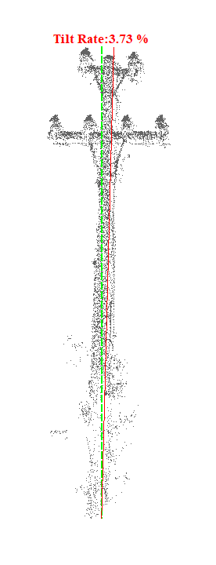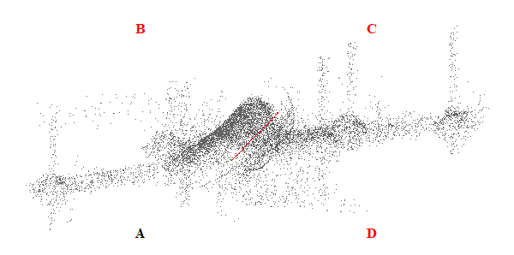
Gambar 52. Kemiringan Menara 52

Tabel 53. Kemiringan Menara 53
Nomor Menara | Searah RoW (%) | Tegak Lurus RoW (%) | Resultan (%) | Nilai Standar (%) | Searah RoW | Tegak Lurus RoW | Penilaian
53 | 4.43 | 1.39 | 4.64 | 5.00 | AD | AB | Lulus
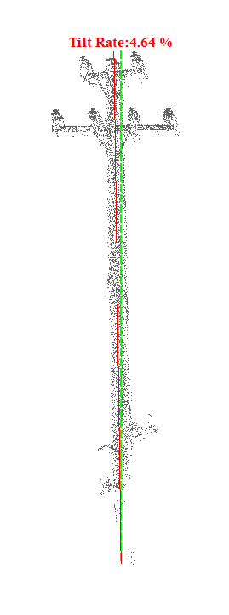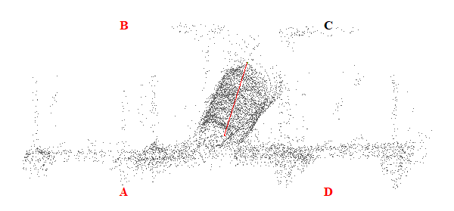
Gambar 53. Kemiringan Menara 53

Tabel 54. Kemiringan Menara 54
Nomor Menara | Searah RoW (%) | Tegak Lurus RoW (%) | Resultan (%) | Nilai Standar (%) | Searah RoW | Tegak Lurus RoW | Penilaian
54 | 2.29 | 2.85 | 3.66 | 5.00 | AD | AB | Lulus
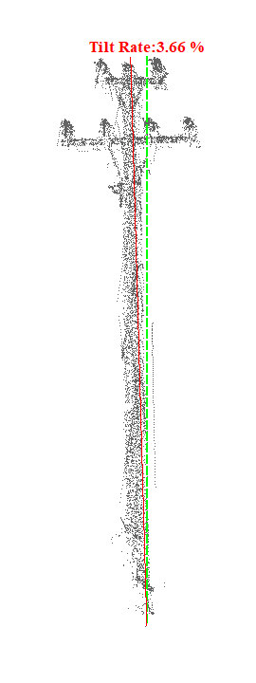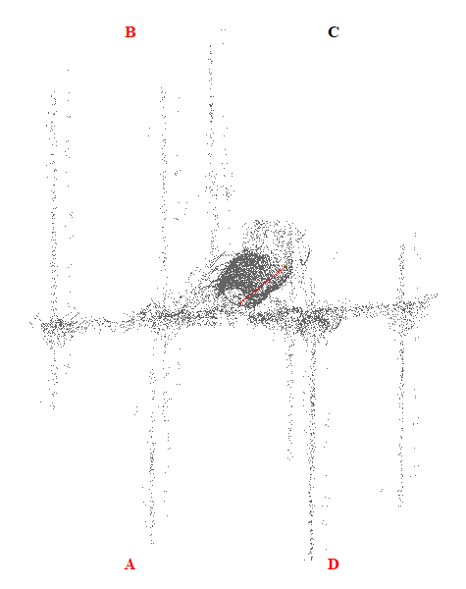
Gambar 54. Kemiringan Menara 54

Tabel 55. Kemiringan Menara 55
Nomor Menara | Searah RoW (%) | Tegak Lurus RoW (%) | Resultan (%) | Nilai Standar (%) | Searah RoW | Tegak Lurus RoW | Penilaian
55 | 0.25 | 1.08 | 1.11 | 5.00 | AD | CD | Lulus
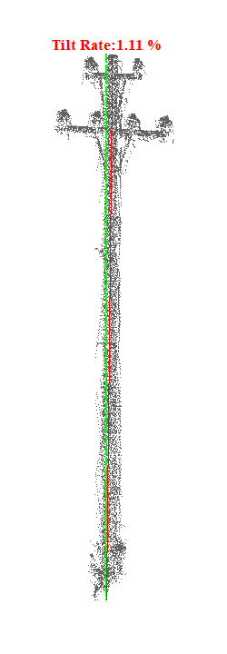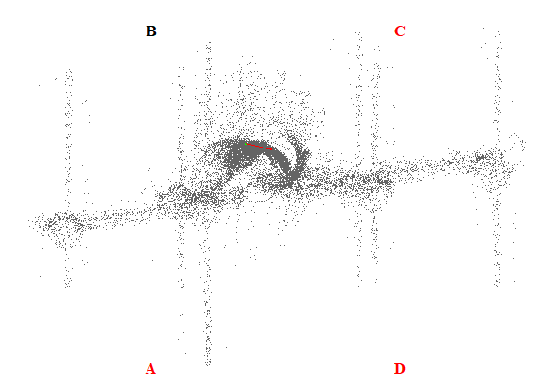
Gambar 55. Kemiringan Menara 55

Tabel 56. Kemiringan Menara 56
Nomor Menara | Searah RoW (%) | Tegak Lurus RoW (%) | Resultan (%) | Nilai Standar (%) | Searah RoW | Tegak Lurus RoW | Penilaian
56 | 0.31 | 2.14 | 2.16 | 5.00 | AD | AB | Lulus
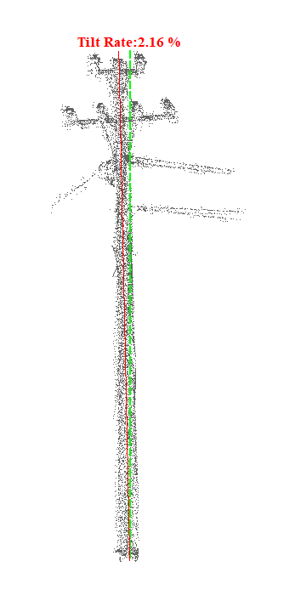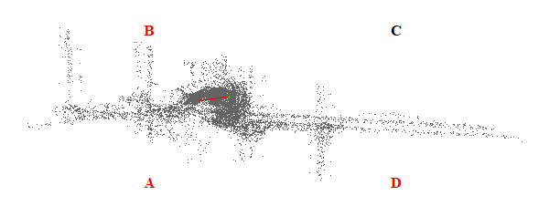
Gambar 56. Kemiringan Menara 56

Tabel 57. Kemiringan Menara 57
Nomor Menara | Searah RoW (%) | Tegak Lurus RoW (%) | Resultan (%) | Nilai Standar (%) | Searah RoW | Tegak Lurus RoW | Penilaian
57 | 3.28 | 5.39 | 6.31 | 5.00 | BC | AB | Tidak Lulus
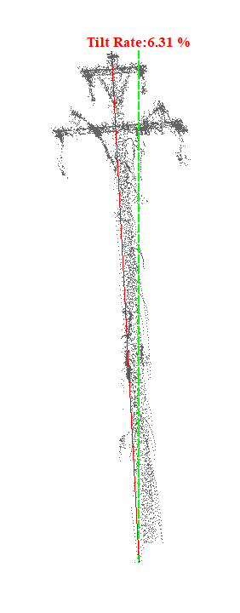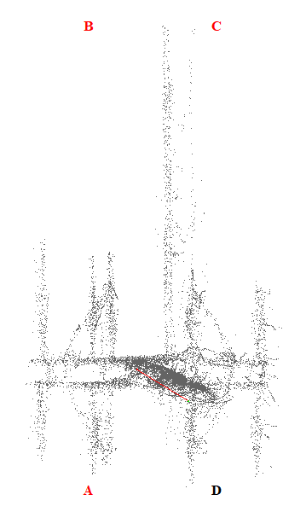
Gambar 57. Kemiringan Menara 57

Tabel 58. Kemiringan Menara 58
Nomor Menara | Searah RoW (%) | Tegak Lurus RoW (%) | Resultan (%) | Nilai Standar (%) | Searah RoW | Tegak Lurus RoW | Penilaian
58 | 1.40 | 0.43 | 1.46 | 5.00 | AD | AB | Lulus
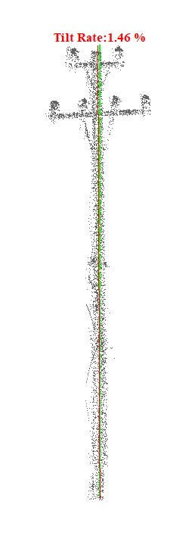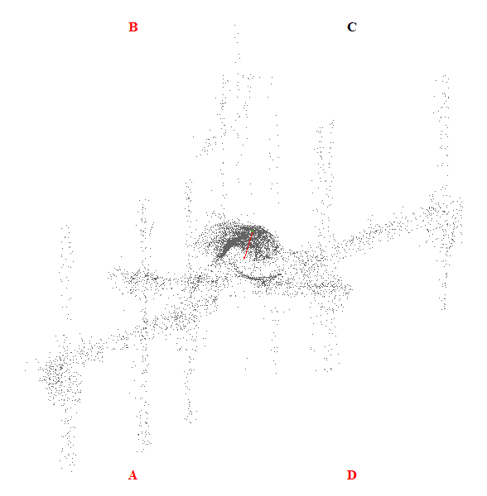
Gambar 58. Kemiringan Menara 58

Tabel 59. Kemiringan Menara 59
Nomor Menara | Searah RoW (%) | Tegak Lurus RoW (%) | Resultan (%) | Nilai Standar (%) | Searah RoW | Tegak Lurus RoW | Penilaian
59 | 1.45 | 3.46 | 3.75 | 5.00 | BC | AB | Lulus
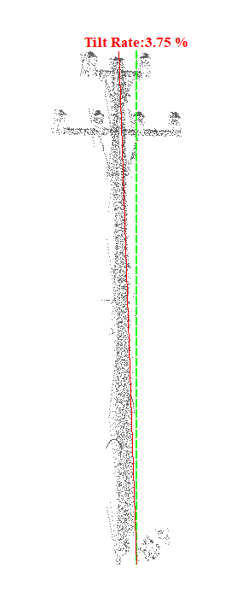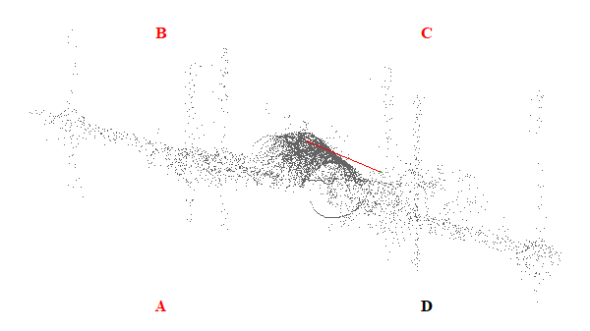
Gambar 59. Kemiringan Menara 59

Tabel 60. Kemiringan Menara 60
Nomor Menara | Searah RoW (%) | Tegak Lurus RoW (%) | Resultan (%) | Nilai Standar (%) | Searah RoW | Tegak Lurus RoW | Penilaian
60 | 6.85 | 4.87 | 8.40 | 5.00 | BC | CD | Tidak Lulus
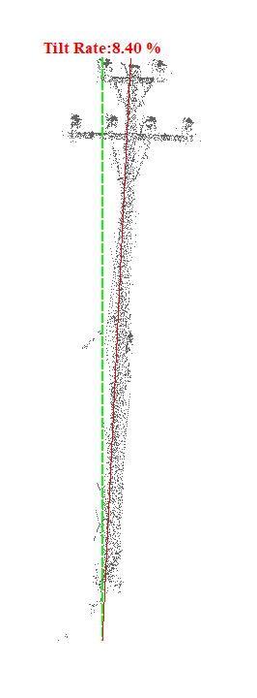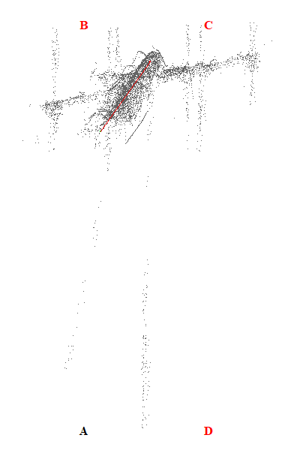
Gambar 60. Kemiringan Menara 60

Tabel 61. Kemiringan Menara 61
Nomor Menara | Searah RoW (%) | Tegak Lurus RoW (%) | Resultan (%) | Nilai Standar (%) | Searah RoW | Tegak Lurus RoW | Penilaian
61 | 0.56 | 2.05 | 2.13 | 5.00 | BC | CD | Lulus
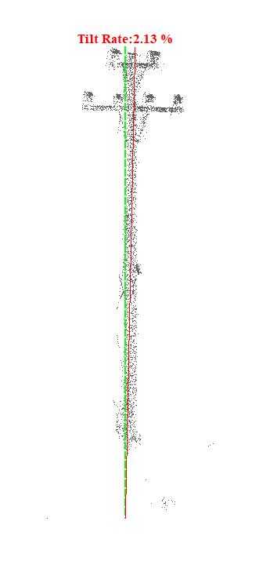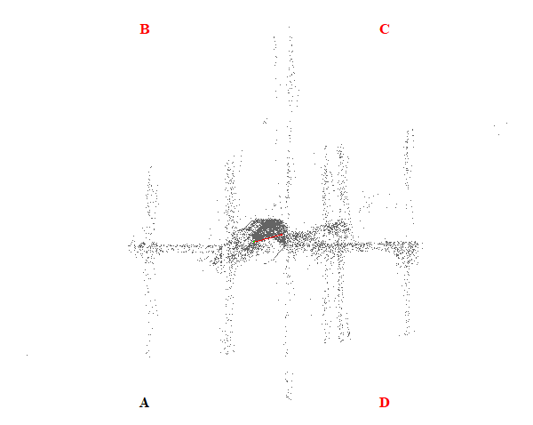
Gambar 61. Kemiringan Menara 61

Tabel 62. Kemiringan Menara 62
Nomor Menara | Searah RoW (%) | Tegak Lurus RoW (%) | Resultan (%) | Nilai Standar (%) | Searah RoW | Tegak Lurus RoW | Penilaian
62 | 2.17 | 6.28 | 6.64 | 5.00 | BC | AB | Tidak Lulus
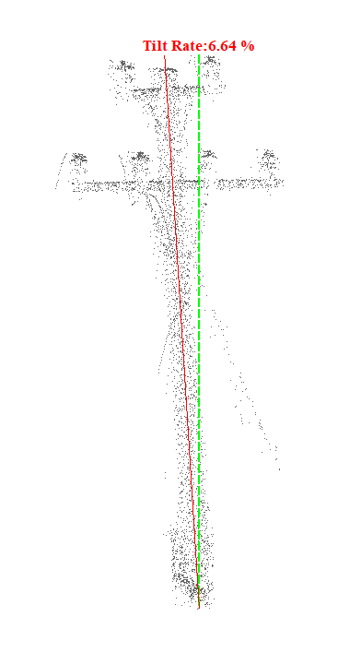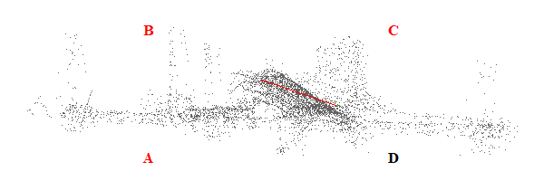
Gambar 62. Kemiringan Menara 62

Tabel 63. Kemiringan Menara 63
Nomor Menara | Searah RoW (%) | Tegak Lurus RoW (%) | Resultan (%) | Nilai Standar (%) | Searah RoW | Tegak Lurus RoW | Penilaian
63 | 4.61 | 2.28 | 5.14 | 5.00 | BC | CD | Tidak Lulus
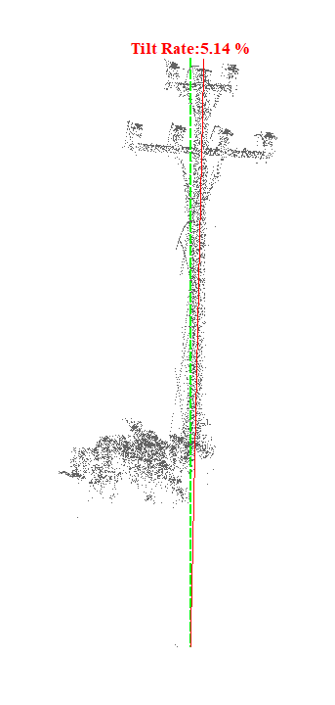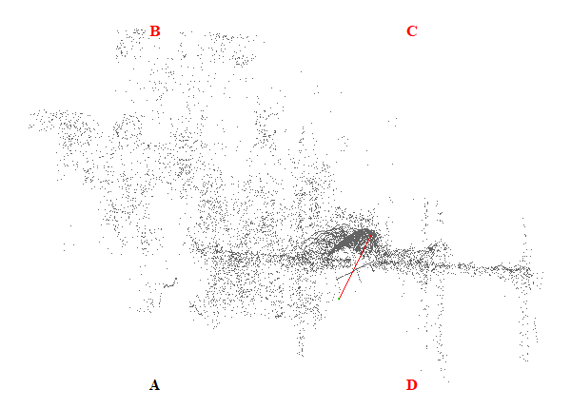
Gambar 63. Kemiringan Menara 63

Tabel 64. Kemiringan Menara 64
Nomor Menara | Searah RoW (%) | Tegak Lurus RoW (%) | Resultan (%) | Nilai Standar (%) | Searah RoW | Tegak Lurus RoW | Penilaian
64 | 4.61 | 1.48 | 4.84 | 5.00 | AD | CD | Lulus
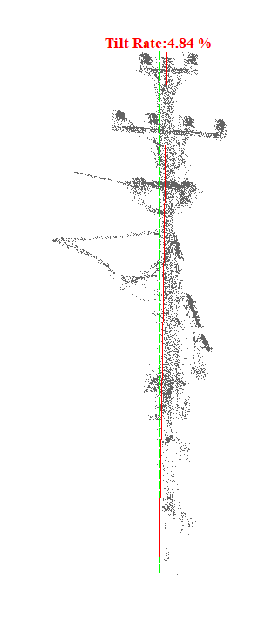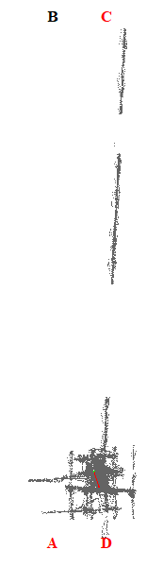
Gambar 64. Kemiringan Menara 64

Tabel 65. Kemiringan Menara 65
Nomor Menara | Searah RoW (%) | Tegak Lurus RoW (%) | Resultan (%) | Nilai Standar (%) | Searah RoW | Tegak Lurus RoW | Penilaian
65 | 3.60 | 0.60 | 3.65 | 5.00 | AD | AB | Lulus
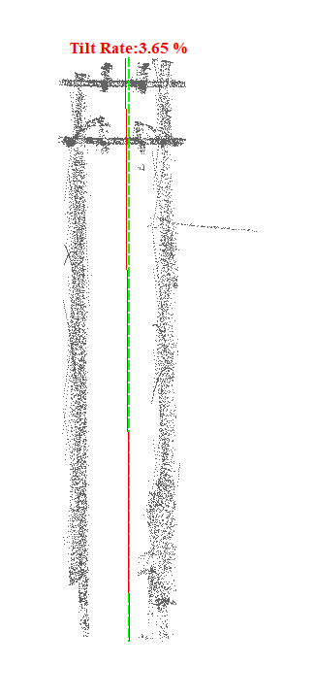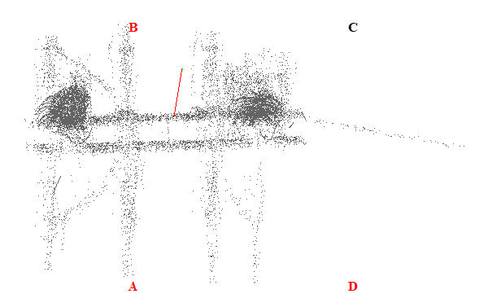
Gambar 65. Kemiringan Menara 65

Tabel 66. Kemiringan Menara 66
Nomor Menara | Searah RoW (%) | Tegak Lurus RoW (%) | Resultan (%) | Nilai Standar (%) | Searah RoW | Tegak Lurus RoW | Penilaian
66 | 4.31 | 0.07 | 4.31 | 5.00 | AD | CD | Lulus
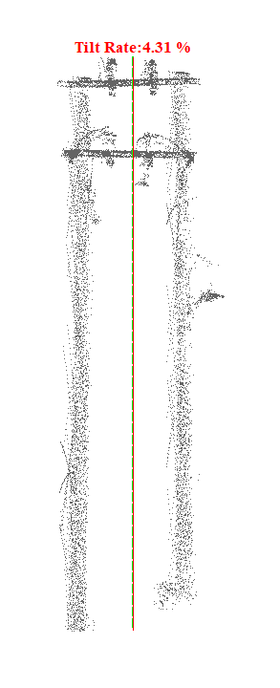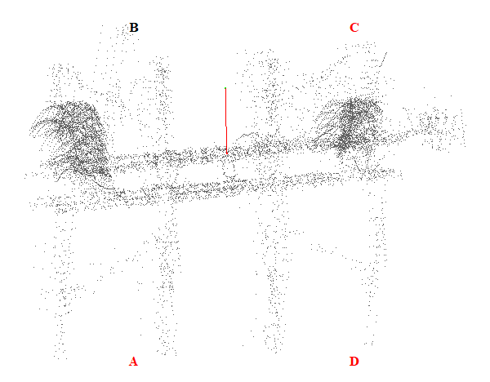
Gambar 66. Kemiringan Menara 66

Tabel 67. Kemiringan Menara 67
Nomor Menara | Searah RoW (%) | Tegak Lurus RoW (%) | Resultan (%) | Nilai Standar (%) | Searah RoW | Tegak Lurus RoW | Penilaian
67 | 4.30 | 0.75 | 4.36 | 5.00 | AD | CD | Lulus
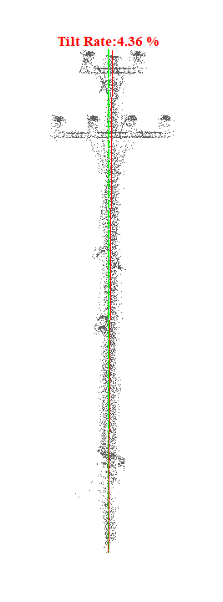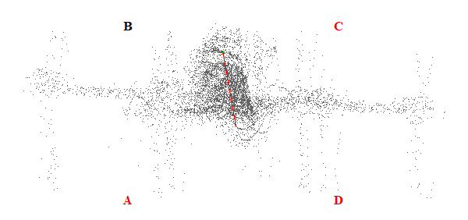
Gambar 67. Kemiringan Menara 67

Tabel 68. Kemiringan Menara 68
Nomor Menara | Searah RoW (%) | Tegak Lurus RoW (%) | Resultan (%) | Nilai Standar (%) | Searah RoW | Tegak Lurus RoW | Penilaian
68 | 4.58 | 1.13 | 4.72 | 5.00 | AD | AB | Lulus
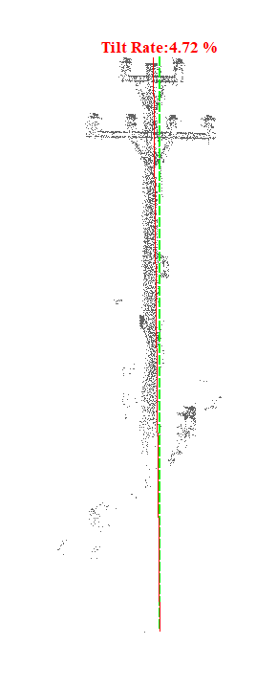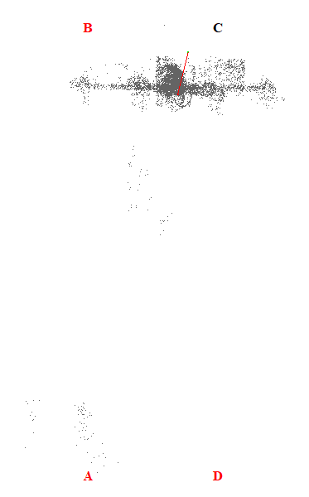
Gambar 68. Kemiringan Menara 68

Tabel 69. Kemiringan Menara 69
Nomor Menara | Searah RoW (%) | Tegak Lurus RoW (%) | Resultan (%) | Nilai Standar (%) | Searah RoW | Tegak Lurus RoW | Penilaian
69 | 0.84 | 6.15 | 6.21 | 5.00 | AD | CD | Tidak Lulus
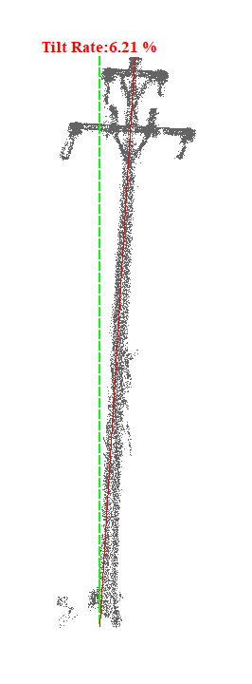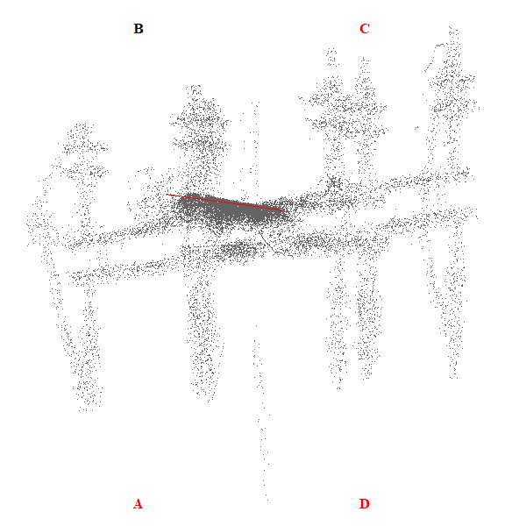
Gambar 69. Kemiringan Menara 69

Tabel 70. Kemiringan Menara 70
Nomor Menara | Searah RoW (%) | Tegak Lurus RoW (%) | Resultan (%) | Nilai Standar (%) | Searah RoW | Tegak Lurus RoW | Penilaian
70 | 8.50 | 2.65 | 8.90 | 5.00 | AD | AB | Tidak Lulus
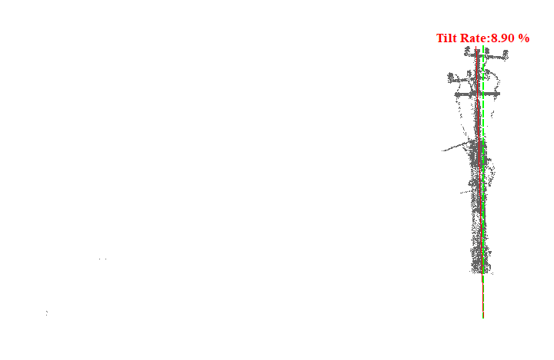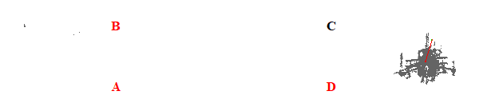
Gambar 70. Kemiringan Menara 70

Tabel 71. Kemiringan Menara 71
Nomor Menara | Searah RoW (%) | Tegak Lurus RoW (%) | Resultan (%) | Nilai Standar (%) | Searah RoW | Tegak Lurus RoW | Penilaian
71 | 0.90 | 4.47 | 4.56 | 5.00 | AD | CD | Lulus
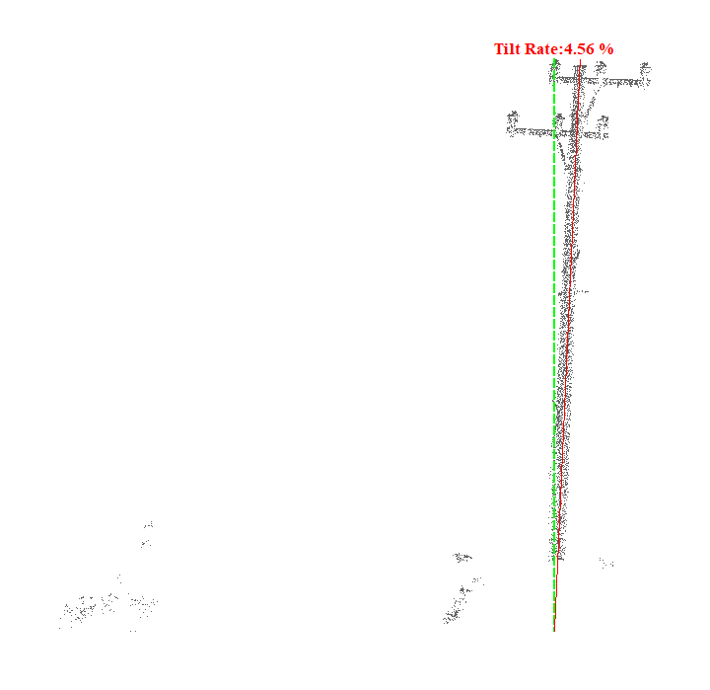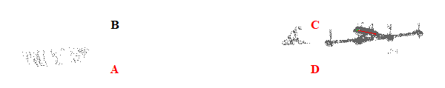
Gambar 71. Kemiringan Menara 71

Tabel 72. Kemiringan Menara 72
Nomor Menara | Searah RoW (%) | Tegak Lurus RoW (%) | Resultan (%) | Nilai Standar (%) | Searah RoW | Tegak Lurus RoW | Penilaian
72 | 1.69 | 3.20 | 3.62 | 5.00 | BC | CD | Lulus
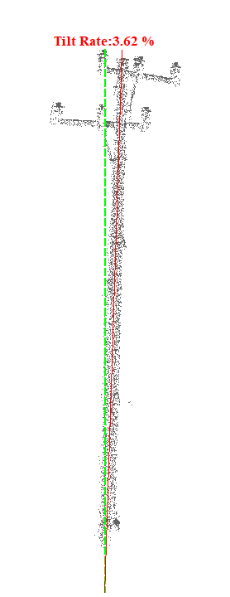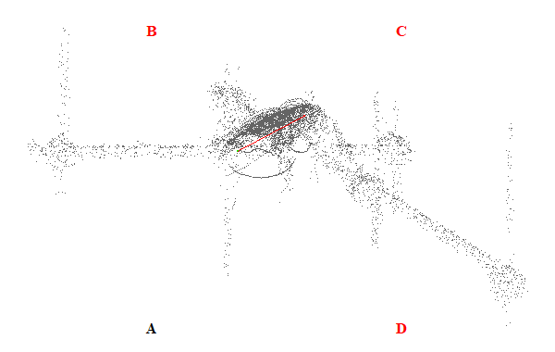
Gambar 72. Kemiringan Menara 72

Tabel 73. Kemiringan Menara 73
Nomor Menara | Searah RoW (%) | Tegak Lurus RoW (%) | Resultan (%) | Nilai Standar (%) | Searah RoW | Tegak Lurus RoW | Penilaian
73 | 0.00 | 3.62 | 3.62 | 5.00 | - | CD | Lulus
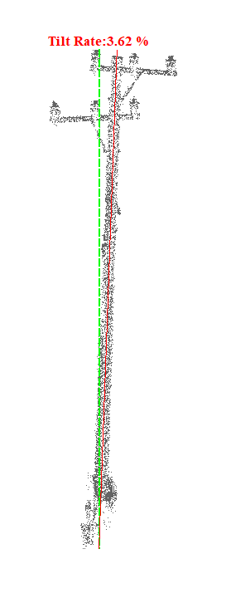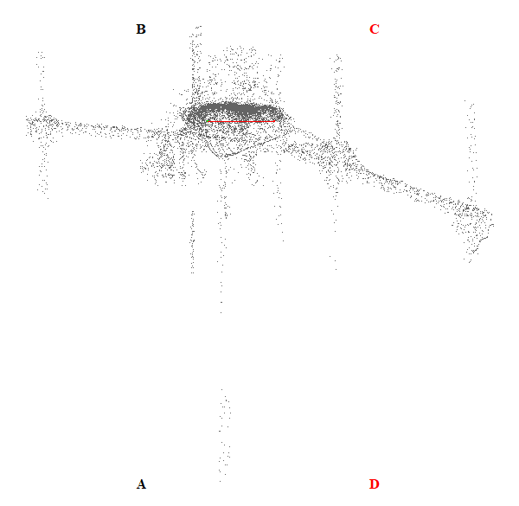
Gambar 73. Kemiringan Menara 73

Tabel 74. Kemiringan Menara 74
Nomor Menara | Searah RoW (%) | Tegak Lurus RoW (%) | Resultan (%) | Nilai Standar (%) | Searah RoW | Tegak Lurus RoW | Penilaian
74 | 6.44 | 1.43 | 6.60 | 5.00 | AD | CD | Tidak Lulus
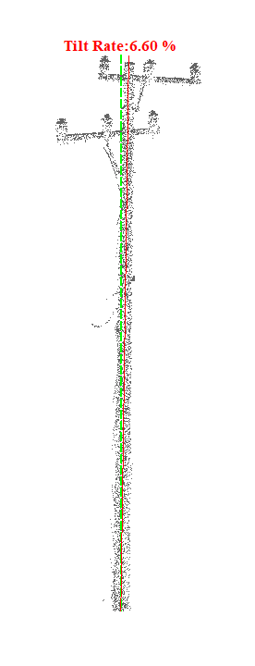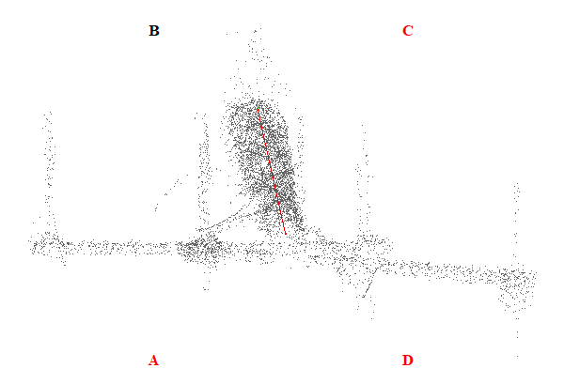
Gambar 74. Kemiringan Menara 74

Tabel 75. Kemiringan Menara 75
Nomor Menara | Searah RoW (%) | Tegak Lurus RoW (%) | Resultan (%) | Nilai Standar (%) | Searah RoW | Tegak Lurus RoW | Penilaian
75 | 1.56 | 2.65 | 3.08 | 5.00 | BC | AB | Lulus
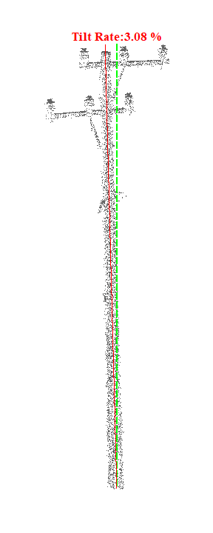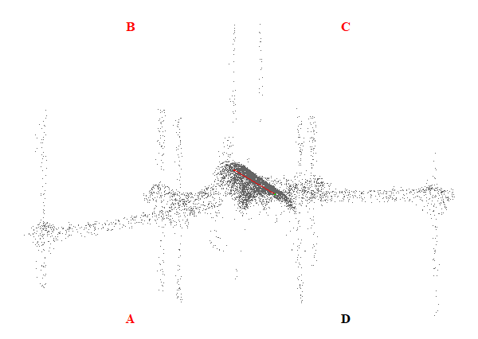
Gambar 75. Kemiringan Menara 75

Tabel 76. Kemiringan Menara 76
Nomor Menara | Searah RoW (%) | Tegak Lurus RoW (%) | Resultan (%) | Nilai Standar (%) | Searah RoW | Tegak Lurus RoW | Penilaian
76 | 1.65 | 2.88 | 3.32 | 5.00 | AD | CD | Lulus
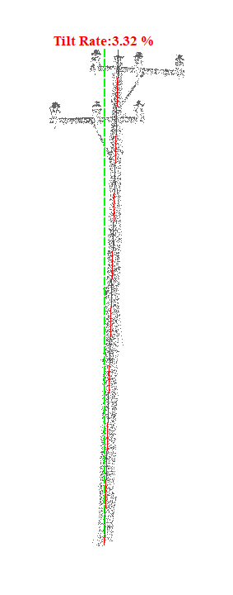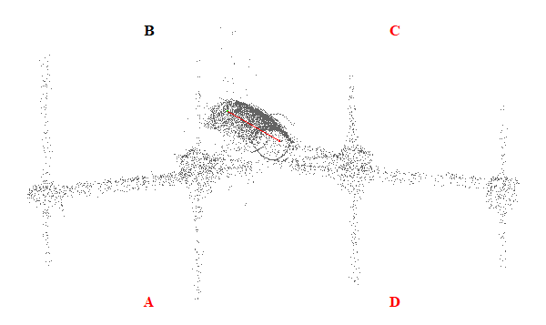
Gambar 76. Kemiringan Menara 76

Tabel 77. Kemiringan Menara 77
Nomor Menara | Searah RoW (%) | Tegak Lurus RoW (%) | Resultan (%) | Nilai Standar (%) | Searah RoW | Tegak Lurus RoW | Penilaian
77 | 6.07 | 5.33 | 8.08 | 5.00 | BC | CD | Tidak Lulus
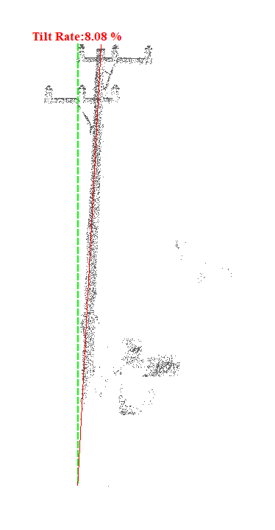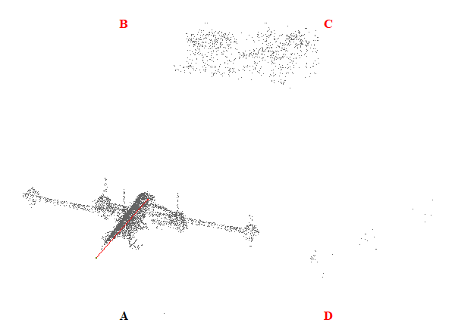
Gambar 77. Kemiringan Menara 77

Tabel 78. Kemiringan Menara 78
Nomor Menara | Searah RoW (%) | Tegak Lurus RoW (%) | Resultan (%) | Nilai Standar (%) | Searah RoW | Tegak Lurus RoW | Penilaian
78 | 2.93 | 2.68 | 3.97 | 5.00 | AD | CD | Lulus
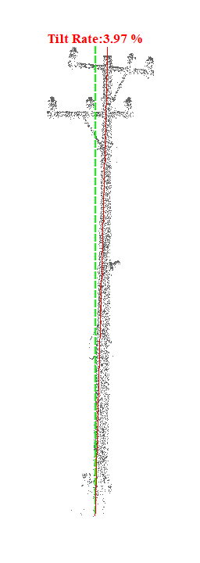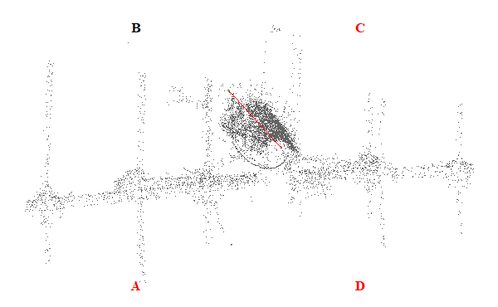
Gambar 78. Kemiringan Menara 78

Tabel 79. Kemiringan Menara 79
Nomor Menara | Searah RoW (%) | Tegak Lurus RoW (%) | Resultan (%) | Nilai Standar (%) | Searah RoW | Tegak Lurus RoW | Penilaian
79 | 4.60 | 0.70 | 4.65 | 5.00 | AD | AB | Lulus
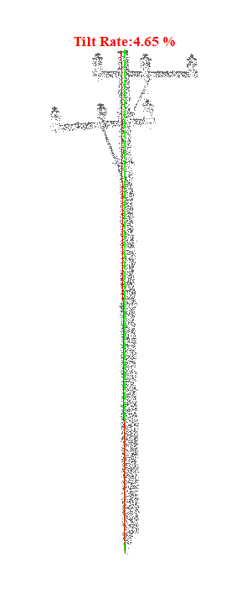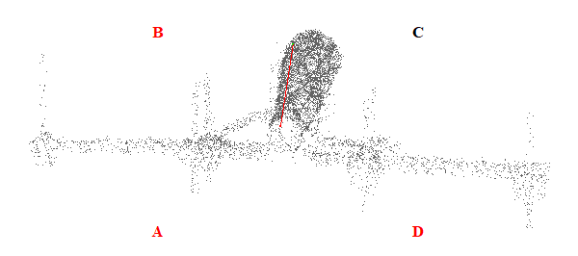
Gambar 79. Kemiringan Menara 79

Tabel 80. Kemiringan Menara 80
Nomor Menara | Searah RoW (%) | Tegak Lurus RoW (%) | Resultan (%) | Nilai Standar (%) | Searah RoW | Tegak Lurus RoW | Penilaian
80 | 0.55 | 4.11 | 4.15 | 5.00 | AD | CD | Lulus
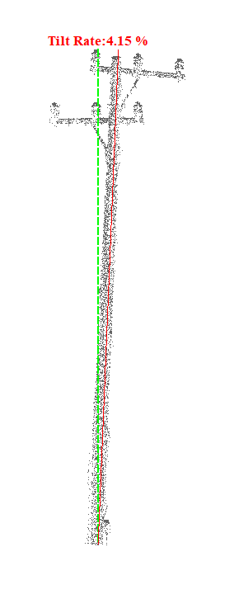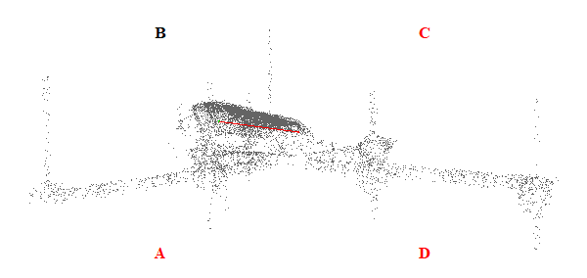
Gambar 80. Kemiringan Menara 80

Tabel 81. Kemiringan Menara 81
Nomor Menara | Searah RoW (%) | Tegak Lurus RoW (%) | Resultan (%) | Nilai Standar (%) | Searah RoW | Tegak Lurus RoW | Penilaian
81 | 3.33 | 0.47 | 3.36 | 5.00 | AD | CD | Lulus
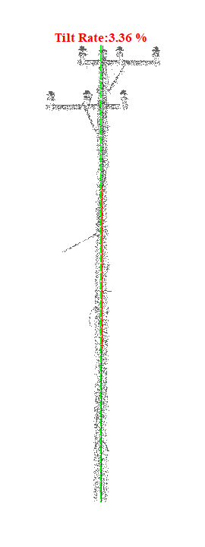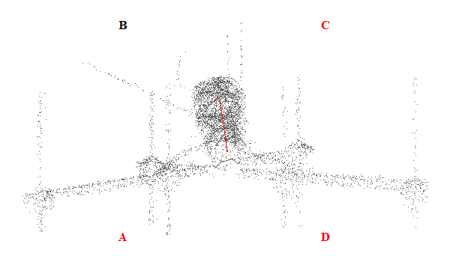
Gambar 81. Kemiringan Menara 81

Tabel 82. Kemiringan Menara 82
Nomor Menara | Searah RoW (%) | Tegak Lurus RoW (%) | Resultan (%) | Nilai Standar (%) | Searah RoW | Tegak Lurus RoW | Penilaian
82 | 0.34 | 10.78 | 10.79 | 5.00 | BC | AB | Tidak Lulus
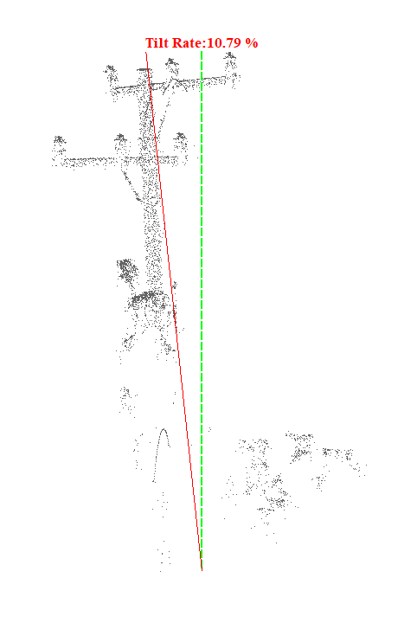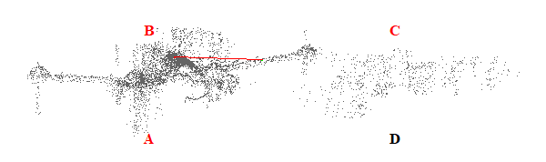
Gambar 82. Kemiringan Menara 82

Tabel 83. Kemiringan Menara 83
Nomor Menara | Searah RoW (%) | Tegak Lurus RoW (%) | Resultan (%) | Nilai Standar (%) | Searah RoW | Tegak Lurus RoW | Penilaian
83 | 2.47 | 1.71 | 3.00 | 5.00 | AD | AB | Lulus
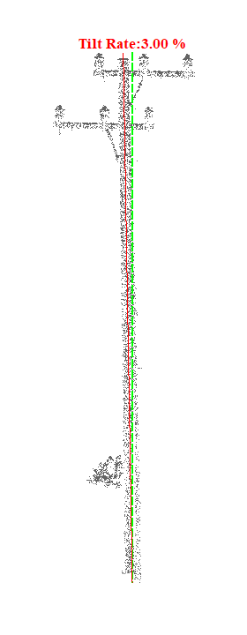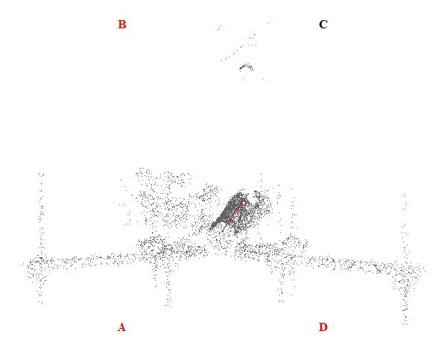
Gambar 83. Kemiringan Menara 83

Tabel 84. Kemiringan Menara 84
Nomor Menara | Searah RoW (%) | Tegak Lurus RoW (%) | Resultan (%) | Nilai Standar (%) | Searah RoW | Tegak Lurus RoW | Penilaian
84 | 10.75 | 2.27 | 10.99 | 5.00 | AD | CD | Tidak Lulus
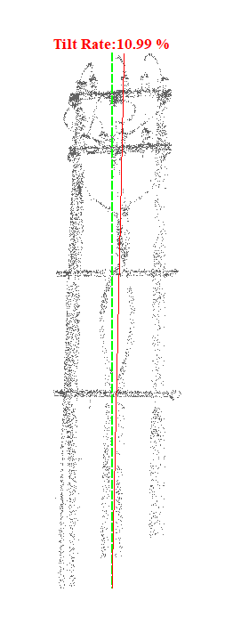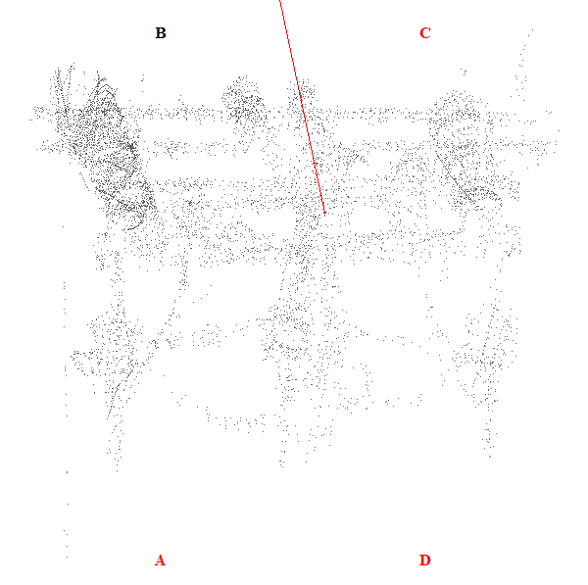
Gambar 84. Kemiringan Menara 84

Tabel 85. Kemiringan Menara 85
Nomor Menara | Searah RoW (%) | Tegak Lurus RoW (%) | Resultan (%) | Nilai Standar (%) | Searah RoW | Tegak Lurus RoW | Penilaian
85 | 4.48 | 1.90 | 4.87 | 5.00 | BC | AB | Lulus
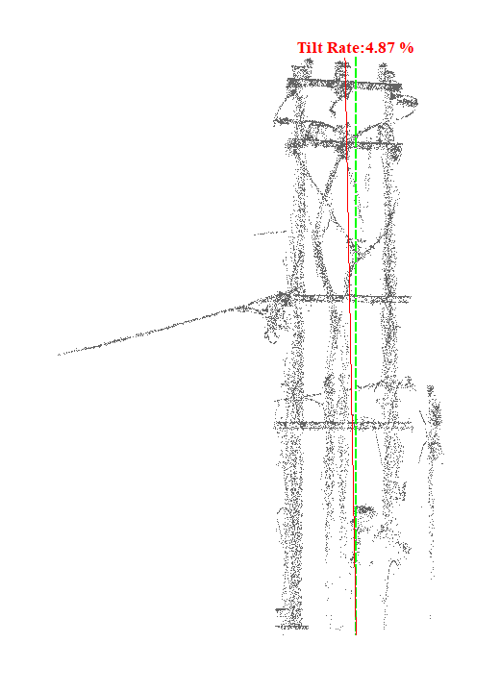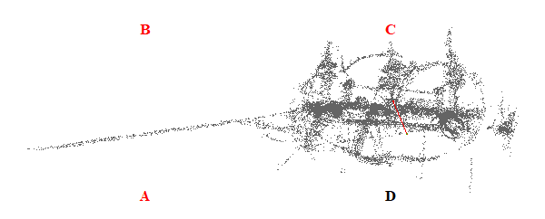
Gambar 85. Kemiringan Menara 85

Tabel 86. Kemiringan Menara 86
Nomor Menara | Searah RoW (%) | Tegak Lurus RoW (%) | Resultan (%) | Nilai Standar (%) | Searah RoW | Tegak Lurus RoW | Penilaian
86 | 8.69 | 3.66 | 9.43 | 5.00 | BC | AB | Tidak Lulus
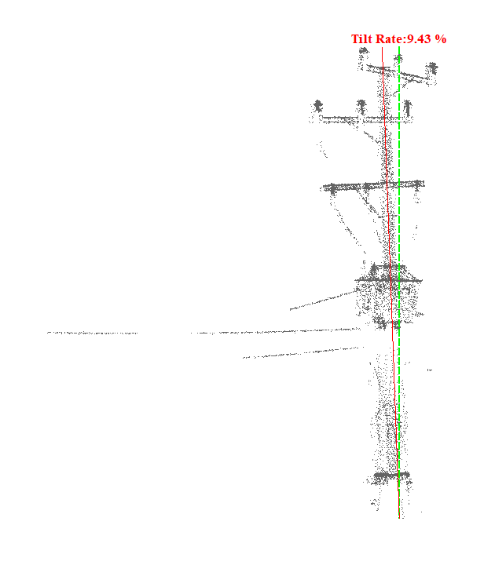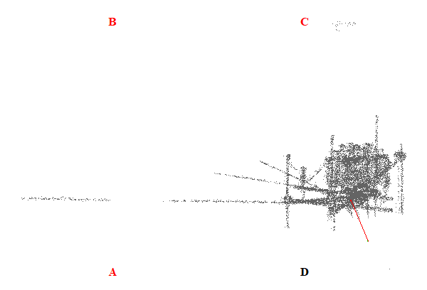
Gambar 86. Kemiringan Menara 86

Tabel 87. Kemiringan Menara 87
Nomor Menara | Searah RoW (%) | Tegak Lurus RoW (%) | Resultan (%) | Nilai Standar (%) | Searah RoW | Tegak Lurus RoW | Penilaian
87 | 0.15 | 1.75 | 1.76 | 5.00 | AD | CD | Lulus
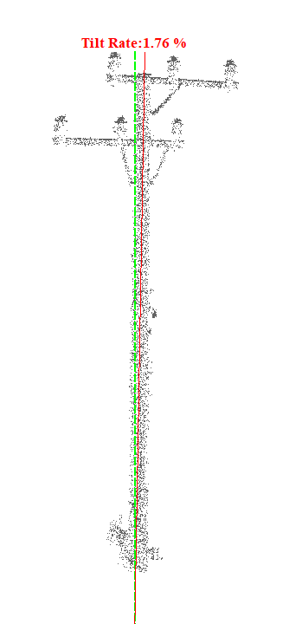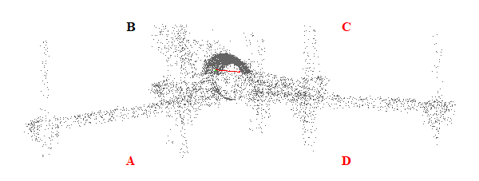
Gambar 87. Kemiringan Menara 87

Tabel 88. Kemiringan Menara 88
Nomor Menara | Searah RoW (%) | Tegak Lurus RoW (%) | Resultan (%) | Nilai Standar (%) | Searah RoW | Tegak Lurus RoW | Penilaian
88 | 0.73 | 0.54 | 0.91 | 5.00 | BC | AB | Lulus
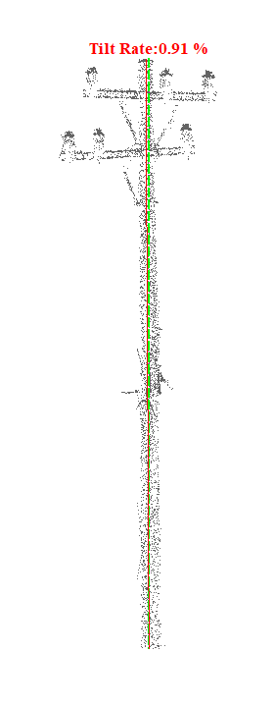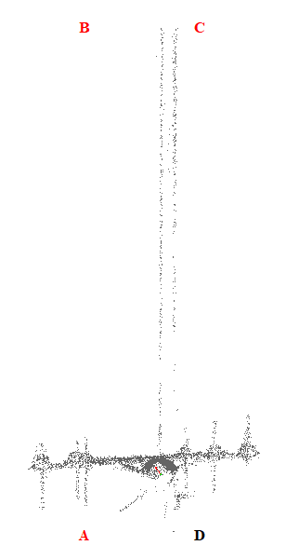
Gambar 88. Kemiringan Menara 88

Tabel 89. Kemiringan Menara 89
Nomor Menara | Searah RoW (%) | Tegak Lurus RoW (%) | Resultan (%) | Nilai Standar (%) | Searah RoW | Tegak Lurus RoW | Penilaian
89 | 1.32 | 1.43 | 1.95 | 5.00 | BC | CD | Lulus
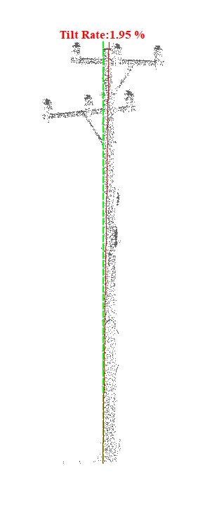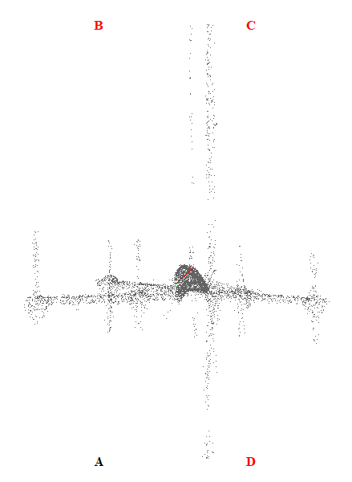
Gambar 89. Kemiringan Menara 89

Tabel 90. Kemiringan Menara 90
Nomor Menara | Searah RoW (%) | Tegak Lurus RoW (%) | Resultan (%) | Nilai Standar (%) | Searah RoW | Tegak Lurus RoW | Penilaian
90 | 6.35 | 6.36 | 8.99 | 5.00 | AD | AB | Tidak Lulus
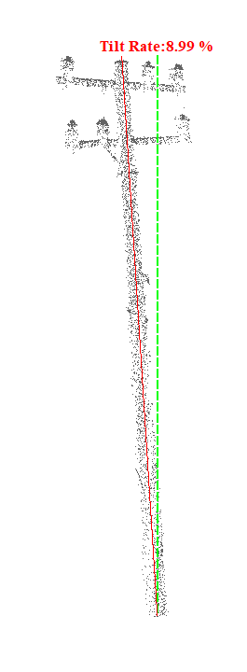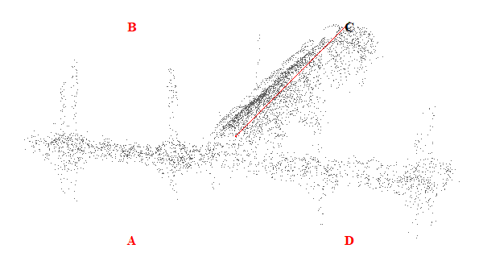
Gambar 90. Kemiringan Menara 90

Tabel 91. Kemiringan Menara 91
Nomor Menara | Searah RoW (%) | Tegak Lurus RoW (%) | Resultan (%) | Nilai Standar (%) | Searah RoW | Tegak Lurus RoW | Penilaian
91 | 0.80 | 0.03 | 0.80 | 5.00 | BC | AB | Lulus
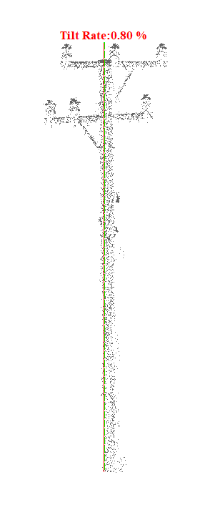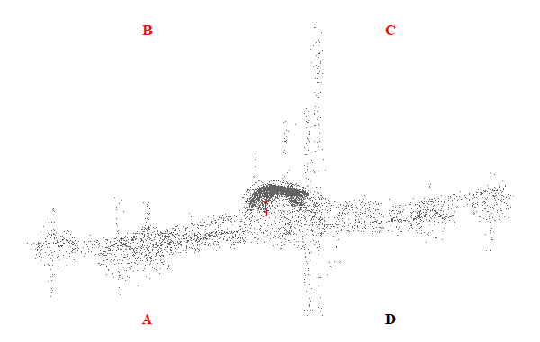
Gambar 91. Kemiringan Menara 91

Tabel 92. Kemiringan Menara 92
Nomor Menara | Searah RoW (%) | Tegak Lurus RoW (%) | Resultan (%) | Nilai Standar (%) | Searah RoW | Tegak Lurus RoW | Penilaian
92 | 7.92 | 0.42 | 7.93 | 5.00 | AD | AB | Tidak Lulus
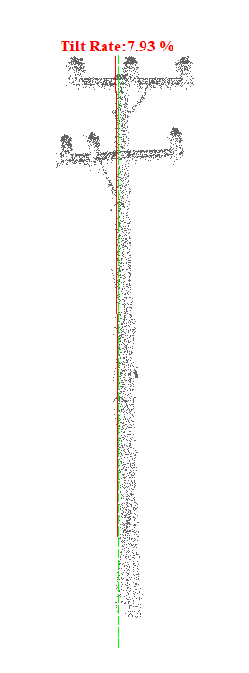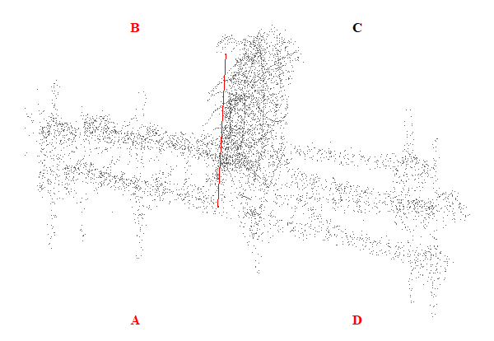
Gambar 92. Kemiringan Menara 92

Tabel 93. Kemiringan Menara 93
Nomor Menara | Searah RoW (%) | Tegak Lurus RoW (%) | Resultan (%) | Nilai Standar (%) | Searah RoW | Tegak Lurus RoW | Penilaian
93 | 11.03 | 5.44 | 12.30 | 5.00 | AD | AB | Tidak Lulus
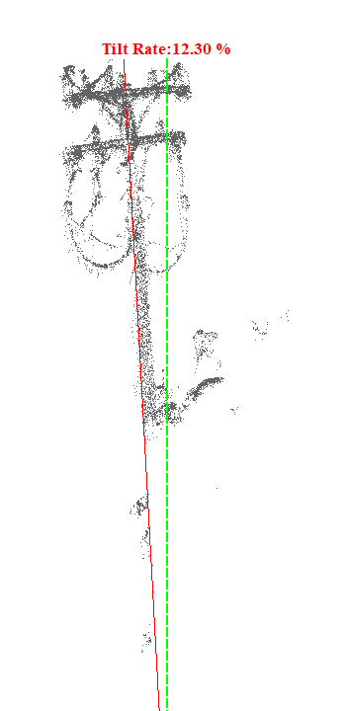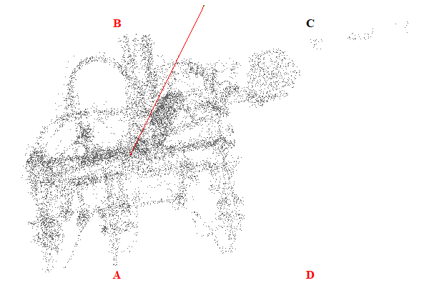
Gambar 93. Kemiringan Menara 93

Tabel 94. Kemiringan Menara 94
Nomor Menara | Searah RoW (%) | Tegak Lurus RoW (%) | Resultan (%) | Nilai Standar (%) | Searah RoW | Tegak Lurus RoW | Penilaian
94 | 3.92 | 2.46 | 4.63 | 5.00 | AD | CD | Lulus
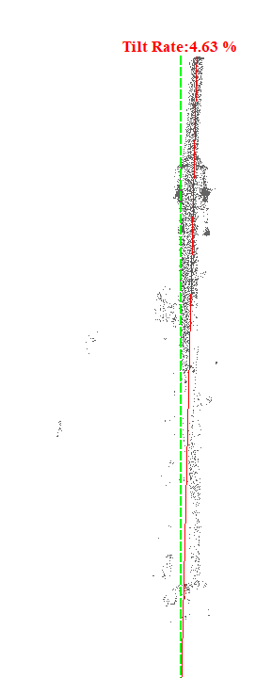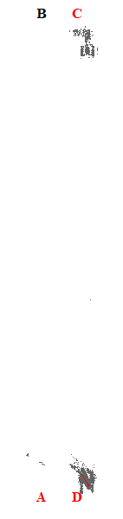
Gambar 94. Kemiringan Menara 94

Tabel 95. Kemiringan Menara 95
Nomor Menara | Searah RoW (%) | Tegak Lurus RoW (%) | Resultan (%) | Nilai Standar (%) | Searah RoW | Tegak Lurus RoW | Penilaian
95 | 8.13 | 1.20 | 8.22 | 5.00 | AD | AB | Tidak Lulus
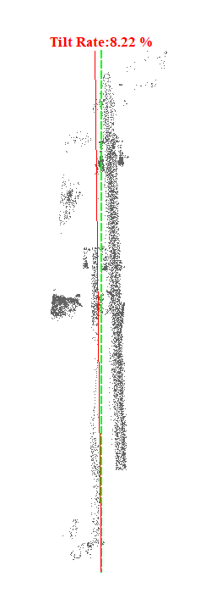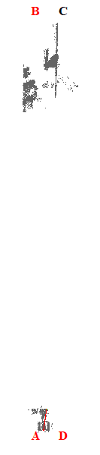
Gambar 95. Kemiringan Menara 95

Tabel 96. Kemiringan Menara 96
Nomor Menara | Searah RoW (%) | Tegak Lurus RoW (%) | Resultan (%) | Nilai Standar (%) | Searah RoW | Tegak Lurus RoW | Penilaian
96 | 10.39 | 1.25 | 10.46 | 5.00 | AD | AB | Tidak Lulus
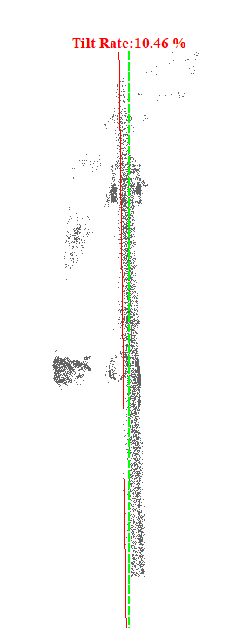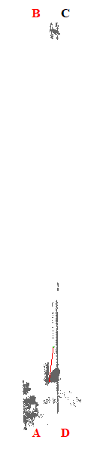
Gambar 96. Kemiringan Menara 96

Tabel 97. Kemiringan Menara 97
Nomor Menara | Searah RoW (%) | Tegak Lurus RoW (%) | Resultan (%) | Nilai Standar (%) | Searah RoW | Tegak Lurus RoW | Penilaian
97 | 12.90 | 3.58 | 13.39 | 5.00 | AD | AB | Tidak Lulus
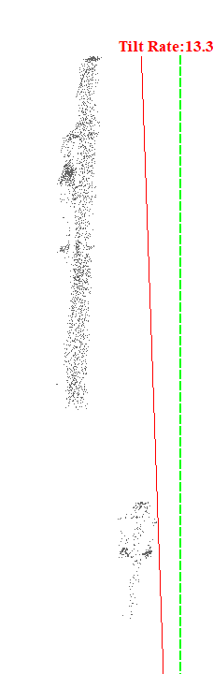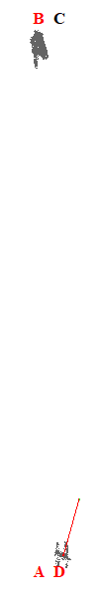
Gambar 97. Kemiringan Menara 97

Tabel 98. Kemiringan Menara 98
Nomor Menara | Searah RoW (%) | Tegak Lurus RoW (%) | Resultan (%) | Nilai Standar (%) | Searah RoW | Tegak Lurus RoW | Penilaian
98 | 12.14 | 5.81 | 13.46 | 5.00 | AD | CD | Tidak Lulus
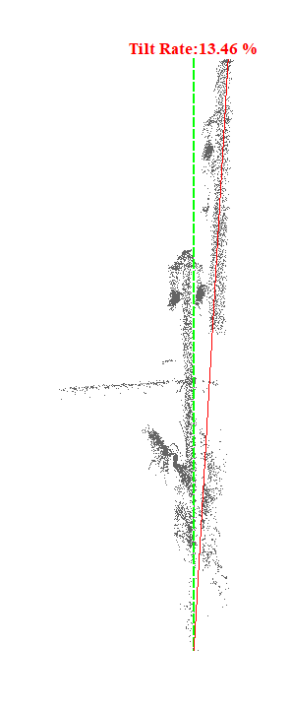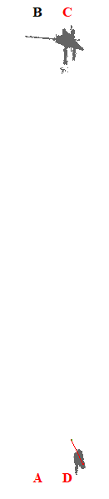
Gambar 98. Kemiringan Menara 98

Tabel 99. Kemiringan Menara 99
Nomor Menara | Searah RoW (%) | Tegak Lurus RoW (%) | Resultan (%) | Nilai Standar (%) | Searah RoW | Tegak Lurus RoW | Penilaian
99 | 36.05 | 6.74 | 36.67 | 5.00 | AD | CD | Tidak Lulus
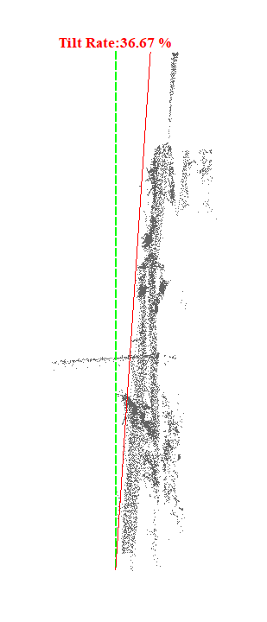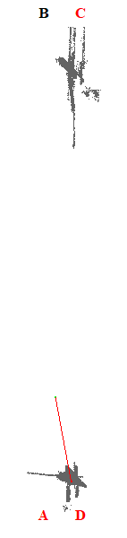
Gambar 99. Kemiringan Menara 99

Tabel 100. Kemiringan Menara 100
Nomor Menara | Searah RoW (%) | Tegak Lurus RoW (%) | Resultan (%) | Nilai Standar (%) | Searah RoW | Tegak Lurus RoW | Penilaian
100 | 0.34 | 2.83 | 2.85 | 5.00 | BC | CD | Lulus
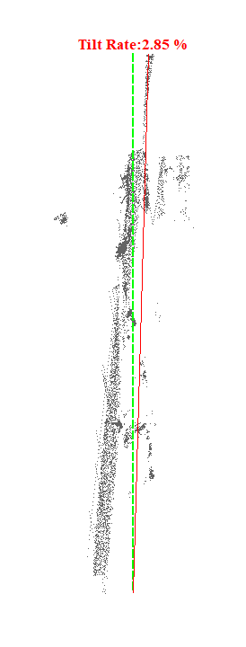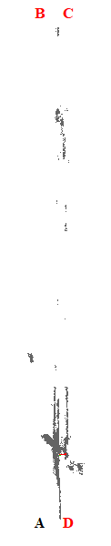
Gambar 100. Kemiringan Menara 100

Tabel 101. Kemiringan Menara 101
Nomor Menara | Searah RoW (%) | Tegak Lurus RoW (%) | Resultan (%) | Nilai Standar (%) | Searah RoW | Tegak Lurus RoW | Penilaian
101 | 5.39 | 17.57 | 18.38 | 5.00 | AD | CD | Tidak Lulus
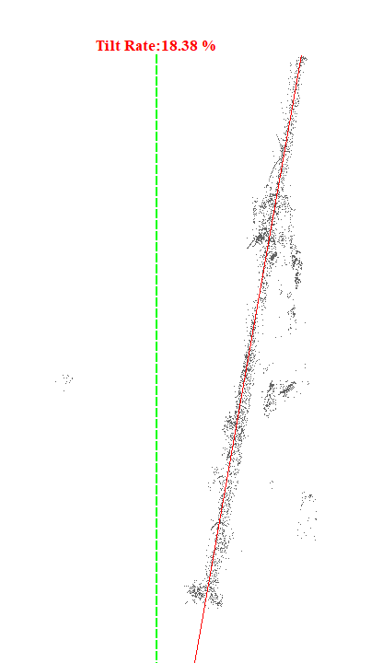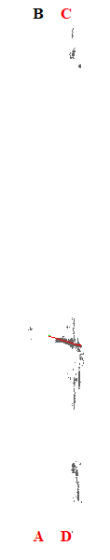
Gambar 101. Kemiringan Menara 101

Tabel 102. Kemiringan Menara 102
Nomor Menara | Searah RoW (%) | Tegak Lurus RoW (%) | Resultan (%) | Nilai Standar (%) | Searah RoW | Tegak Lurus RoW | Penilaian
102 | 13.16 | 9.66 | 16.32 | 5.00 | AD | CD | Tidak Lulus
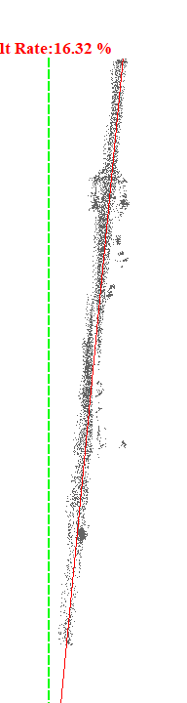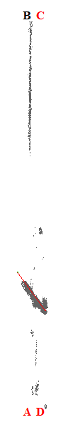
Gambar 102. Kemiringan Menara 102

Tabel 103. Kemiringan Menara 103
Nomor Menara | Searah RoW (%) | Tegak Lurus RoW (%) | Resultan (%) | Nilai Standar (%) | Searah RoW | Tegak Lurus RoW | Penilaian
103 | 8.93 | 1.84 | 9.12 | 5.00 | AD | AB | Tidak Lulus
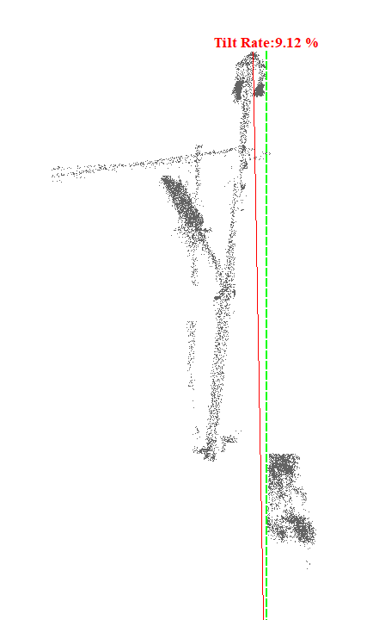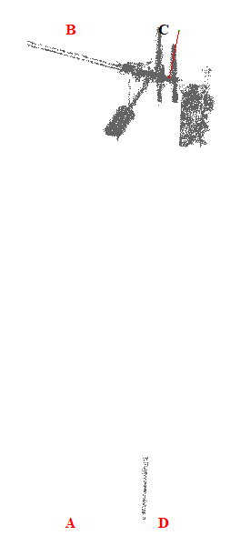
Gambar 103. Kemiringan Menara 103

Tabel 104. Kemiringan Menara 104
Nomor Menara | Searah RoW (%) | Tegak Lurus RoW (%) | Resultan (%) | Nilai Standar (%) | Searah RoW | Tegak Lurus RoW | Penilaian
104 | 1.36 | 3.10 | 3.39 | 5.00 | AD | CD | Lulus
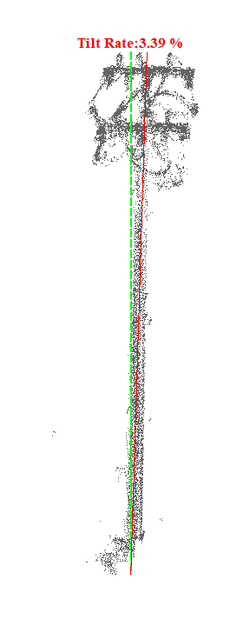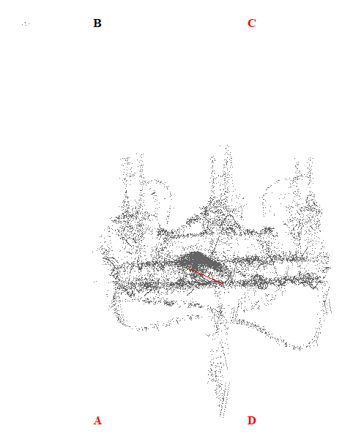
Gambar 104. Kemiringan Menara 104

Tabel 105. Kemiringan Menara 105
Nomor Menara | Searah RoW (%) | Tegak Lurus RoW (%) | Resultan (%) | Nilai Standar (%) | Searah RoW | Tegak Lurus RoW | Penilaian
105 | 3.26 | 0.86 | 3.37 | 5.00 | BC | CD | Lulus
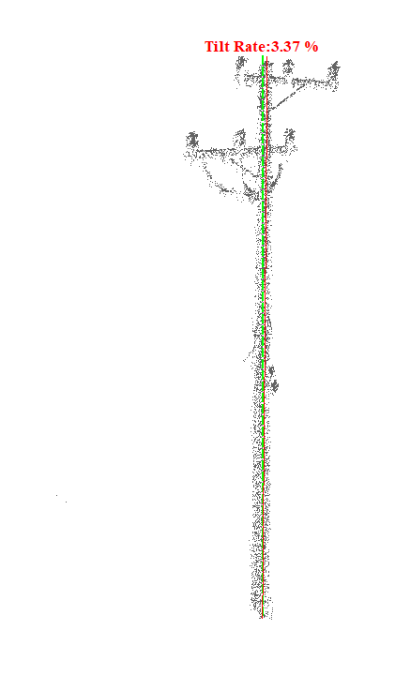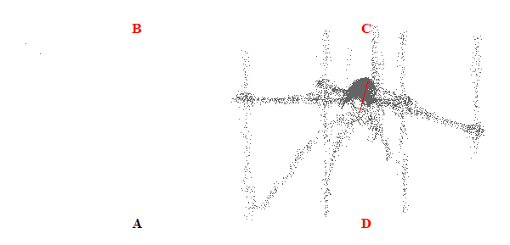
Gambar 105. Kemiringan Menara 105

Tabel 106. Kemiringan Menara 106
Nomor Menara | Searah RoW (%) | Tegak Lurus RoW (%) | Resultan (%) | Nilai Standar (%) | Searah RoW | Tegak Lurus RoW | Penilaian
106 | 0.84 | 0.24 | 0.87 | 5.00 | BC | CD | Lulus
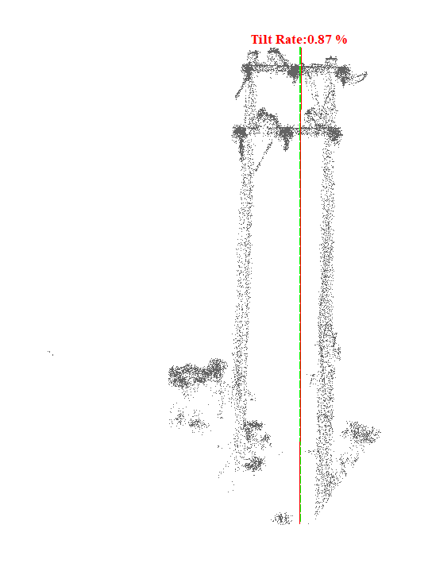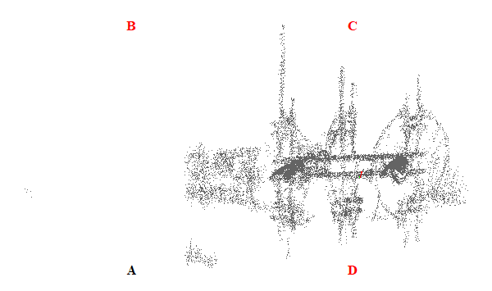
Gambar 106. Kemiringan Menara 106

Tabel 107. Kemiringan Menara 107
Nomor Menara | Searah RoW (%) | Tegak Lurus RoW (%) | Resultan (%) | Nilai Standar (%) | Searah RoW | Tegak Lurus RoW | Penilaian
107 | 2.51 | 3.45 | 4.27 | 5.00 | BC | CD | Lulus
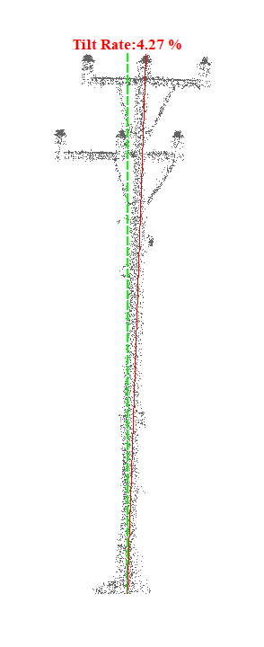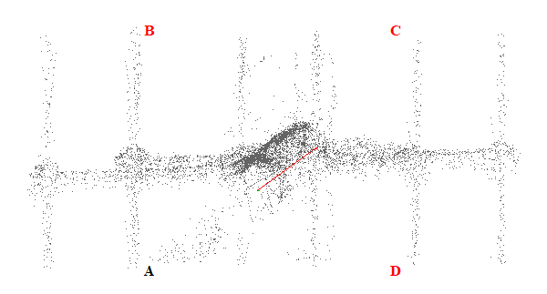
Gambar 107. Kemiringan Menara 107

Tabel 108. Kemiringan Menara 108
Nomor Menara | Searah RoW (%) | Tegak Lurus RoW (%) | Resultan (%) | Nilai Standar (%) | Searah RoW | Tegak Lurus RoW | Penilaian
108 | 0.65 | 0.34 | 0.73 | 5.00 | BC | CD | Lulus
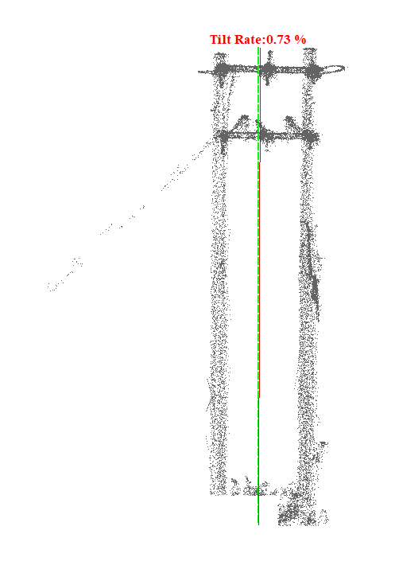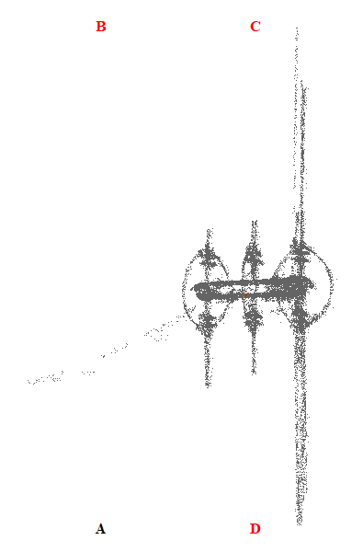
Gambar 108. Kemiringan Menara 108

Tabel 109. Kemiringan Menara 109
Nomor Menara | Searah RoW (%) | Tegak Lurus RoW (%) | Resultan (%) | Nilai Standar (%) | Searah RoW | Tegak Lurus RoW | Penilaian
109 | 2.73 | 7.77 | 8.24 | 5.00 | AD | AB | Tidak Lulus
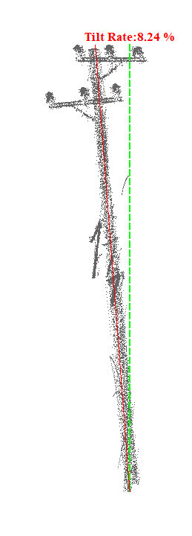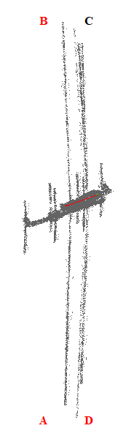
Gambar 109. Kemiringan Menara 109

Tabel 110. Kemiringan Menara 110
Nomor Menara | Searah RoW (%) | Tegak Lurus RoW (%) | Resultan (%) | Nilai Standar (%) | Searah RoW | Tegak Lurus RoW | Penilaian
110 | 3.19 | 0.13 | 3.19 | 5.00 | AD | AB | Lulus
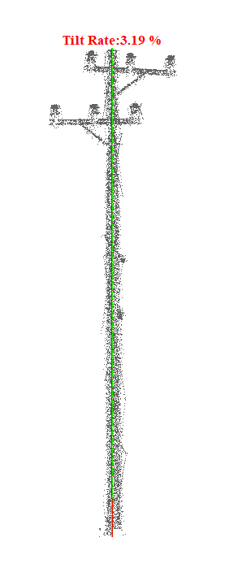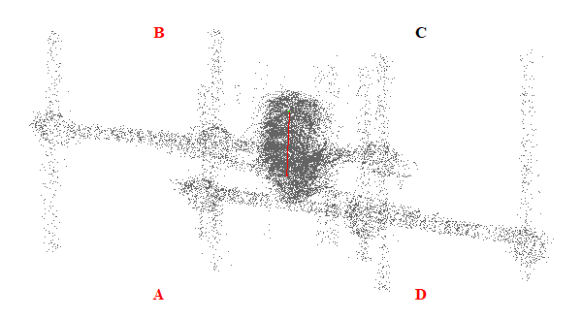
Gambar 110. Kemiringan Menara 110

Tabel 111. Kemiringan Menara 111
Nomor Menara | Searah RoW (%) | Tegak Lurus RoW (%) | Resultan (%) | Nilai Standar (%) | Searah RoW | Tegak Lurus RoW | Penilaian
111 | 3.69 | 0.68 | 3.75 | 5.00 | AD | CD | Lulus
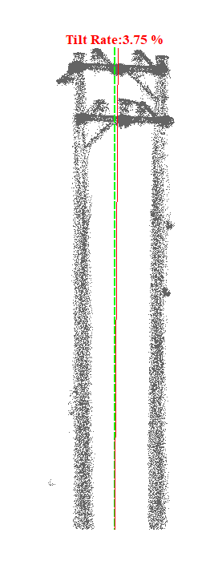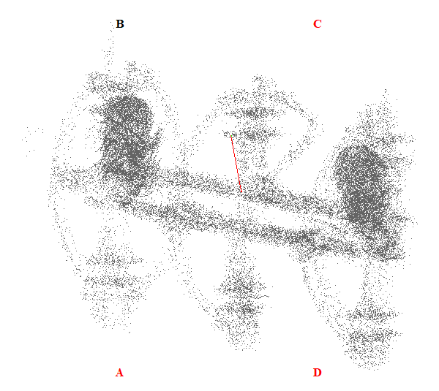
Gambar 111. Kemiringan Menara 111

Tabel 112. Kemiringan Menara 112
Nomor Menara | Searah RoW (%) | Tegak Lurus RoW (%) | Resultan (%) | Nilai Standar (%) | Searah RoW | Tegak Lurus RoW | Penilaian
112 | 0.72 | 1.47 | 1.64 | 5.00 | BC | AB | Lulus
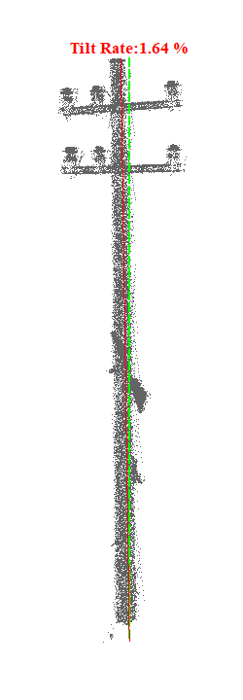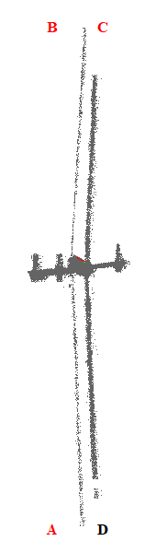
Gambar 112. Kemiringan Menara 112

Tabel 113. Kemiringan Menara 113
Nomor Menara | Searah RoW (%) | Tegak Lurus RoW (%) | Resultan (%) | Nilai Standar (%) | Searah RoW | Tegak Lurus RoW | Penilaian
113 | 1.44 | 10.23 | 10.33 | 5.00 | BC | AB | Tidak Lulus
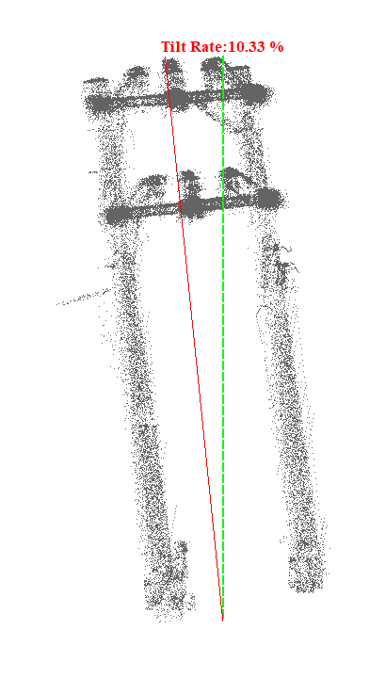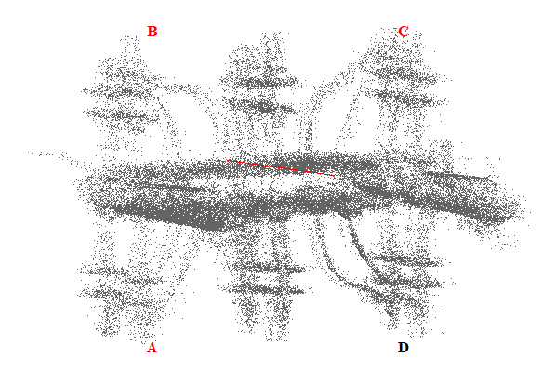
Gambar 113. Kemiringan Menara 113

Tabel 114. Kemiringan Menara 114
Nomor Menara | Searah RoW (%) | Tegak Lurus RoW (%) | Resultan (%) | Nilai Standar (%) | Searah RoW | Tegak Lurus RoW | Penilaian
114 | 5.30 | 0.67 | 5.34 | 5.00 | BC | AB | Tidak Lulus
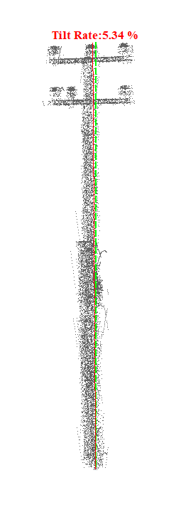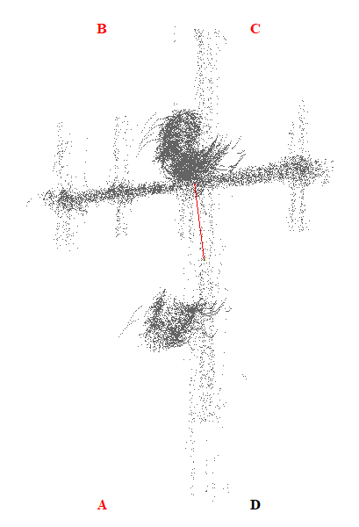
Gambar 114. Kemiringan Menara 114

Tabel 115. Kemiringan Menara 115
Nomor Menara | Searah RoW (%) | Tegak Lurus RoW (%) | Resultan (%) | Nilai Standar (%) | Searah RoW | Tegak Lurus RoW | Penilaian
115 | 2.73 | 3.50 | 4.44 | 5.00 | AD | CD | Lulus
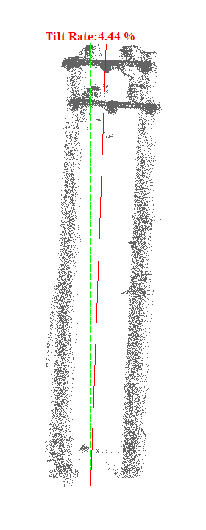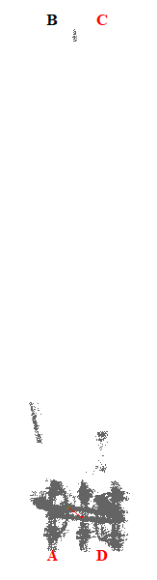
Gambar 115. Kemiringan Menara 115

Tabel 116. Kemiringan Menara 116
Nomor Menara | Searah RoW (%) | Tegak Lurus RoW (%) | Resultan (%) | Nilai Standar (%) | Searah RoW | Tegak Lurus RoW | Penilaian
116 | 0.50 | 8.93 | 8.94 | 5.00 | BC | AB | Tidak Lulus
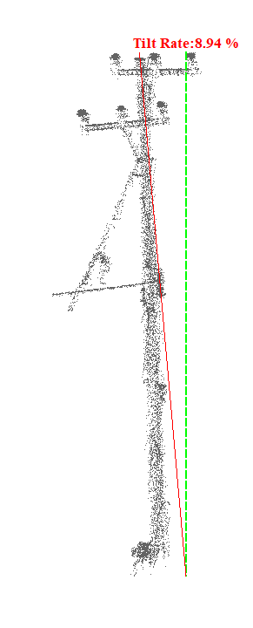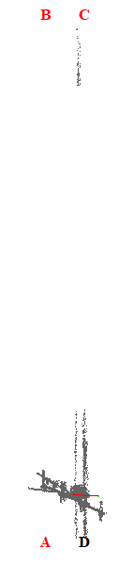
Gambar 116. Kemiringan Menara 116

Tabel 117. Kemiringan Menara 117
Nomor Menara | Searah RoW (%) | Tegak Lurus RoW (%) | Resultan (%) | Nilai Standar (%) | Searah RoW | Tegak Lurus RoW | Penilaian
117 | 17.31 | 0.57 | 17.32 | 5.00 | AD | AB | Tidak Lulus
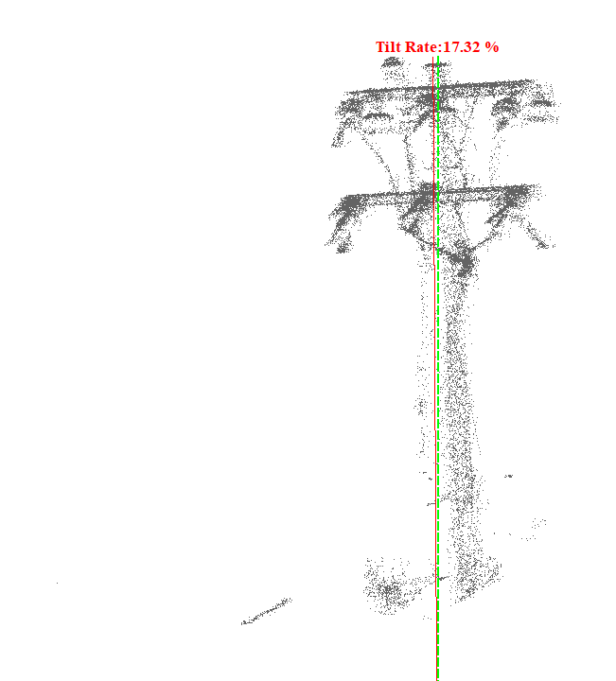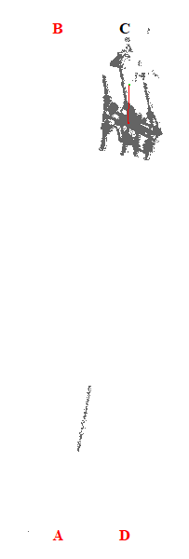
Gambar 117. Kemiringan Menara 117

Tabel 118. Kemiringan Menara 118
Nomor Menara | Searah RoW (%) | Tegak Lurus RoW (%) | Resultan (%) | Nilai Standar (%) | Searah RoW | Tegak Lurus RoW | Penilaian
118 | 5.11 | 11.21 | 12.32 | 5.00 | BC | AB | Tidak Lulus
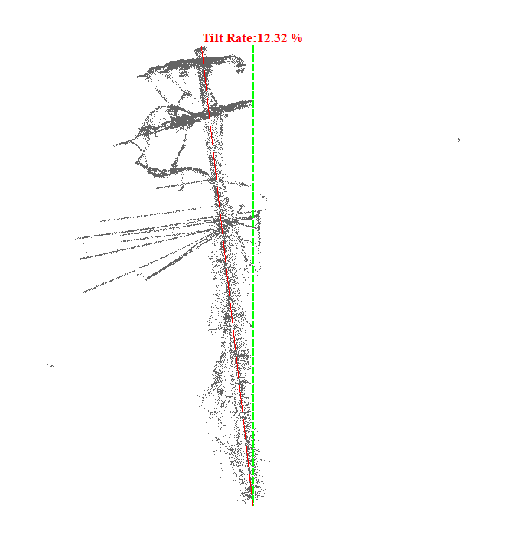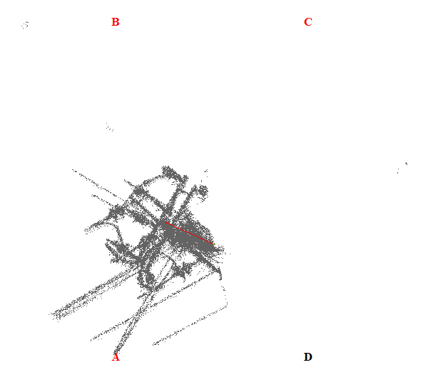
Gambar 118. Kemiringan Menara 118

Tabel 119. Kemiringan Menara 119
Nomor Menara | Searah RoW (%) | Tegak Lurus RoW (%) | Resultan (%) | Nilai Standar (%) | Searah RoW | Tegak Lurus RoW | Penilaian
119 | 5.29 | 9.96 | 11.28 | 5.00 | AD | CD | Tidak Lulus
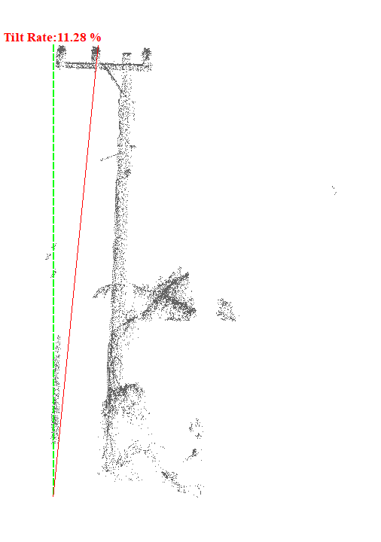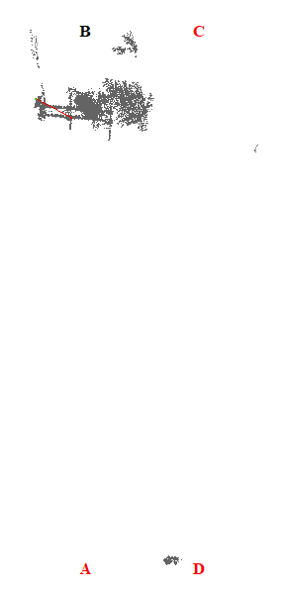
Gambar 119. Kemiringan Menara 119

Tabel 120. Kemiringan Menara 120
Nomor Menara | Searah RoW (%) | Tegak Lurus RoW (%) | Resultan (%) | Nilai Standar (%) | Searah RoW | Tegak Lurus RoW | Penilaian
120 | 6.77 | 16.88 | 18.19 | 5.00 | BC | AB | Tidak Lulus
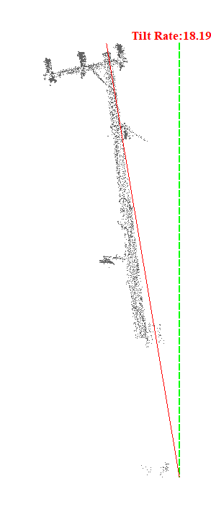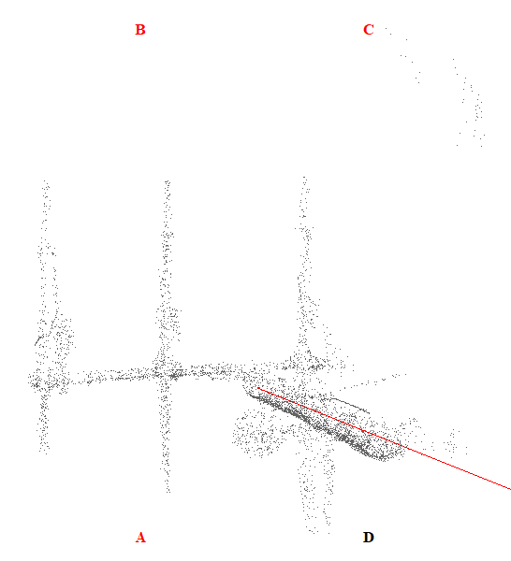
Gambar 120. Kemiringan Menara 120

Tabel 121. Kemiringan Menara 121
Nomor Menara | Searah RoW (%) | Tegak Lurus RoW (%) | Resultan (%) | Nilai Standar (%) | Searah RoW | Tegak Lurus RoW | Penilaian
121 | 11.05 | 11.01 | 15.60 | 5.00 | BC | CD | Tidak Lulus
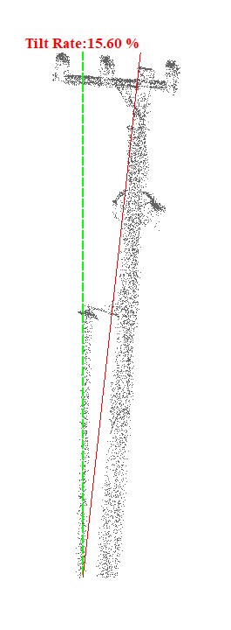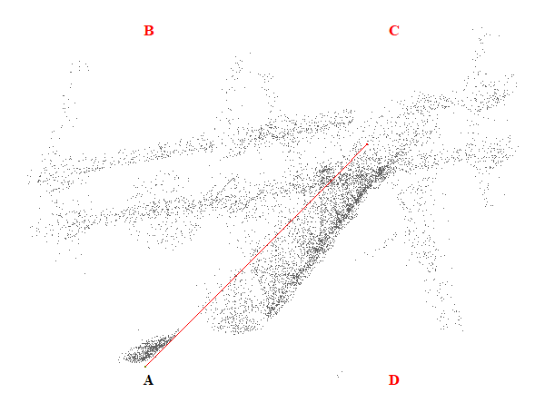
Gambar 121. Kemiringan Menara 121

Tabel 122. Kemiringan Menara 122
Nomor Menara | Searah RoW (%) | Tegak Lurus RoW (%) | Resultan (%) | Nilai Standar (%) | Searah RoW | Tegak Lurus RoW | Penilaian
122 | 4.86 | 10.00 | 11.12 | 5.00 | AD | CD | Tidak Lulus
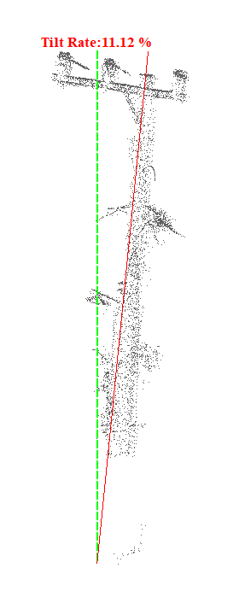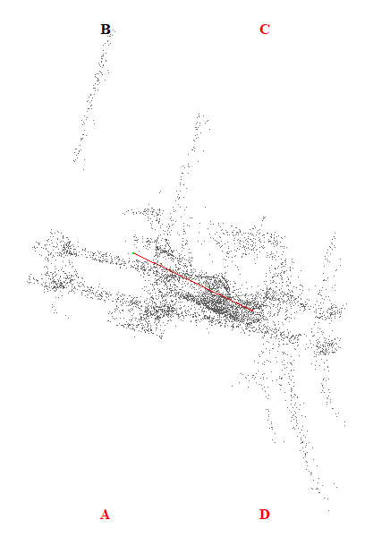
Gambar 122. Kemiringan Menara 122

Tabel 123. Kemiringan Menara 123
Nomor Menara | Searah RoW (%) | Tegak Lurus RoW (%) | Resultan (%) | Nilai Standar (%) | Searah RoW | Tegak Lurus RoW | Penilaian
123 | 1.96 | 1.70 | 2.59 | 5.00 | BC | CD | Lulus
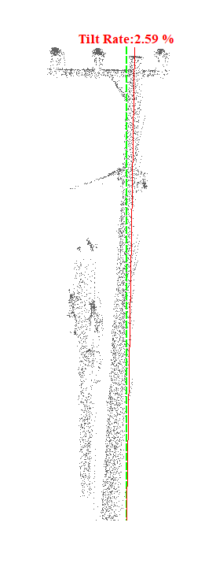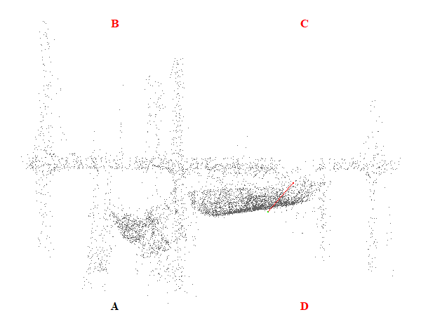
Gambar 123. Kemiringan Menara 123

Tabel 124. Kemiringan Menara 124
Nomor Menara | Searah RoW (%) | Tegak Lurus RoW (%) | Resultan (%) | Nilai Standar (%) | Searah RoW | Tegak Lurus RoW | Penilaian
124 | 1.51 | 8.02 | 8.16 | 5.00 | BC | AB | Tidak Lulus
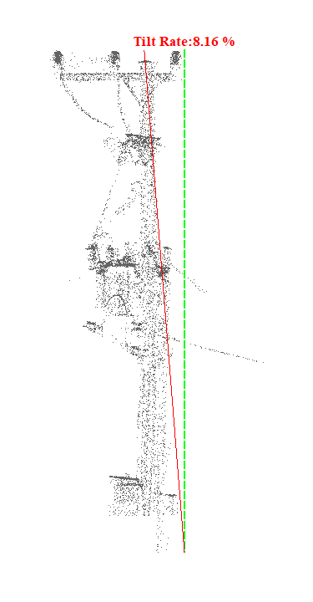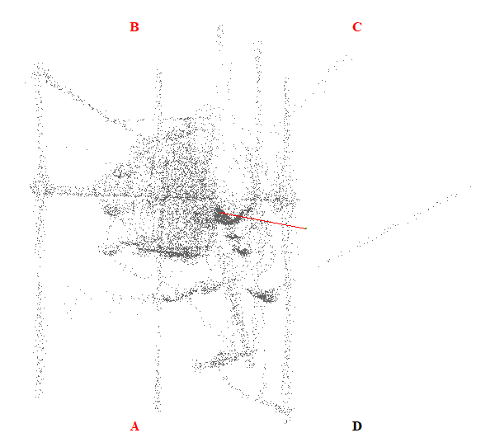
Gambar 124. Kemiringan Menara 124

Tabel 125. Kemiringan Menara 125
Nomor Menara | Searah RoW (%) | Tegak Lurus RoW (%) | Resultan (%) | Nilai Standar (%) | Searah RoW | Tegak Lurus RoW | Penilaian
125 | 0.30 | 29.86 | 29.86 | 5.00 | AD | AB | Tidak Lulus
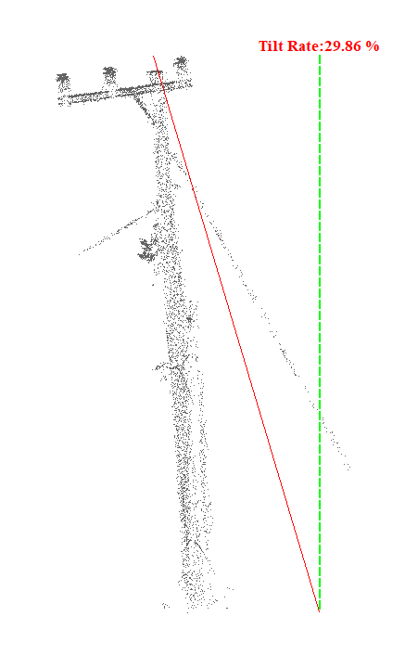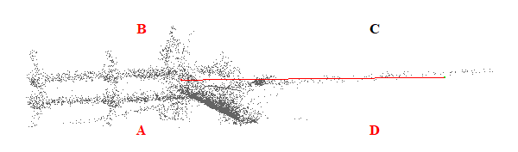
Gambar 125. Kemiringan Menara 125

Tabel 126. Kemiringan Menara 126
Nomor Menara | Searah RoW (%) | Tegak Lurus RoW (%) | Resultan (%) | Nilai Standar (%) | Searah RoW | Tegak Lurus RoW | Penilaian
126 | 1.57 | 5.99 | 6.19 | 5.00 | BC | AB | Tidak Lulus
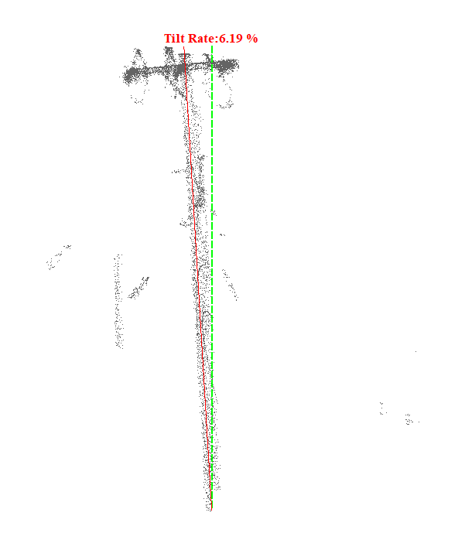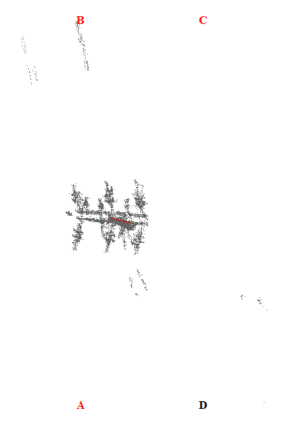
Gambar 126. Kemiringan Menara 126

Tabel 127. Kemiringan Menara 127
Nomor Menara | Searah RoW (%) | Tegak Lurus RoW (%) | Resultan (%) | Nilai Standar (%) | Searah RoW | Tegak Lurus RoW | Penilaian
127 | 0.46 | 5.22 | 5.24 | 5.00 | AD | CD | Tidak Lulus
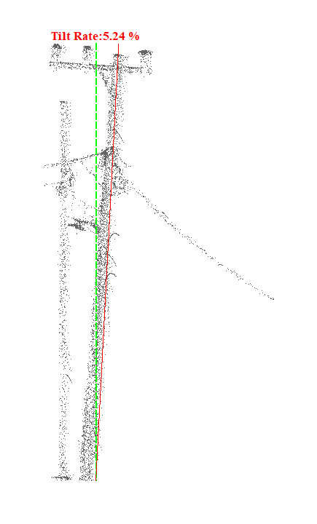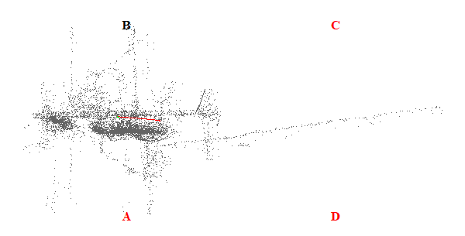
Gambar 127. Kemiringan Menara 127

Tabel 128. Kemiringan Menara 128
Nomor Menara | Searah RoW (%) | Tegak Lurus RoW (%) | Resultan (%) | Nilai Standar (%) | Searah RoW | Tegak Lurus RoW | Penilaian
128 | 0.45 | 1.57 | 1.63 | 5.00 | AD | AB | Lulus
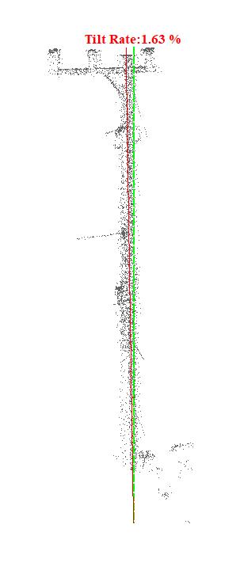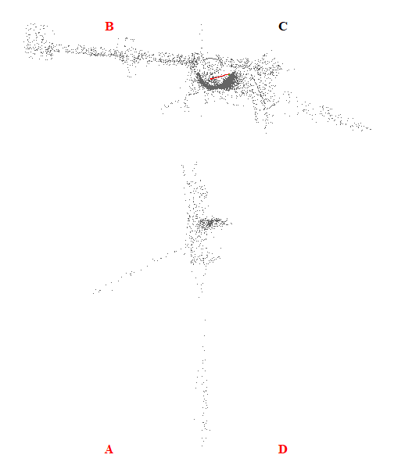
Gambar 128. Kemiringan Menara 128

Tabel 129. Kemiringan Menara 129
Nomor Menara | Searah RoW (%) | Tegak Lurus RoW (%) | Resultan (%) | Nilai Standar (%) | Searah RoW | Tegak Lurus RoW | Penilaian
129 | 5.59 | 11.91 | 13.16 | 5.00 | BC | AB | Tidak Lulus
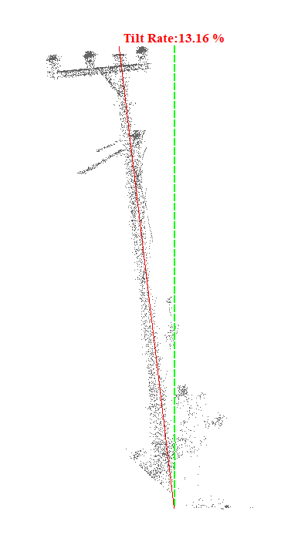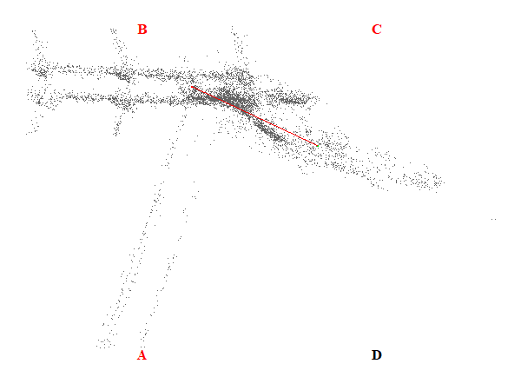
Gambar 129. Kemiringan Menara 129

Tabel 130. Kemiringan Menara 130
Nomor Menara | Searah RoW (%) | Tegak Lurus RoW (%) | Resultan (%) | Nilai Standar (%) | Searah RoW | Tegak Lurus RoW | Penilaian
130 | 1.36 | 2.25 | 2.63 | 5.00 | BC | CD | Lulus
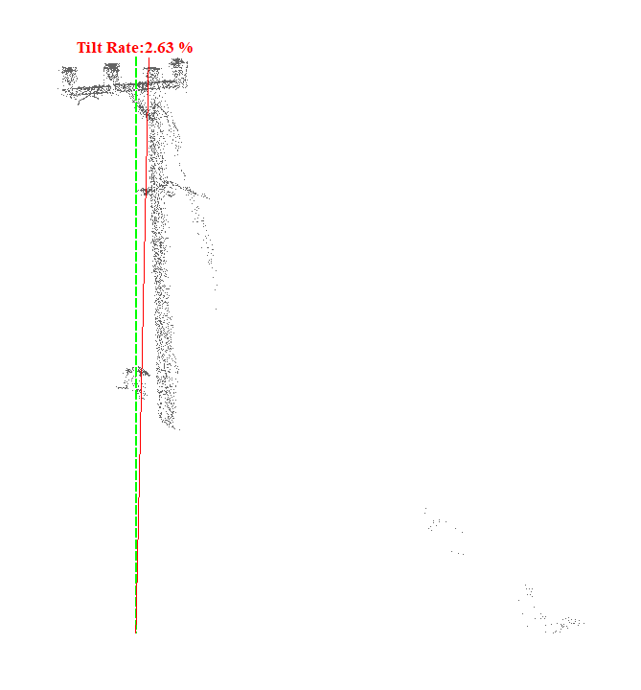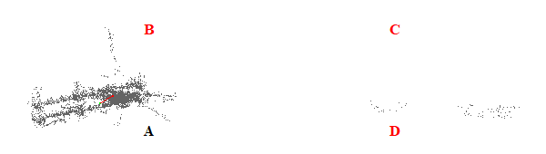
Gambar 130. Kemiringan Menara 130

Tabel 131. Kemiringan Menara 131
Nomor Menara | Searah RoW (%) | Tegak Lurus RoW (%) | Resultan (%) | Nilai Standar (%) | Searah RoW | Tegak Lurus RoW | Penilaian
131 | 7.05 | 9.58 | 11.89 | 5.00 | AD | AB | Tidak Lulus
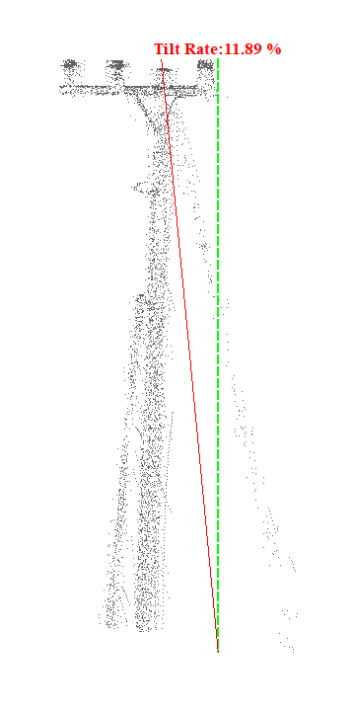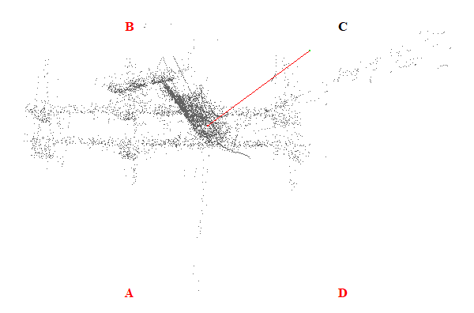
Gambar 131. Kemiringan Menara 131

Tabel 132. Kemiringan Menara 132
Nomor Menara | Searah RoW (%) | Tegak Lurus RoW (%) | Resultan (%) | Nilai Standar (%) | Searah RoW | Tegak Lurus RoW | Penilaian
132 | 1.14 | 2.58 | 2.82 | 5.00 | AD | CD | Lulus
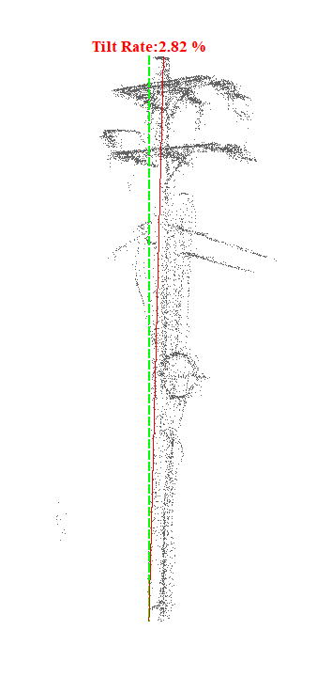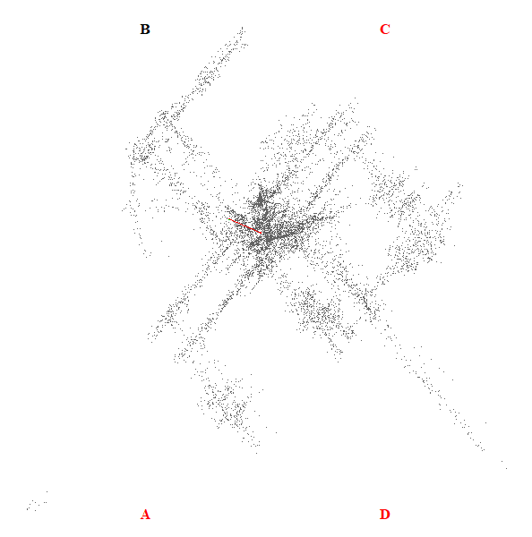
Gambar 132. Kemiringan Menara 132

Tabel 133. Kemiringan Menara 133
Nomor Menara | Searah RoW (%) | Tegak Lurus RoW (%) | Resultan (%) | Nilai Standar (%) | Searah RoW | Tegak Lurus RoW | Penilaian
133 | 5.95 | 3.08 | 6.70 | 5.00 | BC | CD | Tidak Lulus
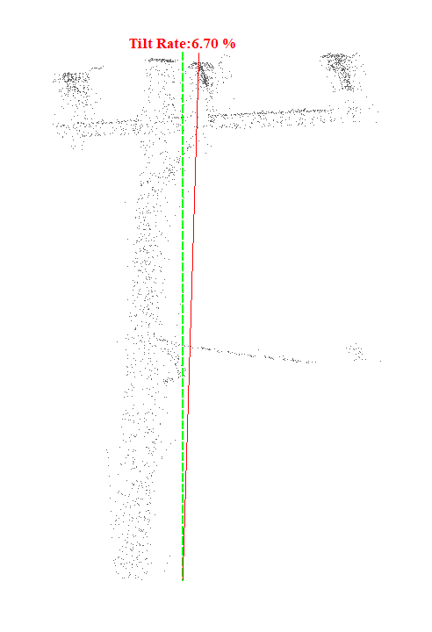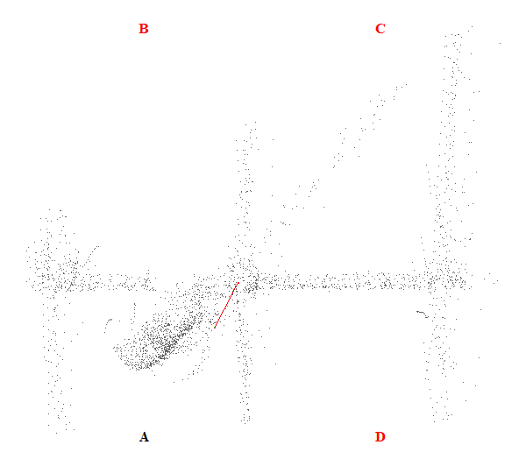
Gambar 133. Kemiringan Menara 133

Tabel 134. Kemiringan Menara 134
Nomor Menara | Searah RoW (%) | Tegak Lurus RoW (%) | Resultan (%) | Nilai Standar (%) | Searah RoW | Tegak Lurus RoW | Penilaian
134 | 7.08 | 4.04 | 8.15 | 5.00 | BC | CD | Tidak Lulus
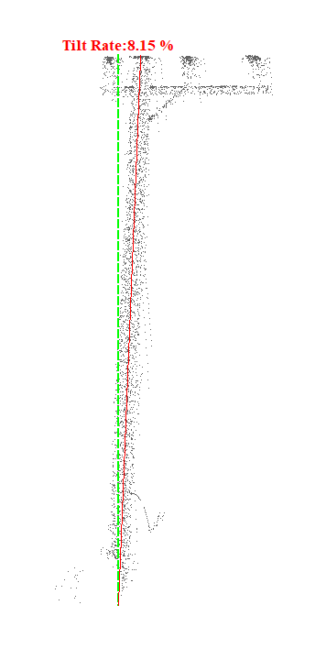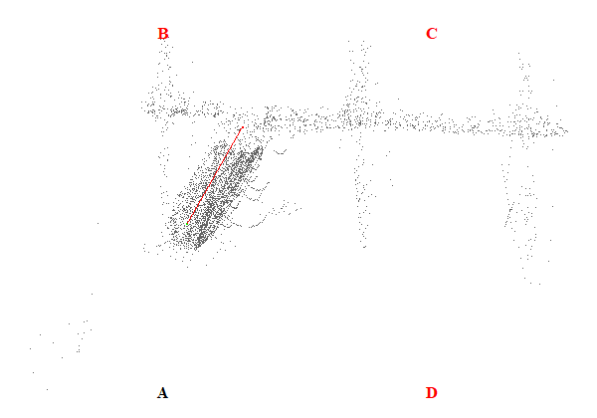
Gambar 134. Kemiringan Menara 134

Tabel 135. Kemiringan Menara 135
Nomor Menara | Searah RoW (%) | Tegak Lurus RoW (%) | Resultan (%) | Nilai Standar (%) | Searah RoW | Tegak Lurus RoW | Penilaian
135 | 4.75 | 19.61 | 20.18 | 5.00 | BC | AB | Tidak Lulus
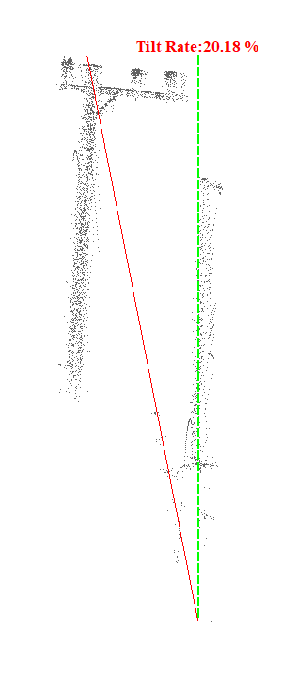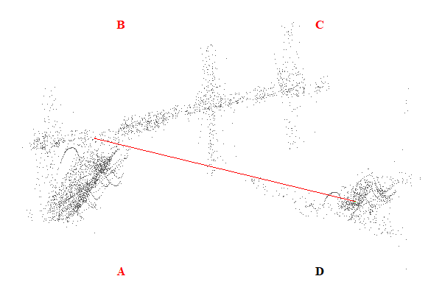
Gambar 135. Kemiringan Menara 135

Tabel 136. Kemiringan Menara 136
Nomor Menara | Searah RoW (%) | Tegak Lurus RoW (%) | Resultan (%) | Nilai Standar (%) | Searah RoW | Tegak Lurus RoW | Penilaian
136 | 9.93 | 2.35 | 10.20 | 5.00 | BC | CD | Tidak Lulus
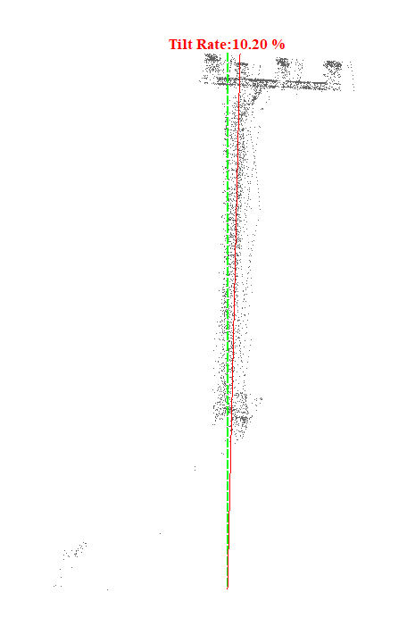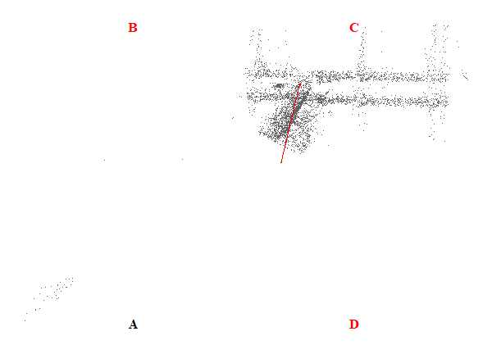
Gambar 136. Kemiringan Menara 136

Tabel 137. Kemiringan Menara 137
Nomor Menara | Searah RoW (%) | Tegak Lurus RoW (%) | Resultan (%) | Nilai Standar (%) | Searah RoW | Tegak Lurus RoW | Penilaian
137 | 6.48 | 1.09 | 6.57 | 5.00 | BC | AB | Tidak Lulus
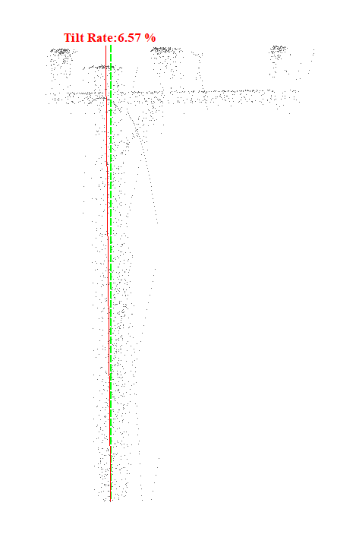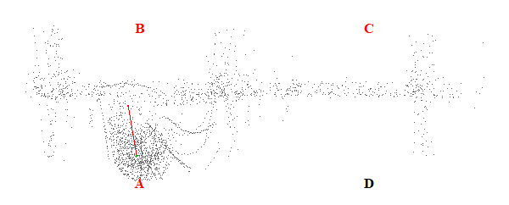
Gambar 137. Kemiringan Menara 137

Tabel 138. Kemiringan Menara 138
Nomor Menara | Searah RoW (%) | Tegak Lurus RoW (%) | Resultan (%) | Nilai Standar (%) | Searah RoW | Tegak Lurus RoW | Penilaian
138 | 7.24 | 17.57 | 19.00 | 5.00 | BC | CD | Tidak Lulus
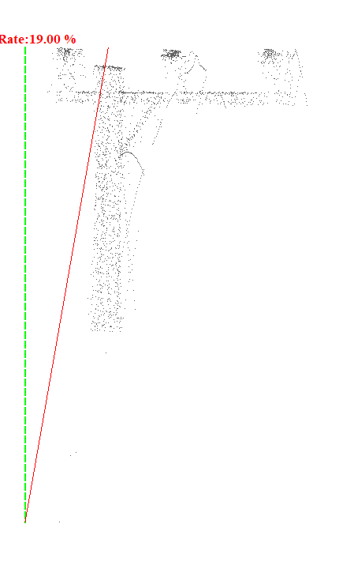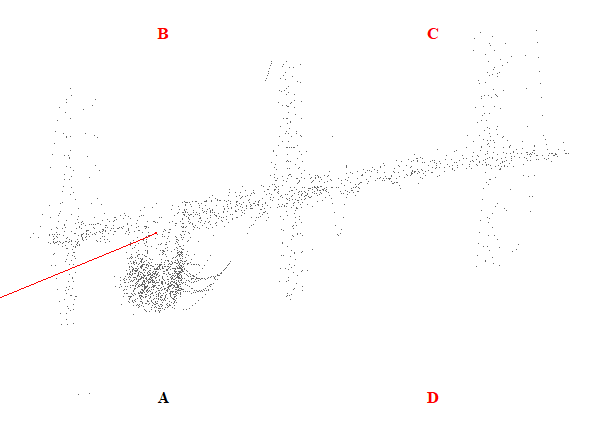
Gambar 138. Kemiringan Menara 138

Tabel 139. Kemiringan Menara 139
Nomor Menara | Searah RoW (%) | Tegak Lurus RoW (%) | Resultan (%) | Nilai Standar (%) | Searah RoW | Tegak Lurus RoW | Penilaian
139 | 1.54 | 0.13 | 1.55 | 5.00 | BC | AB | Lulus
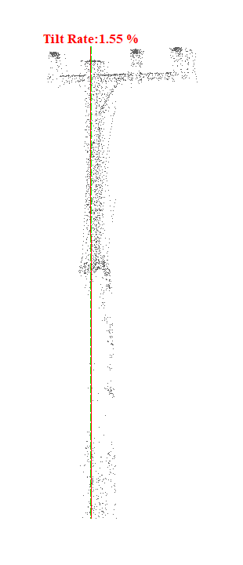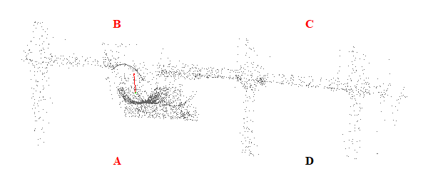
Gambar 139. Kemiringan Menara 139

Tabel 140. Kemiringan Menara 140
Nomor Menara | Searah RoW (%) | Tegak Lurus RoW (%) | Resultan (%) | Nilai Standar (%) | Searah RoW | Tegak Lurus RoW | Penilaian
140 | 1.01 | 6.89 | 6.96 | 5.00 | AD | CD | Tidak Lulus
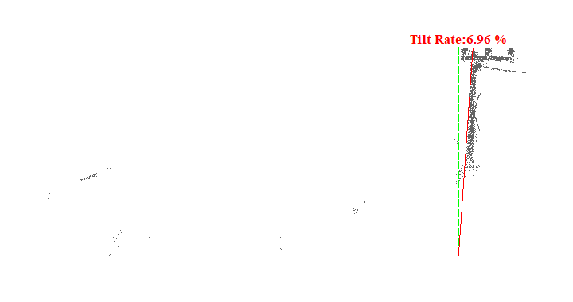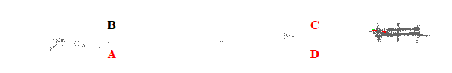
Gambar 140. Kemiringan Menara 140

Tabel 141. Kemiringan Menara 141
Nomor Menara | Searah RoW (%) | Tegak Lurus RoW (%) | Resultan (%) | Nilai Standar (%) | Searah RoW | Tegak Lurus RoW | Penilaian
141 | 0.98 | 1.98 | 2.21 | 5.00 | AD | CD | Lulus
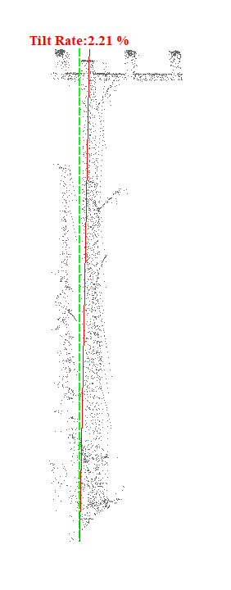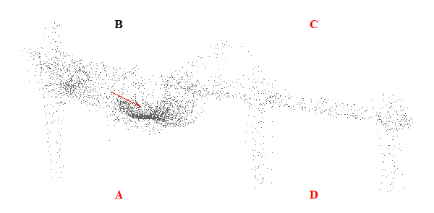
Gambar 141. Kemiringan Menara 141

Tabel 142. Kemiringan Menara 142
Nomor Menara | Searah RoW (%) | Tegak Lurus RoW (%) | Resultan (%) | Nilai Standar (%) | Searah RoW | Tegak Lurus RoW | Penilaian
142 | 0.58 | 4.56 | 4.60 | 5.00 | AD | CD | Lulus
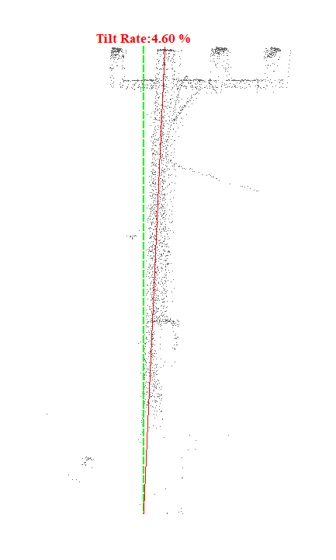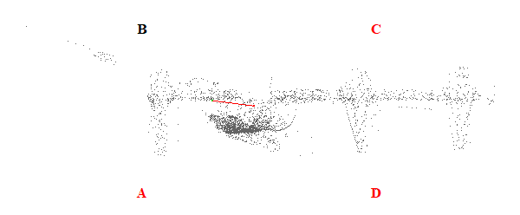
Gambar 142. Kemiringan Menara 142

Tabel 143. Kemiringan Menara 143
Nomor Menara | Searah RoW (%) | Tegak Lurus RoW (%) | Resultan (%) | Nilai Standar (%) | Searah RoW | Tegak Lurus RoW | Penilaian
143 | 3.00 | 2.48 | 3.89 | 5.00 | AD | CD | Lulus
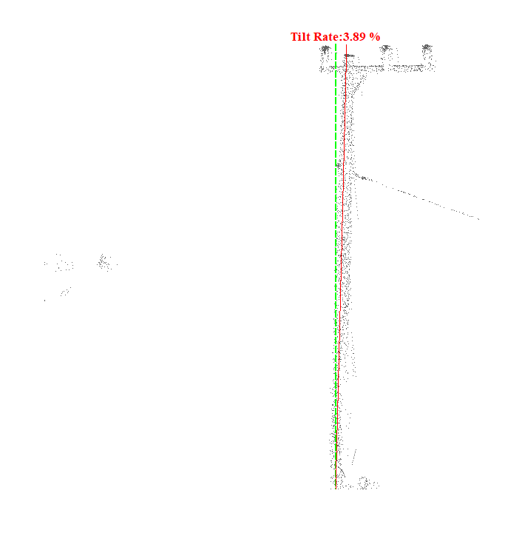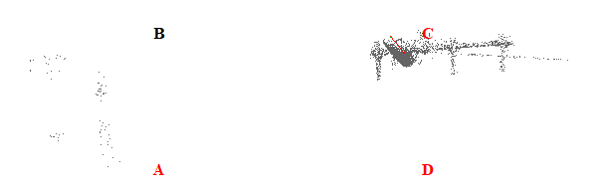
Gambar 143. Kemiringan Menara 143

Tabel 144. Kemiringan Menara 144
Nomor Menara | Searah RoW (%) | Tegak Lurus RoW (%) | Resultan (%) | Nilai Standar (%) | Searah RoW | Tegak Lurus RoW | Penilaian
144 | 15.90 | 2.36 | 16.07 | 5.00 | BC | AB | Tidak Lulus
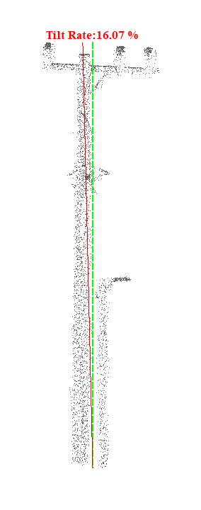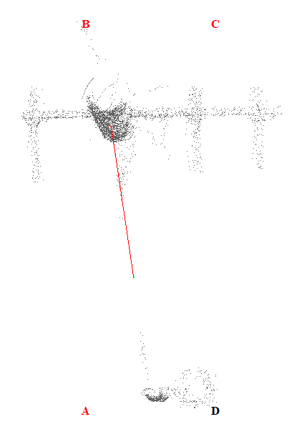
Gambar 144. Kemiringan Menara 144

Tabel 145. Kemiringan Menara 145
Nomor Menara | Searah RoW (%) | Tegak Lurus RoW (%) | Resultan (%) | Nilai Standar (%) | Searah RoW | Tegak Lurus RoW | Penilaian
145 | 3.60 | 2.09 | 4.16 | 5.00 | AD | CD | Lulus
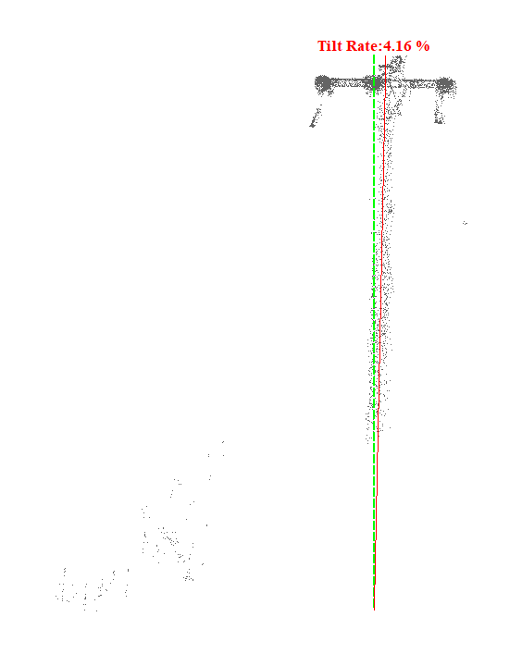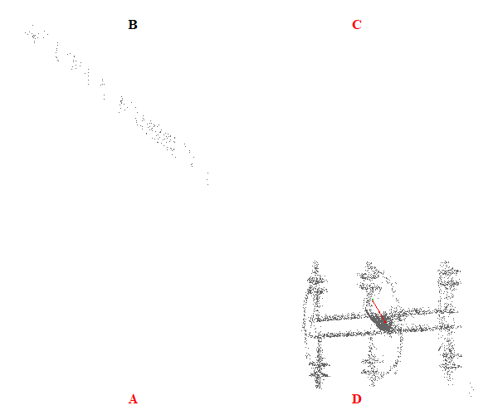
Gambar 145. Kemiringan Menara 145

Tabel 146. Kemiringan Menara 146
Nomor Menara | Searah RoW (%) | Tegak Lurus RoW (%) | Resultan (%) | Nilai Standar (%) | Searah RoW | Tegak Lurus RoW | Penilaian
146 | 0.00 | 4.03 | 4.03 | 5.00 | - | CD | Lulus
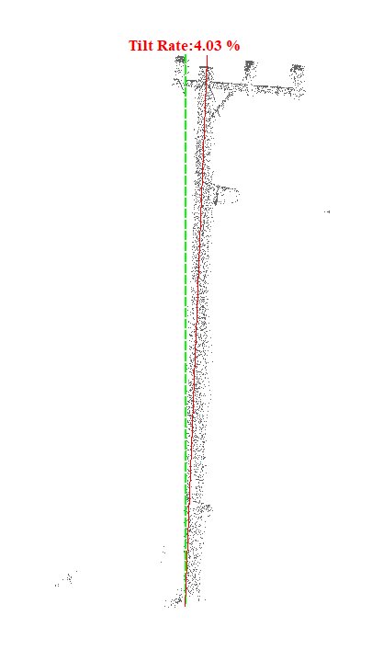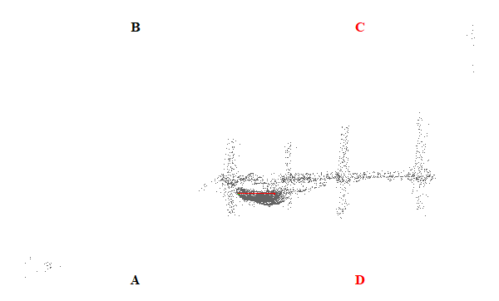
Gambar 146. Kemiringan Menara 146

Tabel 147. Kemiringan Menara 147
Nomor Menara | Searah RoW (%) | Tegak Lurus RoW (%) | Resultan (%) | Nilai Standar (%) | Searah RoW | Tegak Lurus RoW | Penilaian
147 | 1.05 | 2.22 | 2.46 | 5.00 | AD | CD | Lulus
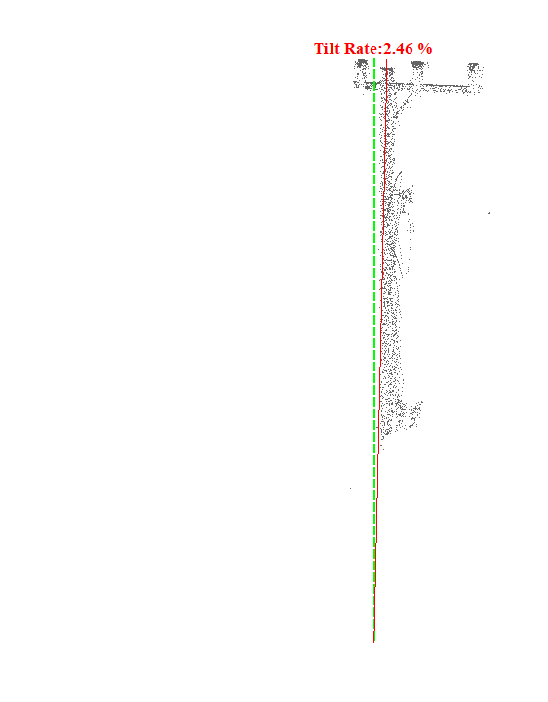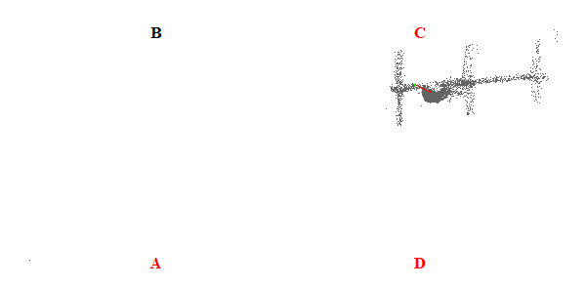
Gambar 147. Kemiringan Menara 147

Tabel 148. Kemiringan Menara 148
Nomor Menara | Searah RoW (%) | Tegak Lurus RoW (%) | Resultan (%) | Nilai Standar (%) | Searah RoW | Tegak Lurus RoW | Penilaian
148 | 0.59 | 1.85 | 1.94 | 5.00 | AD | AB | Lulus
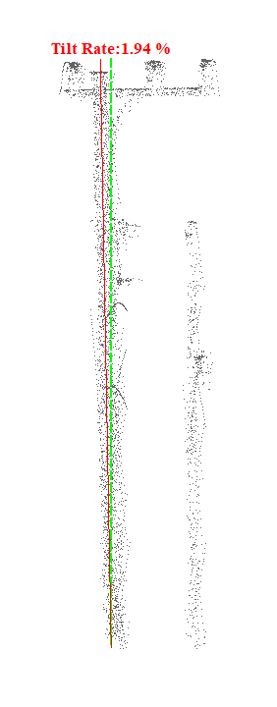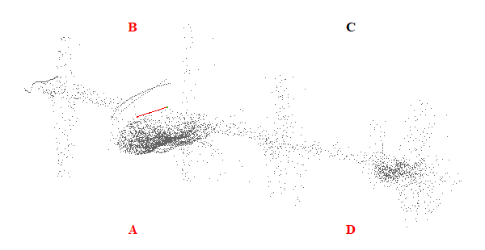
Gambar 148. Kemiringan Menara 148

Tabel 149. Kemiringan Menara 149
Nomor Menara | Searah RoW (%) | Tegak Lurus RoW (%) | Resultan (%) | Nilai Standar (%) | Searah RoW | Tegak Lurus RoW | Penilaian
149 | 4.44 | 16.73 | 17.31 | 5.00 | AD | CD | Tidak Lulus
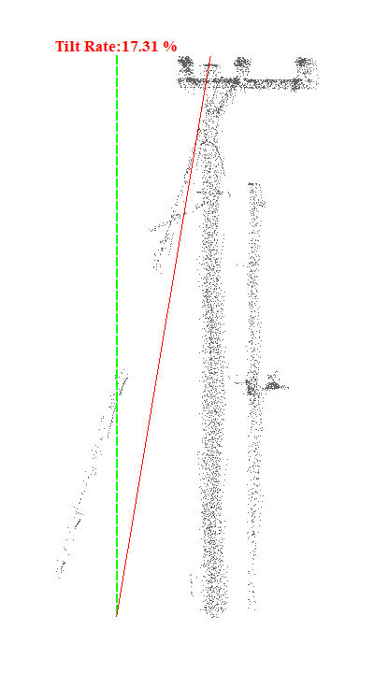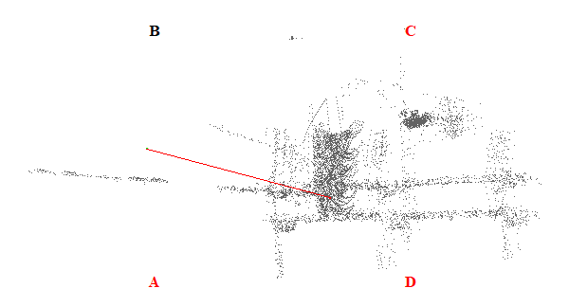
Gambar 149. Kemiringan Menara 149

Tabel 150. Kemiringan Menara 150
Nomor Menara | Searah RoW (%) | Tegak Lurus RoW (%) | Resultan (%) | Nilai Standar (%) | Searah RoW | Tegak Lurus RoW | Penilaian
150 | 1.19 | 1.56 | 1.96 | 5.00 | AD | AB | Lulus
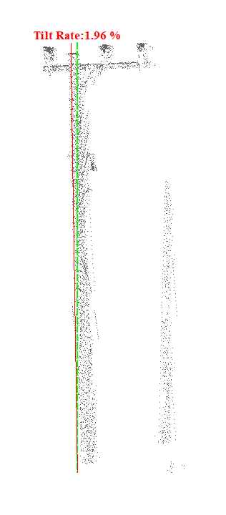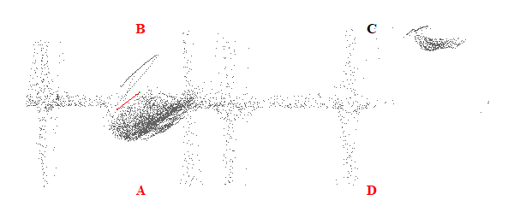
Gambar 150. Kemiringan Menara 150

Tabel 151. Kemiringan Menara 151
Nomor Menara | Searah RoW (%) | Tegak Lurus RoW (%) | Resultan (%) | Nilai Standar (%) | Searah RoW | Tegak Lurus RoW | Penilaian
151 | 4.69 | 1.75 | 5.01 | 5.00 | AD | AB | Tidak Lulus
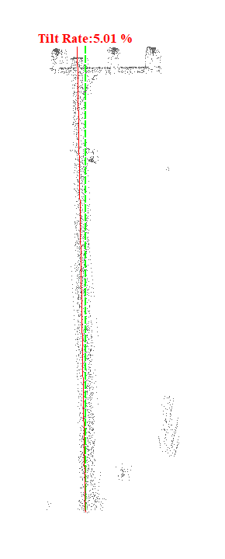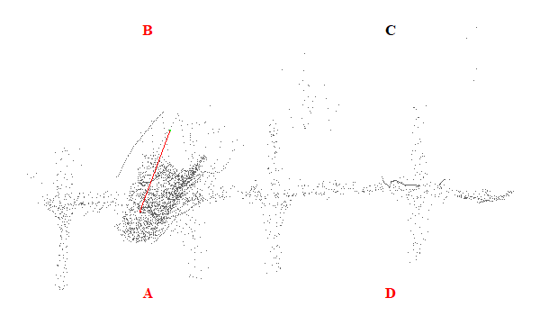
Gambar 151. Kemiringan Menara 151

Tabel 152. Kemiringan Menara 152
Nomor Menara | Searah RoW (%) | Tegak Lurus RoW (%) | Resultan (%) | Nilai Standar (%) | Searah RoW | Tegak Lurus RoW | Penilaian
152 | 1.57 | 0.50 | 1.65 | 5.00 | AD | CD | Lulus
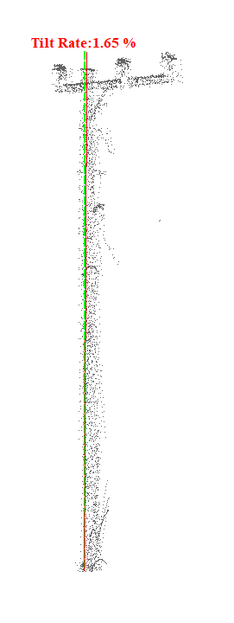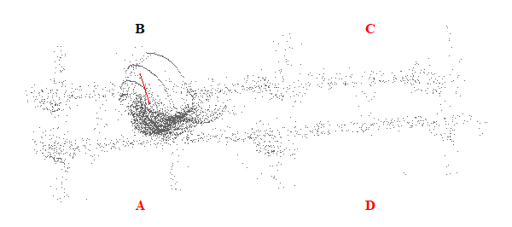
Gambar 152. Kemiringan Menara 152

Tabel 153. Kemiringan Menara 153
Nomor Menara | Searah RoW (%) | Tegak Lurus RoW (%) | Resultan (%) | Nilai Standar (%) | Searah RoW | Tegak Lurus RoW | Penilaian
153 | 1.27 | 4.27 | 4.45 | 5.00 | AD | CD | Lulus
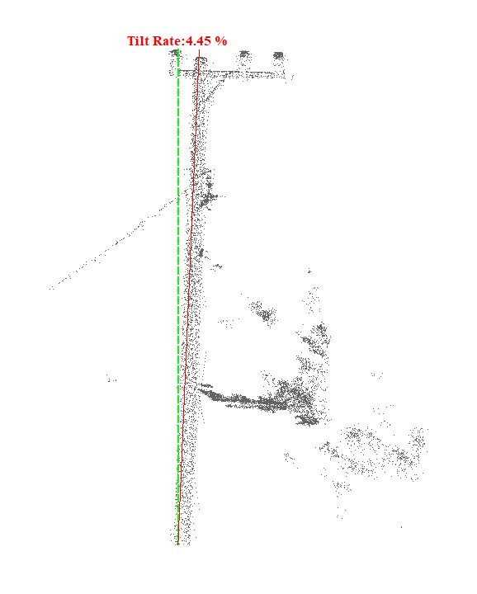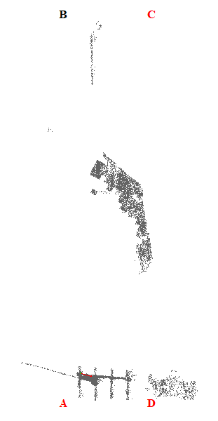
Gambar 153. Kemiringan Menara 153

Tabel 154. Kemiringan Menara 154
Nomor Menara | Searah RoW (%) | Tegak Lurus RoW (%) | Resultan (%) | Nilai Standar (%) | Searah RoW | Tegak Lurus RoW | Penilaian
154 | 9.15 | 36.80 | 37.92 | 5.00 | AD | CD | Tidak Lulus
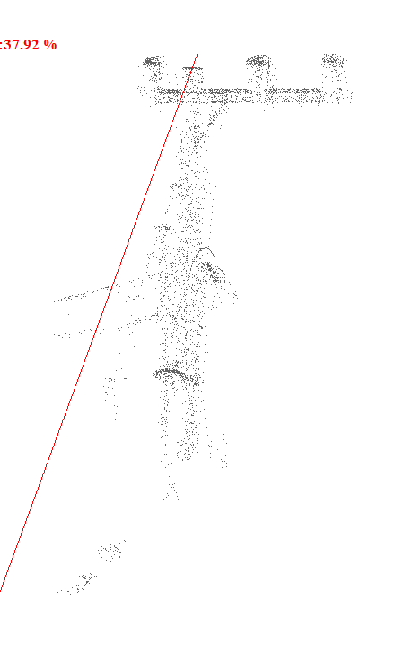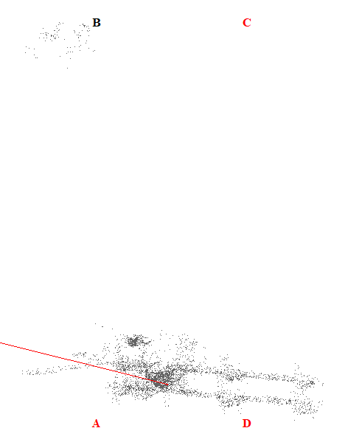
Gambar 154. Kemiringan Menara 154

Tabel 155. Kemiringan Menara 155
Nomor Menara | Searah RoW (%) | Tegak Lurus RoW (%) | Resultan (%) | Nilai Standar (%) | Searah RoW | Tegak Lurus RoW | Penilaian
155 | 2.29 | 2.15 | 3.14 | 5.00 | AD | AB | Lulus
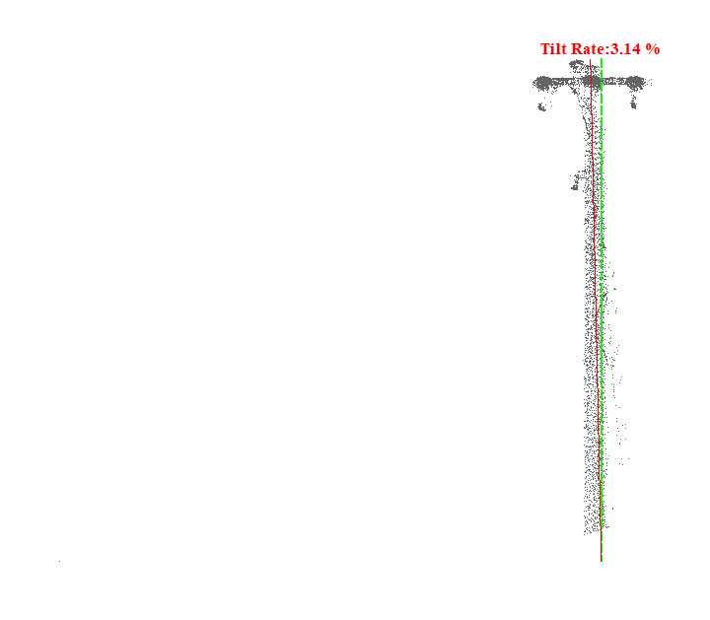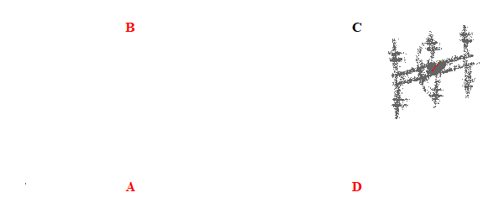
Gambar 155. Kemiringan Menara 155

Tabel 156. Kemiringan Menara 156
Nomor Menara | Searah RoW (%) | Tegak Lurus RoW (%) | Resultan (%) | Nilai Standar (%) | Searah RoW | Tegak Lurus RoW | Penilaian
156 | 1.18 | 5.99 | 6.11 | 5.00 | BC | CD | Tidak Lulus
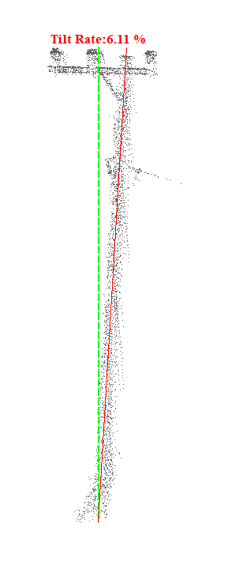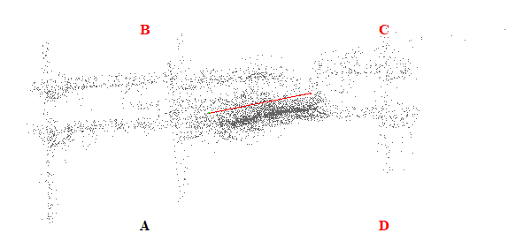
Gambar 156. Kemiringan Menara 156

